YEAR 3 writing units – progression map
 |  | Autumn 1 |  | Autumn 2
 | Literary Leaf Text | 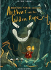  Arthur and the Golden Rope  By Joe Todd Stanton |  | 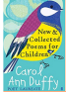  New and Collected Poems for Children  By Carol Ann Duffy
Author focus this term | Writing Root  (Unit) | 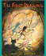  The First Drawing  By Mordicai Gerstein |   The Heart and the Bottle  By Oliver Jeffers |   The Barnabus Project  By The Fan Brothers | 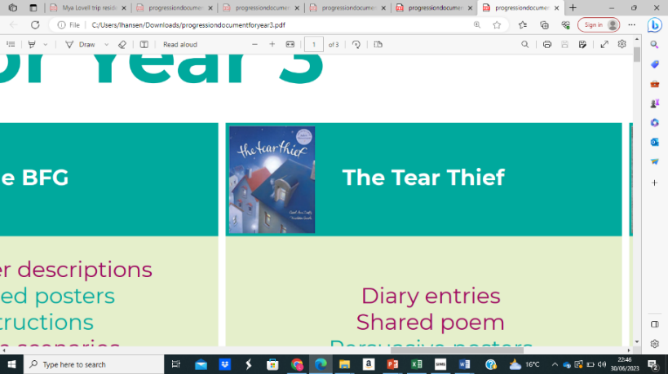  The Tear Thief  By Carol Ann Duffy
 | Outcomes  Narrative  Non-fiction | Imaginary Stone Age scenarios  Diary of a Stone Age boy  Description of a woolly mammoth  First person recount  First person historical narrative | Dialogue  Postcards  Character descriptions  Diary entries  Poetry  Letters of advice | Instructional writing  Descriptions  Advertisements  Writing in role  Letters of advice  Dialogue | Diary entries Shared poem Persuasive posters  Letters of explanation Discussion
 | Main Outcome | Own version historical narrative | Own version dilemma narrative | Brochures | Discussion
 | Audience/  Form | - Imaginary Stone Age scenarios  - Diary of a Stone Age boy  - Description of a woolly mammoth  - First person recount  - First person historical narrative | - Conversation between Grandpa and the girl  - Postcard from the girl  - Character description of the girl  - Diary entry as the girl  - Poem about emotions  - Letter of advice to a friend  - Own version ‘dilemma’ narrative | - Description of ‘perfect pets’  - Shop advert  - Thought bubble for Barnabus  - Diary entry as Barnabus/ failed pet  - Escape plan instructions  - Brochure to advertise a new pet shop | - Diary entry in role as the Tear Thief  - Shared group / class poem  - Letter to the Tear Thief from the girl  - Posters about importance of crying  - Letter of advice to the girl  - Newspaper article about stolen tears
 | Purpose | Reflect  Describe  Entertain | Recount  Describe  Reflect  Entertain  Persuade | Describe  Persuade  Reflect  Instruct | Recount Entertain Inform
Grammar coverage  (these may be taught multiple times throughout the sequence)  * indicates coverage from a different year group | Word | modal verbs*  regular* / irregular plural  nouns | prefixes – un, mis, dis *  abstract nouns  similes  adjectives ending ‘ous’ | types of nouns  imperative verbs  suffix -er | noun phrases expanded with ‘of’ simile / metaphor
 | Sentence | subordination – because, as, since*  conditional sentences – if  noun phrases expanded with ‘with’*  fronted adverbials | questions *  exclamations *  adverbial phrases  conjunctions to sequence / contrast / explain | adverbs of time  expanded noun phrases  prepositions  range of sentence types*  conjunctions - because  fronted adverbials* | range of sentence types * conditional sentences – if conjunctions – because / when
 | Punctuation | exclamation marks *  question marks *  inverted commas for speech  apostrophes for possession / omission * | question marks *  inverted commas for speech | apostrophes for contraction*  inverted commas for speech  commas to mark clauses* | apostrophes for possession * adverbial phrases  begin to use commas after fronted adverbials *  inverted commas for speech
 | Text | paragraphs to group material | present perfect  paragraphs to group material  bullet points to organise * | present perfect  paragraphs to group material | verbs in progressive form *  present perfect tense  bullet points to organise * paragraphs to group material

 |  | Spring 1 |  | Spring 2
 | Literary Leaf Text |   Earth Shattering Events  By Robert Jacobs |  | 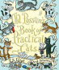  Old Possum’s Book of Practical Cats  By T.S. Eliot
Author focus this term | Writing Root  Unit | 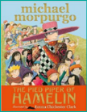  The Pied Piper of Hamelin  By Michael Morpurgo |   The Last Garden  By Rachel Ip | 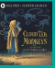  Cloud Tea Monkeys  By Mal Peet & Elspeth Graham |   Small in the City  By Sidney Smith
 | Outcomes  Narrative  Non-fiction | Writing in role  Information reports  Adverts  Formal letters | Setting descriptions  Adverts  Recounts  Instructional flyers  Online responses  Dialogue  Formal speech | Descriptive passages  Writing in role  ‘How to’ guides  Letters  Discussions | Setting descriptions  Poems  Diary entries  Dialogue  Letters of advice  Lost posters
 | Main Outcome | Own version myth / legend | Own version narrative | Non-chronological report | Extended narrative
 | Audience/  Form | - First person reaction to seeing rats  - Information report about rats  - Advert for a rat-catcher  - Persuasive letter to the Mayor  - Own version myth | - Setting description of the city then and now  - Advert to come to the garden  - Recount in role  - Instructions for staying safe  - Response to an online post  - Formal awards speech  - Own version tale of overcoming adversity | - Descriptive paragraph of an illustration  - Thought bubble for Tashi  - ‘How to’ instructions for tasting tea  - Letter of thanks to monkeys  - Non-chronological report about tea | - Description of city setting  - Poem about being small in the city  - Diary entry of being in the city  - Letter of advice to Small  - Lost poster for cat  - Alternative ending to story  - Narrative from perspective of cat
 | Purpose | Reflect  Inform  Persuade | Describe  Persuade  Describe  Recount | Describe  Reflect  Inform | Describe  Entertain  Persuade  Inform
Grammar coverage  (these may be taught multiple times throughout the sequence)  * indicates coverage from a different year group | Word | word classes *  adverbs with -ly *  -sion / -tion suffix  modal verbs * | -ful / -less suffix *  adverbs with -ly *  superlatives -est * | use forms of a or an  imperative verbs  homophones | adverbs with -ly *  personification
 | Sentence | noun phrases with ‘of’* conjunctions – as, because, but, although, so  sentence types *  conditional sentences – if questions *  adverbial phrases | abstract noun phrases with ‘of’  subordinating / contrasting conjunctions  sentence types *  subordinate clauses  prepositions – before / after  adverbials of time | expanded noun phrases  prepositions  conjunctions of time /place / cause  sentence types * | contrasting / extending conjunctions  expanded noun phrases  prepositions  questions / commands *  -ly adverbs to sequence
 | Punctuation | question marks * | possessive apostrophe*  commas after fronted adverbials *  inverted commas for speech  apostrophes for contraction | inverted commas for speech  sentence ending punctuation * | questions marks *  inverted commas for speech
 | Text | heading / subheadings to organise  pronouns to avoid repetition *  paragraphs to group material | present perfect  paragraphs to group material | present perfect  headings and subheadings  paragraphs to group material | present perfect  paragraphs to group material

 |  | Summer 1 |  | Summer 2
Author focus this term | Literary Leaf Text | 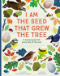  I am the Seed that Grew the Tree  By Fiona Waters |  |   A Necklace of Raindrops  By Joan Aiken
 | Writing Root  Unit |   The Mysteries of Harris Burdick  By Chris Van Allsberg |   Flotsam  By David Wiesner |   Our Tower  By Joseph Coehlo | 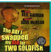  The Day I Swapped my Dad for Two Goldfish  By Neil Gaiman
 | Outcomes  Narrative  Non-fiction | Diary entries  Dialogue  Setting descriptions  Captions and titles | Postcards  Setting descriptions  Non-chronological reports  Informal letters | Sound poem of a walk to the park  Setting descriptions  Conversation between children and Tree-Grown Man  Diary entry of one child  Letter to the Tree-Grown Man  Extended fantasy narrative | Dialogue  Thought bubbles  Missing scenes  Diary entries
 | Main Outcome | Mystery narrative | Sequel | Poem | Own version narrative
 | Audience/  Form | - Atmospheric setting description  - Diary entry of girl with caterpillars  - New titles for illustrations  - Captions to accompany new  - titles  - Short mystery story  - Mystery story based on a photograph | - Postcard to a friend  - Logbook entries to describe findings  - Report about types of camera  - Message in a bottle letter to find a scientist  - Mystery narrative sequel | - Sound poem of a walk to the park  - Setting descriptions  - Conversation between children and Tree-Grown Man  - Diary entry of one child  - Letter to the Tree-Grown Man  - Extended fantasy narrative | - Dialogue  - Thought bubble for Nathan  - Missing scene  - Diary entry for Dad  - Own version ‘swap’ story
 | Purpose | Describe  Inform  Entertain | Inform  Describe  Entertain | Entertain  Describe  Reflect  Inform | Reflect  Entertain
Grammar coverage  (these may be taught multiple times throughout the sequence)  * indicates coverage from a different year group | Word | -ing suffix (gerunds)  -un prefix *  similes | -sub prefix | onomatopoeia
 | Sentence | questions / statements *  noun phrases with ‘of’ *  prepositions of place  adverbs of time | conjunctions - but, so *  conjunctions of time and cause – because, as, since  adverbial phrases  fronted adverbials *  expanded noun phrases  prepositions – of, with, through, around, on | prepositions – in, of  expanded noun phrases  range of sentence types *  conjunctions - but, although, before, after, while  adverbials of time  order of clauses * | conjunctions – because, when, while  multi-clause sentences  adverbs /adverbial phrases of time  fronted adverbials *
 | Punctuation | questions marks *  inverted commas for speech | comma after fronted adverbials * | inverted commas for speech  apostrophes for contraction *  bullet points to organise * | inverted commas for speech  apostrophes for possession and  contraction *  comma after fronted adverbials *
 | Text | present / past perfect  paragraphs to group material | paragraphs to group material  pronouns to avoid repetition | present perfect  simple past tense *  paragraphs to group material | simple past tense *  past progressive *

