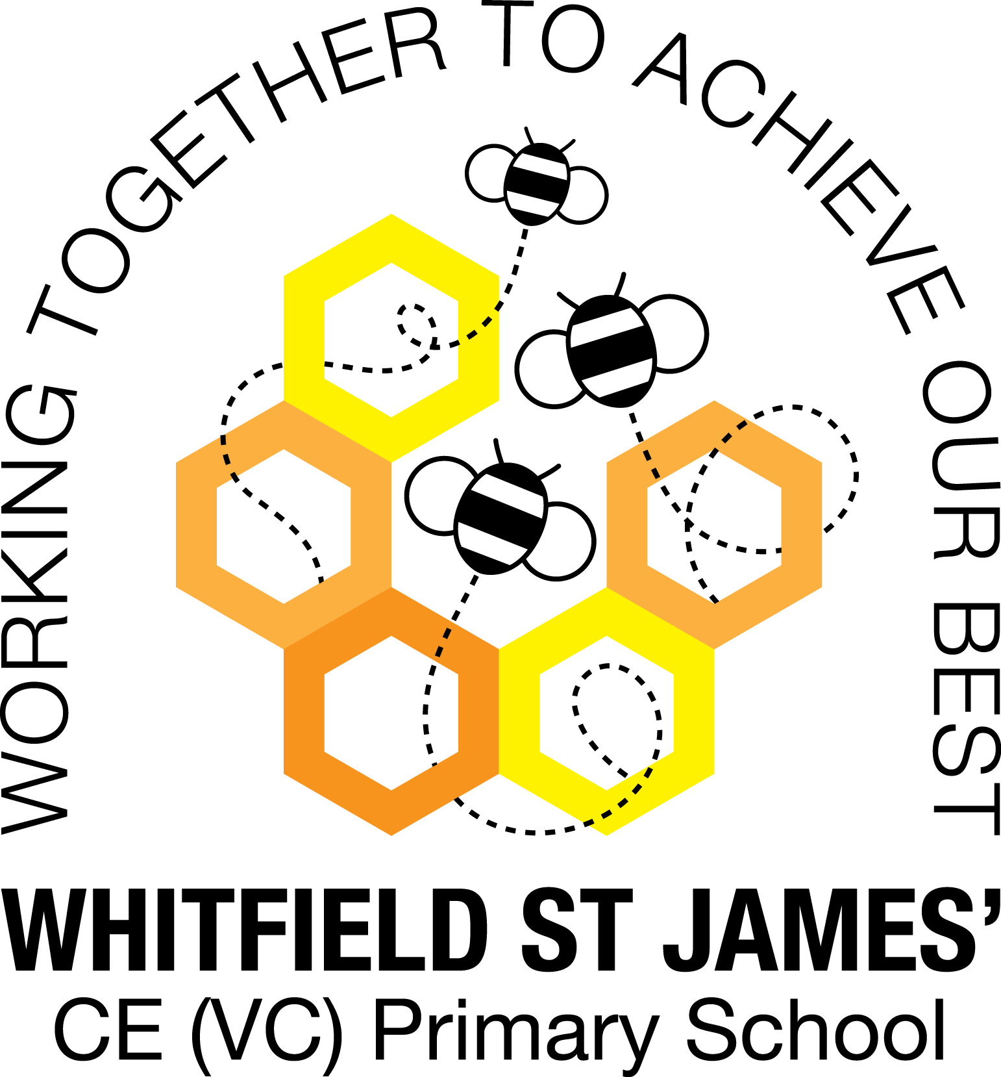

WHITFIELD ST JAMES’ CE (VC) PRIMARY SCHOOL

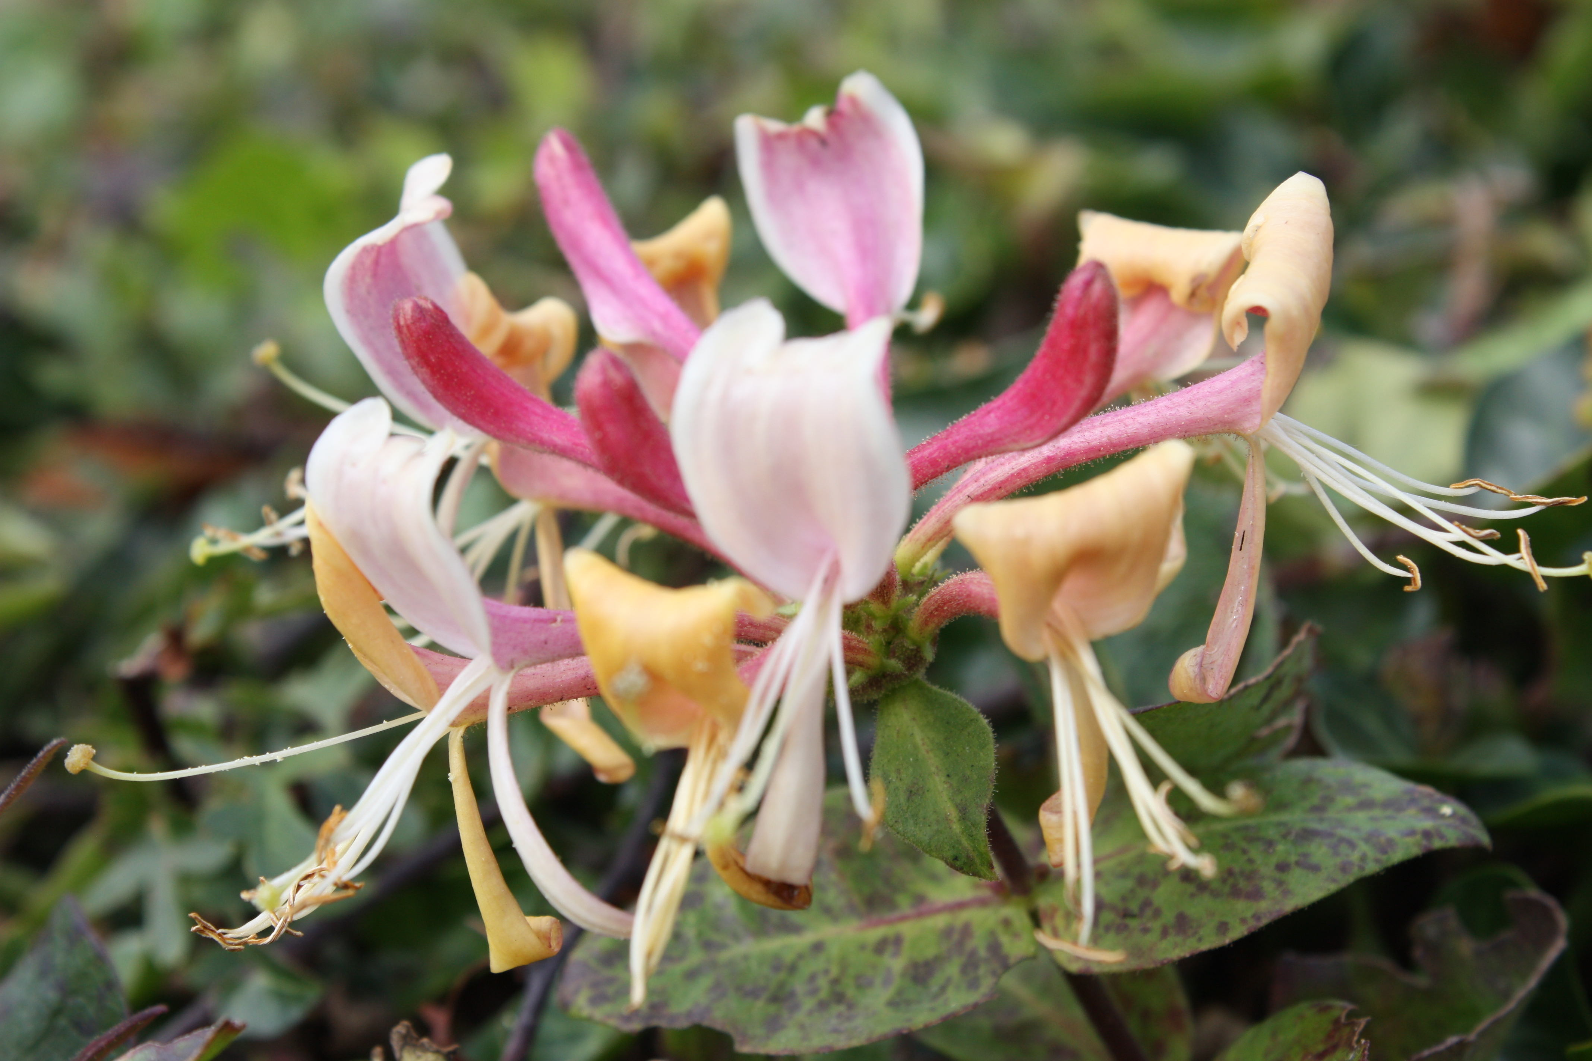

Monday 6th June 2022
Dear parents and carers of Honeysuckles class,
I hope that you have all had a lovely half term break and the children feel rested and ready to learn! Hopefully, everyone enjoyed a good dose of sunshine!
We will continue with our Beast Creator topic for the next few weeks due to last half term bring such a short one and our special Jubilee week.
If your child has completed any homework on this topic they can bring it into school in the second week of term to show the class.
English
We will be continuing our Vipers work on Charlotte’s web in Guided Reading. The children will be writing a comic style story based on a deadly minibeast and they will continue to practice their SPAG (spelling and grammar) skills with different tasks.
Maths
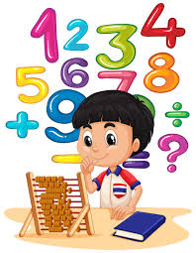
In maths, we will finish off our money topic and then move on to time, shape and statistics. The children will continue to be encouraged to log on to TT Rockstars to help them to learn their times tables or to keep working on their speed of recall of the multiplication facts. Please encourage your children to do this, as a secure knowledge of the tables helps the children in all areas of maths. The children are making such great progress with this and enjoying completing bronze, silver, gold, European and Olympic weekly challenges. Thank you for your support!
The Y4s will be carrying out their multiplication checks in school in the last week of June.
Topic
Our new topic, which we will start in the 3rd week of term, will be called Dynamic Dynasties. Please keep looking at the weekly snapshots on the class page of the school website for any information about a wow day. This project teaches children about the history of ancient China, focusing primarily on the Shang Dynasty, and explores the lasting legacy of the first five Chinese dynasties, some of which can still be seen in the world today. The children will also be creating some art work in a project named Taotie. This project teaches children about the significance and art of the taotie motif, including ancient and contemporary casting methods.
Accompanying this newsletter is a knowledge organiser and home learning guide, which contains some suggested activities that your child can do at home .

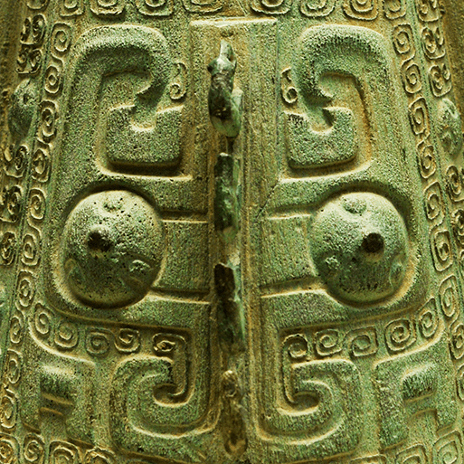
Other subjects

Honeysuckles will continue to be taught by Mrs Purdy on Tuesday afternoons, which is my afternoon out of class. She will be teaching them indoor (or outdoor) PE, German and some PSHE.

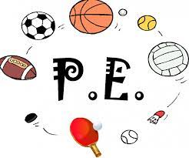
PE

Your child will need to come in to school in their PE kit on Mondays and Tuesdays each week. Please could their kit be in line with our uniform policy, which is a plain white t-shirt or polo shirt, plain black shorts, plain black jogging bottoms and trainers. It may be a good idea for anyone with pierced ears to leave their earrings out on PE days to save them having to take them out or if your child struggles to remove their earrings, they can tape them over (tape will not be provided by school).

WOPPS (wider opportunities whole class music instrument lessons)
The children will continue to have a music lesson on Thursday afternoons. Please remember to look after the instrument at home and bring it in to school every Thursday. Their final session will be on the 23rd June. We are hoping to perform to you on that date – please look out for texts or information on the weekly snapshots for a performance time.
Homework
We will continue with our homework routine – which is working well. Remember homework will be given out on a Friday and will be due in on the following Thursday when children will bring their homework books in to school for their work to be marked. Children will be provided with maths homework, spelling homework and they will also be expected to read at least five times a week, and for their reading to be recorded in their reading record. Many thanks with your support with this.
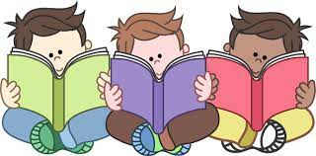
Reading
Your child will continue to be provided with a reading book in line with their reading age. In class, children will have access to books off our reading shelves as well as library books (which are brought in to the classroom for children to access) and we will also have our 50 Reads Challenge books in our reading treasure chest. These books are specific to Y4/5, and the children are encouraged to read as many, ideally all, of the books during their time in Y4/5. Thank you for your support in encouraging your child to read! Please encourage your child to tick off the treasure chest books they have read on the list in their homework book.
I hope that you have found this information useful. I am sorry that some of it is repeated. If you ever need to contact me, please don’t hesitate, you can phone school or can email me directly on honeysuckle@st-james.derbyshire.sch.uk
Thank you for your support.
Best wishes,
Mrs Collins

