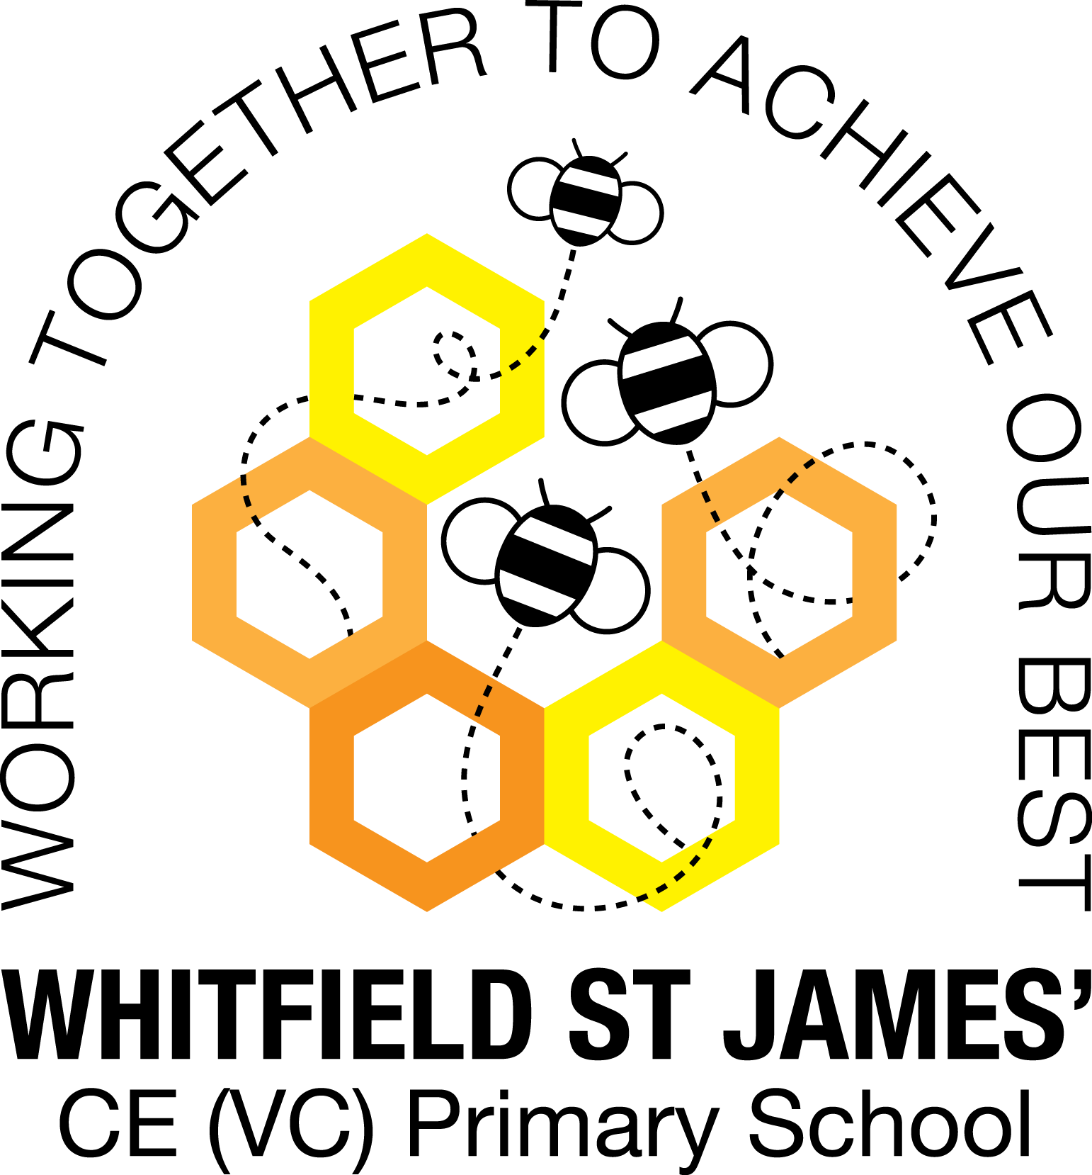

WHITFIELD ST JAMES’ CE (VC) PRIMARY SCHOOL

Monday 6th June 2022
Dear parents and carers of Tulip class,
We hope you are looking forward to our final topic for this academic year. Many of our routines are continuing from last half term so please bear with any repetition in this letter.
English and maths
This term our English lessons will be based around our new topic ‘Playlist’. We will be learning to analyse texts more critically and writing poems, songs, sIogans, adverts, posters and leaflets. In maths, we will continue to use White Rose to structure our lessons and we will be focusing on shape, measure and recapping our arithmetic skills. Thank you for continuing to encourage your children to log on to TT Rockstars, this will help them to learn their times tables and work on their speed of recall of the multiplication facts. The Year 4 children will be assessed shortly on their knowledge of times tables and related division facts. Please can all children continue to practise using ‘Sound Check’ every week.


Topic
What’s that noise? A bash? A crash? A shake, a rattle or a low, bass hum? Which do you prefer - an acoustic singer or a booming brass band? A solitary voice singing sweetly and quietly or a magnificent choir lifting the roof? Take out your ear plugs as you journey through the valley of sound and find out about instruments, the sounds they make and how they are produced. Discover how sounds are made and which sounds travel the furthest. Then, sing up and compose a class song for the local talent contest, Class Factor. Can you write a number one hit? Be sure to stand up straight, warm up your voice and sing your heart out. When your performance is done, sit back and listen to calming classical melodies, a soothing lullaby or your favourite boy band ballad. Can you hear me over there? Or do I need to TALK MORE LOUDLY?

This half term, we’ll listen to a live musical performance, picking out the different sounds and techniques. Roger McGough’s poem, The Sound Collector, will inspire us to go on a sound walk around school. We’ll investigate the volume of sounds and make vibrations using different equipment. Our toes will be tapping along to all kinds of music, and we’ll be listening to song lyrics to get lots of ideas to write our own. We’ll create artwork that represents jazz music, and look at famous, jazz-influenced art. We’ll find out how our ear works, how sound travels and learn about pitch. In DT, we’ll investigate how musical instruments work and enjoy making our own. We’ll share our favourite music and explore how music is used in everyday life. As a challenge, we’ll create an uplifting celebration song.

Wow day
For our Wow day on the first day back Monday 6th June, children are invited to come in dressed as a musician. It could be your character from TT Rock Stars day or someone completely different from any time period or type of music.
We will also be having a talent show so if your child would like to, they could perform a short act to the class.
Help your child prepare for their project by looking at the list of suggestions of activities to do at home.

Other lessons
Our PE days continue to be on Thursdays and Fridays. Could you please ensure your child comes into school in their PE kit on these days. Please could their kit be in line with our uniform policy, which is a plain blue jumper or school jumper, a white t-shirt or polo shirt, plain black shorts or plain black jogging bottoms and trainers. As the weather gets warmer, a t-shirt and shorts would be best. It may be a good idea for anyone with pierced ears to leave their earrings out on PE days to save them having to take them out, or if your child struggles to remove their earrings, they can tape them over (tape will not be provided by school). It would also be good if children with long hair could have it tied up on all days (but especially PE days) to prevent it getting caught. On one of our PE days when the children are wearing appropriate outdoor clothes, we will be doing the hill walk postponed from our Mountains and Rivers topic. We will also continue to learn German and children will continue to be taught RE weekly. This half term they are learning about promises made in stories from the bible and by people in their everyday lives today, such as wedding ceremonies.

Homework
Homework will be given out on a Friday and will be due in on the following Thursday, although homework books can be brought in before Thursday and placed in the homework box in the classroom. Children will be provided with maths and spelling homework and they will also be expected to read at least five times a week. Thank you for recording their home reading in their reading record. The homework sent home is a piece of work your child should be able to complete independently as it is based on spelling patterns or maths taught during the previous week.

Reading
Your child will continue to be provided with a reading book and have access to books from our classroom reading shelves, library books and also our 50 Reads Challenge books.
Sunshine!
We hope we will get some lovely sunny weather in the weeks ahead. Please ensure your child comes to school with a named sun hat, water bottle and that sun cream is applied before they arrive in the morning. Thank you!
If you ever need to contact us, please don’t hesitate, you can phone school or can email us directly on tulip@st-james.derbyshire.sch.uk
Thank you for your support.
Best wishes,
Mrs Mackey and Mr Ford.

