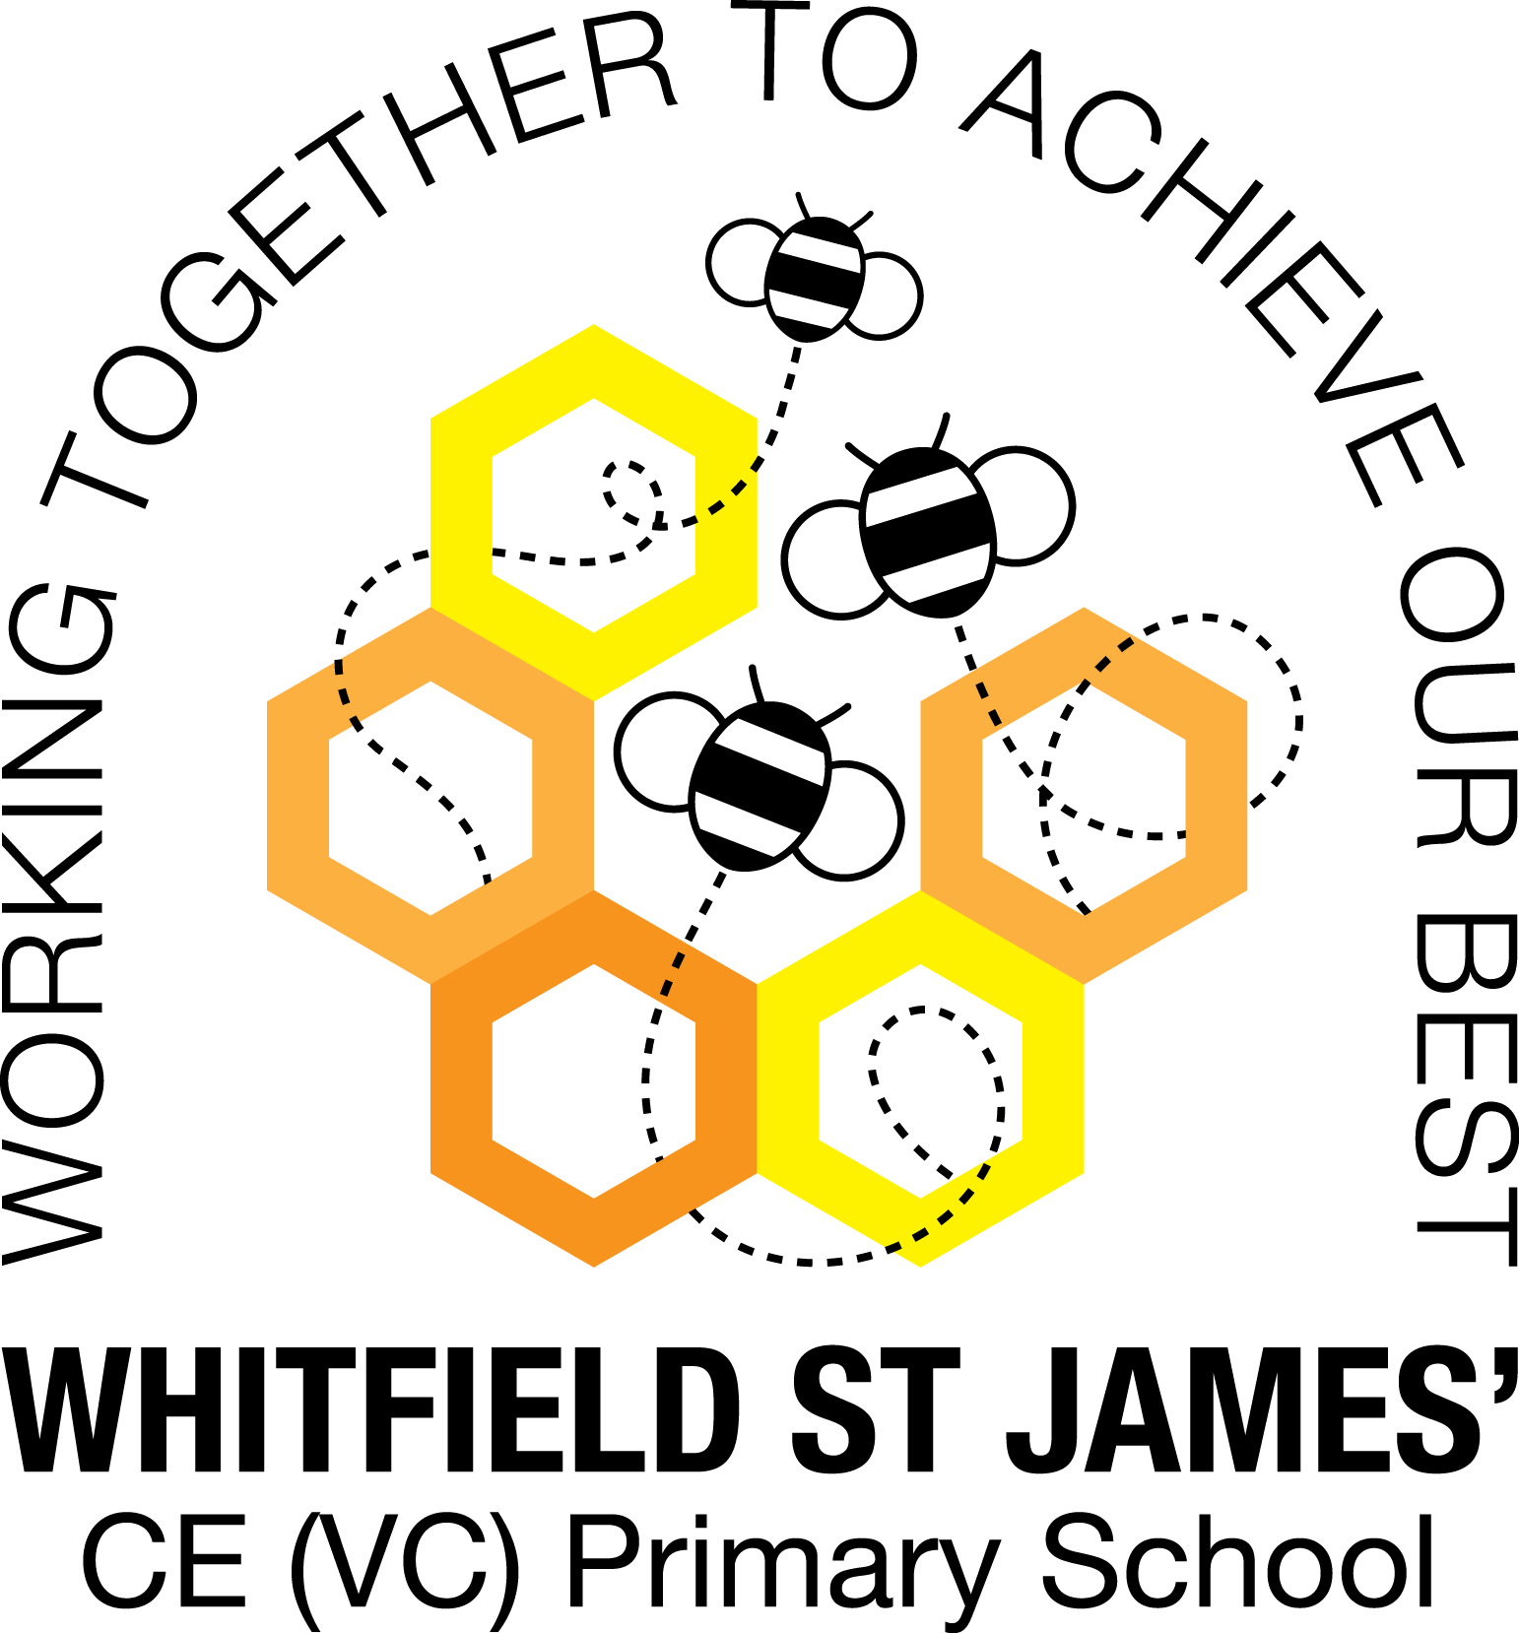

WHITFIELD ST JAMES’ CE (VC) PRIMARY SCHOOL

Monday 6th June 2022
Dear parents and carers of Orchid Class,
Mrs Walker and I hope that you have all had a lovely half term break and that the children are raring to go for their last half term – for some, their last half term in primary school! We have a very busy few weeks ahead with lots of exciting things for the children to look forward to.
English and maths
This term we will begin our English lessons by studying a narrative unit based around a short film called ‘Francis’. We will be producing some short-burst descriptive writing leading up to extended pieces of writing, including a journal entry. We will also continue to develop our knowledge of SPAG (spelling, punctuation and grammar rules) and will apply this to our writing. In guided reading, we will study a picture book called ‘The Journey’ and use our VIPERS skills to comprehend and respond to the text. We will continue to read our class book ‘Who Let the Gods Out?’ by Maz Evans.
In maths, we will be recapping a statistics unit and finishing off properties of shape. Towards the end of the term we will be look at converting units of measure which will help to consolidate multiplying and dividing by 10, 100 and 1,000. Children will continue to be encouraged to log on to TT Rockstars to help them to learn their times tables or to keep working on their speed of recall of the multiplication facts. Please encourage your children to do this, as a secure knowledge of the tables helps the children in all areas of maths. Thank you for your support!
Topic
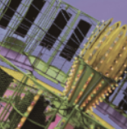
Our new topic is called ‘Scream Machine’ and we will begin studying this topic following our WOW day visit to Alton Towers on Tuesday 14th June. Here is on overview of the topic:
Roll up, roll up. You’re going on a day trip to a theme park, to soak up the unique sights, smells and sounds of the fair. Learn about the science behind roller coasters and write poems that are shaped as a loop the loop. Design a theme park and show your ideas on a digital map. Time for some mini investigations. Cam mechanisms, pendulums, pulleys and prototypes. Let’s go behind the scenes to see forces at work. Good news. The engineers at ‘Scream Towers’ love your work and want you to build a death defying new drop ride for their theme park. Make a working model and test it out with uncooked eggs. Cracking stuff. Okay, ready to ride? Don’t forget to scream if you want to go faster.
Accompanying this newsletter is a knowledge organiser about the topic, which you can read with your child, to find out what we are going to be learning about over the course of the term. Also accompanying the newsletter is a home learning guide, which contains some suggested activities that your child can do at home, as well as recommended reading around this topic. Any work done can be returned to school on the last Monday of term, so that we can look at it over the last couple of days of term.

Other subjects
Orchids will continue to be taught by Mr Doyle on Friday afternoons; he will continue to teach them PE and RE. In our RE lessons, we will continue to follow the Derbyshire Agreed Syllabus for RE and also the diocese-recommended scheme ‘Understanding Christianity’ and this term we are looking at the key question ‘What would Jesus do?’ We will also be exploring special days, festivals and significant people during our lessons and daily collective worship in class. For PSHE, we will be following Derbyshire’s recommended scheme ‘PSHE Matters’ and our focus this term will continue to be Zones of Regulation. In addition to this, we will be teaching the children the RSE (Relationships and Sex Education) curriculum objectives about how babies are made and how babies are born. A letter shall be sent out about this in due course. We shall also be covering a lot of our music learning objectives by learning to perform our songs for our end of year production, and we shall also be continuing with our German lessons, learning how to talk about our school and the subjects we enjoy.

PE
For the rest of the school year, your child will need to come in to school in their PE kit on Friday and on Thursday they will need to be in their swimming kit, with their school uniform over the top. Please could you make sure that their PE kit is in line with our uniform policy, which is a plain white t-shirt or polo shirt, plain black shorts, plain black jogging bottoms and trainers. It may be a good idea for anyone with pierced ears to leave their earrings out on PE days to save them having to take them out, or if your child struggles to remove their earrings, they can tape them over (tape will not be provided by school). Children with long hair must also tie their hair back every day, but especially on PE days.
Reading
Your child will continue to be provided with a reading book in line with their reading age. In class, children will have access to books off our reading shelves as well as library books (which are brought in to the classroom for children to access) and we will also have our 50 Reads Challenge books in our reading treasure chest. These books are specific to Y6, and the children are encouraged to read as many, ideally all, of the books during their time in Y6. It is essential that those children who are free readers are reading books that are challenging enough for their age, and that they are accessing a wide range of genres and authors, and the 50 Reads Challenge is perfect for this! It is lovely to see how much the children are enjoying reading these books. Thank you for your support in encouraging your child to read!
Transition to Y7
This term, as you know, the children have their transition days to look forward to at their secondary schools. Pupils attending New Mills can also look forward to a visit from Mrs Adrio on Wednesday 8th June.
To help them to be ‘Y7 ready’, there are a few things that it would be beneficial for them to work on at home. The first one is homework. Many of the children are not completing their weekly homework and are forgetting to have their homework book in school every Thursday. Please could you remind them how important it is to complete their homework and to remember to bring their book in each week. They will have a lot of homework set by different teachers in Y7, and it is important that they are prepared for this by making sure that they do their homework each week while in Y6.
Shoelaces! We try to encourage them to learn how to tie them by themselves, so please could you reiterate this message at home too! Thank you.
Time-telling: For those children who are not very confident telling the time, please could you help them to practise at home? This will help them when they have to find their way around school to different lessons and follow a timetable. Thank you for your support.

Residential
For those children who are not coming on the residential with us (Wednesday 30th June – Friday 1st July), they will be taught by myself. The staff accompanying the children on the residential will be Miss Warburton, Mrs Mettrick, Mrs Walker, Mr Ford and Mr Hannan.
For those children who are going on the residential, any further information that you may need will be sent out as and when needed over the next couple of weeks.
Y6 production – Pirates of the Curry Bean
All children now know which parts they are playing in Pirates of the Curry Bean. Please could you help your child to put together a costume for the play? The script should give you an idea of what they will need to wear, but if you are not sure, please just ask, or look on YouTube for videos of other schools who have done this play! We have already done this in class to kick-start the children thinking about what they might need to wear! If you don’t think you will be able to find a costume for your child, please let us know as soon as possible so that we can find them one in school.
Our dress rehearsals to the rest of the school will be on Friday 15th July and Monday 18th July, so could we please ask that costumes are in school no later than Monday 11th July, in a named bag/on a hanger with their name on it. We will store them on a clothes rail so that they are safe and un-creased.
Thank you for your support in helping us put on a fabulous end of year show!
I hope that you have found this information useful. If you ever need to contact me, please don’t hesitate, you can phone school or can email me directly on orchid@st-james.derbyshire.sch.uk
Thank you for your support.
Best wishes,
Miss Kuczaj

