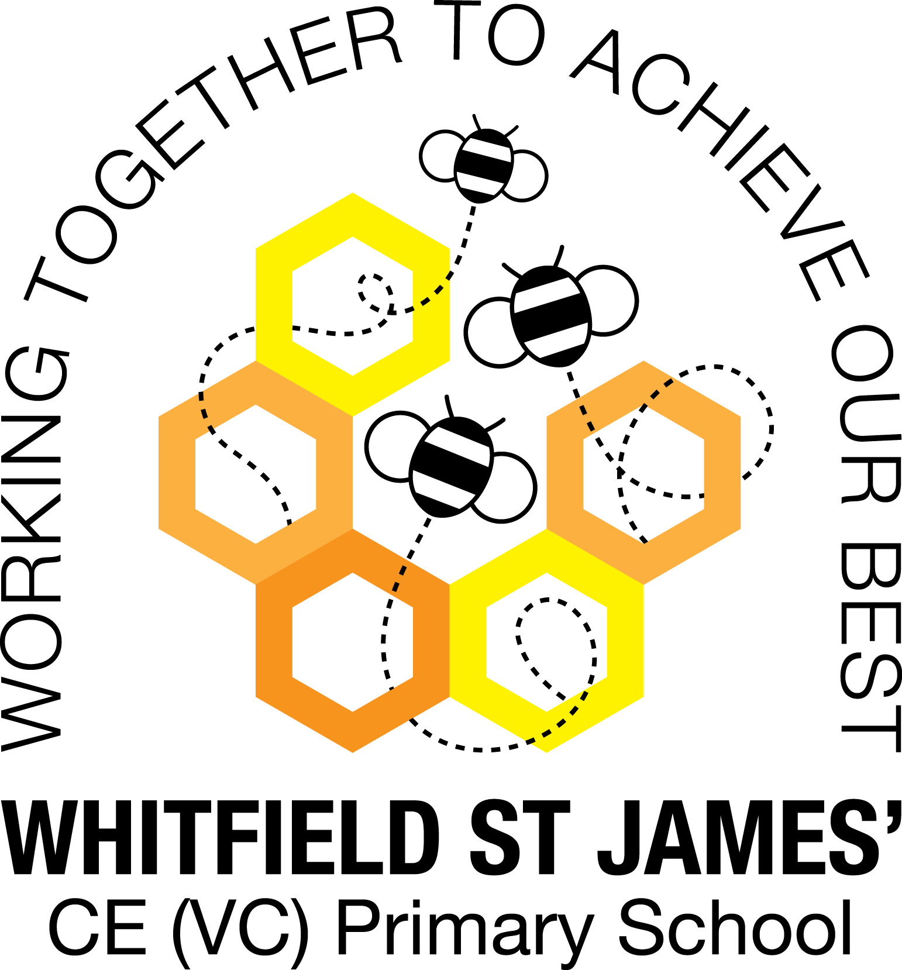

WHITFIELD ST JAMES’ CE (VC) PRIMARY SCHOOL

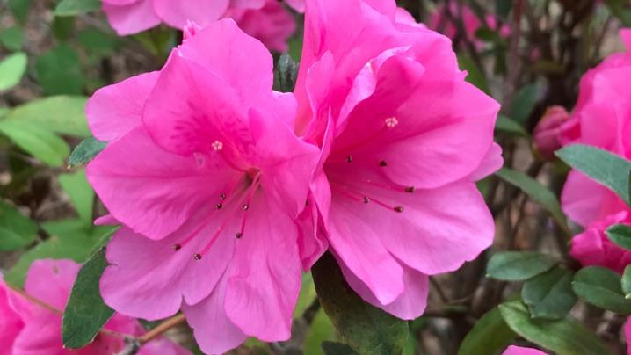

6th June 2022
Dear parents and carers of Azalea’s class,
I hope that you have all had a lovely break. Last term was amazing, it was only a short one but everybody worked extremely hard. We are now entering our final half term in year 5. The year has flown by and now it’s our final opportunity to get “year 6 ready”.
English and maths
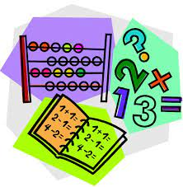
This term our English lessons will be based around our topic ‘Scream Machine”. We are aiming to fit a lot in to our final half term: we will be writing poetry, narratives which will focus on speech and adverts persuading people to come to a theme-park. We will begin our half term by looking at short video clip called “The Shirt Machine” to inspire our writing. We will also continue to develop our knowledge of SPaG (spelling, punctuation and grammar rules). Our SPaG knowledge progressed a lot last half term, it is such an important part of the curriculum which develops the children as writers. Hopefully this continues this next half term. Any quick fire questions at home would be really beneficial such as: word class, punctuation marks (how to use them) and clause types such as subordinate and relative clauses.
In maths, we have been looking at angles and we will continue our work on geometry this term. This will include shape names, position, direction and reflection. We will finish the year off by completing our unit of work on measurement. I have really started to notice a drop in the children’s column method knowledge. I encourage everyone to support their children at home with some simple addition, subtraction and multiplication questions; ensuring they use the formal column method. Thank you for your support.
The children will continue to be encouraged to log on to TT Rockstars to help them learn their times tables or to keep working on their speed of recall of the multiplication facts. I saw an increase of children using TT Rockstars last half term and it makes a great difference, well done everyone who has logged on; thank you for your support at home.
Topic
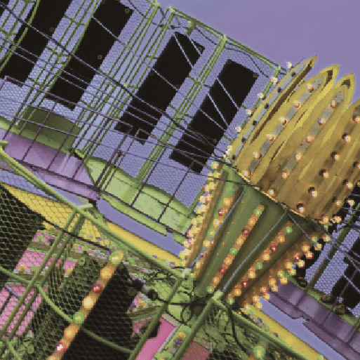
Our new topic is called ‘Scream Machine’. Within this topic we’ll be writing to capture the excitement of riding a roller coaster and investigating the wonders of centripetal force. After carrying out fair tests to investigate the materials used to make roller coasters, we’ll design rides of our own. In our computing work, we’ll upload photographs of rides and examine online theme park maps. Then, we’ll use advanced techniques and commands to search for information on the internet. We’ll design a roller coaster using software such as Scratch and look at online advertising.
Accompanying this newsletter is a knowledge organiser about the topic, which you can read with your child to find out what we are going to be learning about over the course of the half term. Last half term we began our topic by studying the knowledge organiser, this was fantastic to help carry our knowledge forward. Also accompanying the newsletter is a home learning guide, which contains some suggested activities that your child can do at home, as well as recommended reading around this topic. Any work done can be returned to school on the last Monday of term so that we can look at it over the last couple of days of term.
Other subjects
Azaleas will continue to be taught by Mrs Purdy on Wednesday afternoons, which is my afternoon out of class. She will be teaching them RE and German. For PSHE, we will be following Derbyshire’s recommended scheme - PSHE Matters. Throughout the year, we will be looking at friendships, money, relationships, keeping mentally and physically healthy as well as taking responsibility and exploring emotions. This term the children will be taught RSE lessons (relationships and sex education) and further information will be sent out about this very soon. Our RE lessons, we will be following the Derbyshire Agreed Syllabus for RE and also the diocese-recommended scheme ‘Understanding Christianity’. We will also be exploring special days, festivals and significant people during our lessons and daily collective worship in class.
PE
Children should continue to come to school in their PE kit on a Monday and Friday. Please could their kit be in line with our uniform policy, which is a plain white t-shirt or polo shirt, plain black shorts, plain black jogging bottoms and trainers. It may be a good idea for anyone with pierced ears to leave their earrings out on PE days to save them having to take them out, or if your child struggles to remove their earrings, they can tape them over (tape will not be provided by school).
Homework
Homework will be given out on a Friday and will be due in on the following Thursday, when children will bring their homework books in to school for their work to be marked. Children will be provided with maths homework, spelling homework and they will also be expected to read at least five times a week, and for their reading to be recorded in their reading record. I urge the children to continue logging on to TT Rockstars, as I can track their progress online and it is really making a huge difference to them.
Reading
Your child will continue to be provided with a reading book in line with their reading age. In class, children will have access to books off our reading shelves as well as library books (which are brought in to the classroom for children to access) and we will also have our 50 Reads Challenge books in our reading treasure chest. These books are specific to Y5, and the children are encouraged to read as many, ideally all, of the books during their time in Y5. It is essential that those children who are free readers are reading books that are challenging enough for their age, and that they are accessing a wide range of genres and authors, and the 50 Reads Challenge is perfect for this! It is lovely to see how much the children are enjoying reading these books. Thank you for your support in encouraging your child to read!
I hope that you have found this information useful. If you ever need to contact me, please don’t hesitate, you can phone school or can email me directly on azalea@st-james.derbyshire.sch.uk
Thank you for your support.
Best wishes,
Mr Hannan

