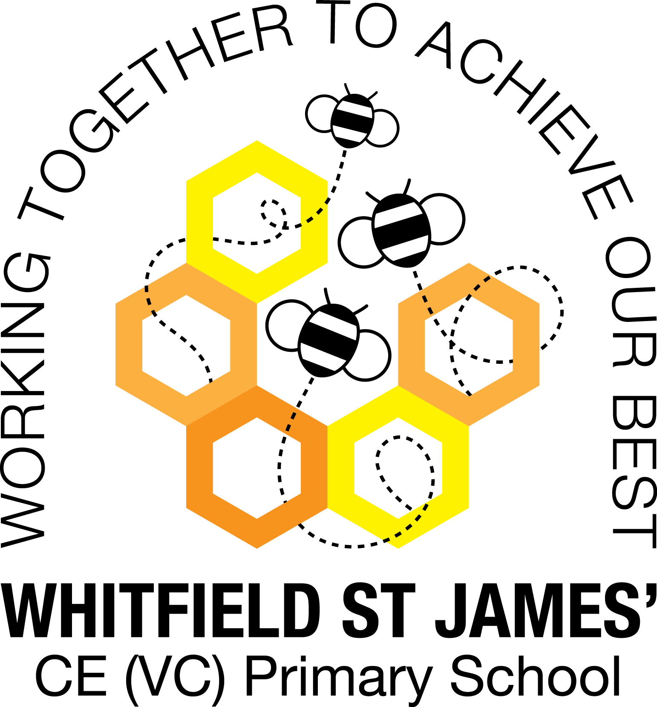

WHITFIELD ST JAMES’ CE (VC) PRIMARY SCHOOL

6th June 2022

Dear parents and carers of Aloe Vera class,

I hope that you have all had a lovely May half term break. I am very much looking forward to the weeks ahead of us, which are set to be very busy. Below is some general information as well as some more class-specific information to prepare you and your children for the final half of the summer term. I apologise if some of this information is repeated.

English and maths
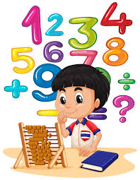
This half term we will start a new guided reading unit on the book The Bear and The Piano, while continuing with handwriting and spelling, punctuation and grammar. In addition to this, we will also have English lessons linked to our new topic, Playlist, where we will be studying literary techniques used in poetry and traditional songs, writing a biography of a famous musician and creating our slogans and posters to advertise a music event, to name but a few.
In Maths, the year 3’s will initially continue their learning about fractions while the year 2’s will complete a unit of work on geometry. Both year groups will then move on to looking at time and then finish with measurements of mass, capacity and temperature. The children will continue to be encouraged to log on to TT Rockstars to help them to learn their times tables or to keep working on their speed of recall of the multiplication facts. We will also continue to dedicate some of our learning time in class to this, as a secure knowledge of the tables helps the children in all areas of maths as they move forward through the school.

Topic
Our new topic is called ‘Playlist’ and it focuses primarily on music and sound. This topic incorporates many subjects such as Art, Music and Science. Accompanying this newsletter you will find a knowledge organiser, which you can read with your child, to find out more about what we are going to be learning. There is also a home learning guide and workbook, which contains some suggested activities that your child can do at home. Any work done can be returned to school on the last Monday of this half term, so that we can look over it together as a class.

Other subjects
Mrs Purdy will continue to teach the class MFL (German) and PE on a Thursday afternoon. In our RE lessons, we will continue to follow the Derbyshire Agreed Syllabus for RE and also the diocese-recommended scheme. For PSHE, we will be following Derbyshire’s recommended scheme ‘PSHE Matters’ as well as continuing to use ‘R Time’ to support our learning. While in Computing we will be using a computer to create music.

PE
As has always been the case, your child will need to come in to school in their PE kit on Tuesday and Thursday each week. Please could their kit be in line with our uniform policy, which is a plain white t-shirt or polo shirt, plain black shorts, plain black jogging bottoms and trainers. It may be a good idea for anyone with pierced ears to leave their earrings out on PE days to save them having to take them out, or if your child struggles to remove their earrings, they can tape them over (tape will not be provided by school).

Home Learning
We will continue with the previous routine the class are used to of setting homework every Friday and collecting it in the following Thursday. Your children will receive one piece of maths and one piece of SPAG related homework per week. This is always linked to the learning done in class. Children are also expected to read at least five times a week at home and for this to be recorded in their reading record. As mentioned previously, please see the home learning guide for ideas on supporting your child’s topic learning at home.

Reading
Your child will continue to be provided with a reading book in line with their reading age. In class, children have access to books off our reading shelves and are able to change their book as soon as they have finished it. Additionally, the class are able to visit the school library and loan a book during their allocated time slot, which is fortnightly on a Wednesday. We also have our 50 Reads Challenge books in our reading treasure chest. These books are specific to Y2/3, and the children are encouraged to read as many, ideally all, of the books during their time in Y2/3. Thank you for your support in encouraging your child to read!

I hope that you have found this information useful. If you ever need to contact me, please don’t hesitate. You can phone school or can email me directly on aloevera@st-james.derbyshire.sch.uk
Thank you for your support.

Best wishes,
Mrs Lockett

