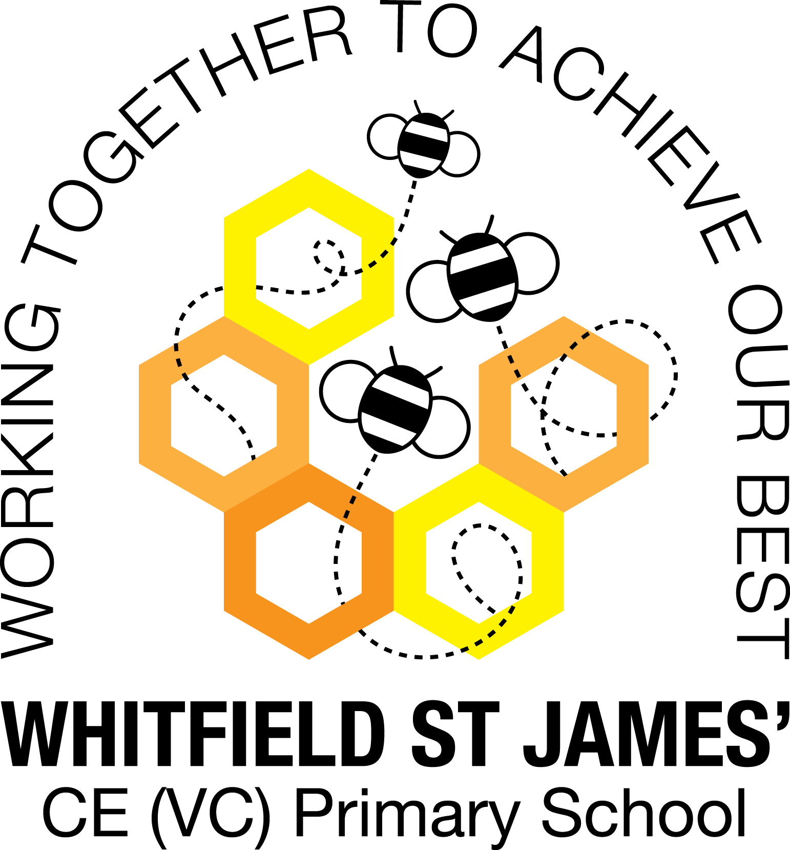.

WHITFIELD ST JAMES’ CE (VC) PRIMARY SCHOOL



Dear Parents and Carers,

**Re: Parent Partnership Newsletter: Summer Term 2 2022**

Welcome back! We hope you’ve all had a well-deserved half term holiday. We hope you had fun celebrating the Queen’s platinum jubilee.

We’ve had a wonderful start to this half term. We had the most spectacular trip to the beach. The children were so well behaved and thoroughly enjoyed themselves- you should be really proud of them. See our snapshot to find out more about what we got up to.

In the Coastline project, your child will use maps to learn about the location of the world’s seas and oceans and keys to learn about map symbols. They will also find out about the directions on a compass. They will learn about the human and physical features of a coastline, including the effects of erosion and how to stay safe when visiting the coast. They will have the opportunity to learn about the work of the RNLI, what happened to the SS Rohilla and about the coastal town of Whitby, including how Captain Cook is linked to the town. They will research the tourism industry and consider what features make a place a successful tourist destination. They will also be comparing the coastline from years ago to now and reflecting on their trip to the beach.

**What to bring in every day:**

* A waterproof coat – everyday, clearly labelled with your child’s name.
* A Book bag.
* Reading book and reading record.
* Please label all clothing as we seem to be losing jumpers and cardigans every day.
* Please don’t bring toys/cuddles in from home.

**Other information**

* Homework books need to come back to school on a Thursday and homework will be sent back on a Friday.
* Reading books need to be in everyday because we read every day and they will have their books changed throughout the week depending on when they finish their book as a reading group.

**Key dates coming up:**

Wednesday 29th June- Sing up day – Non uniform day (Voluntary donation of £1 to support music in school)

Thursday 7th July (in the morning)- KS1 Sports day

Friday 8th July- Transition day

Friday 8th July- Music and BBQ 5pm-7pm (All parents and families are welcome. We will set tables out, have live music, bouncy castle and BBQ)

Friday 22nd July- Finish for the summer

Should you have any questions or concerns please do not hesitate to contact us by email or speak to the class teacher directly. The end of the school day is a good time once all the children have been handed over to their respective adults. Please refrain from posting on social media and contact the class teacher.

Mrs Heys, Mrs Madigan & Miss Sparkes  
[daisy@st-james.derbyshire.sch.uk](mailto:daisy@st-james.derbyshire.sch.uk)