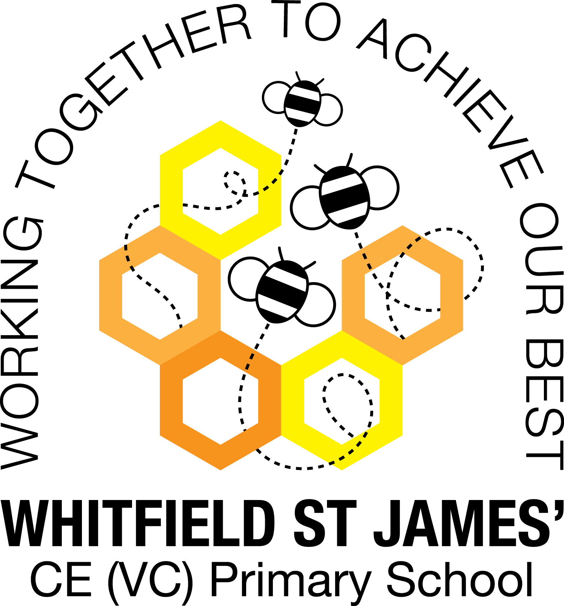

WHITFIELD ST JAMES’ CE (VC) PRIMARY SCHOOL

Year 4 Statutory Multiplication Tables Check

Friday 7th May 2022
Dear parents and carers of year 4 children,
Thank you for your support with all things times tables this year! Special thanks too for encouraging your children to log in and practise their learning on Times Tables Rock Stars.
I am sure you will now know that taking part in the DfE Multiplication Tables Check is mandatory for year 4s in 2022.
You are getting this letter because your child’s school has decided to opt into the TTRS Officially Unofficial Multiplication Tables Check (“OUMTC”), which is a dummy run, taking place in May.
What is involved?
While at school, in a quiet setting, your child will log in to TT Rock Stars and complete two Soundcheck games. Soundcheck replicates the Multiplication Tables Check itself and your child is already familiar with how it works. When your child logs in on the day we do the OUMTC, they will be automatically guided through the simple process of playing two Soundcheck games – one game to warm up and one to really show us what they’re made of. Both games are made up of 25 questions and should be given their best shot.
When?
The OUMTC will be done at some point in the school day between 9th and 27th May. Your child’s teacher will inform the children when it is time to take part.
What do you need to do?
NOTHING – yay!
Pupils will be completing the OUMTC Soundcheck games in school – all you need to do is keep up the encouragement – practise makes perfect. Your child should continue to play in Garage, Studio and Soundcheck – work on those tricky ones!
What next?
The results will help us with our year 4 teaching next year and to provide us with end of year progress information for your child.
Thank you for your support and please do get in touch with your child’s class teacher if you have any further questions.
Thank you for your support.
Kind regards,
Miss Warburton (KS2 Leader) and the Y4 teachers (Mr Ford, Mrs Mackey and Mrs Collins)

