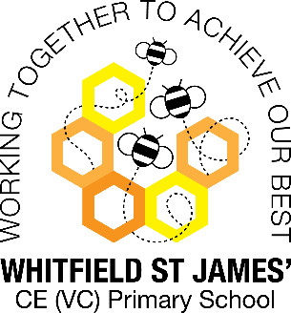
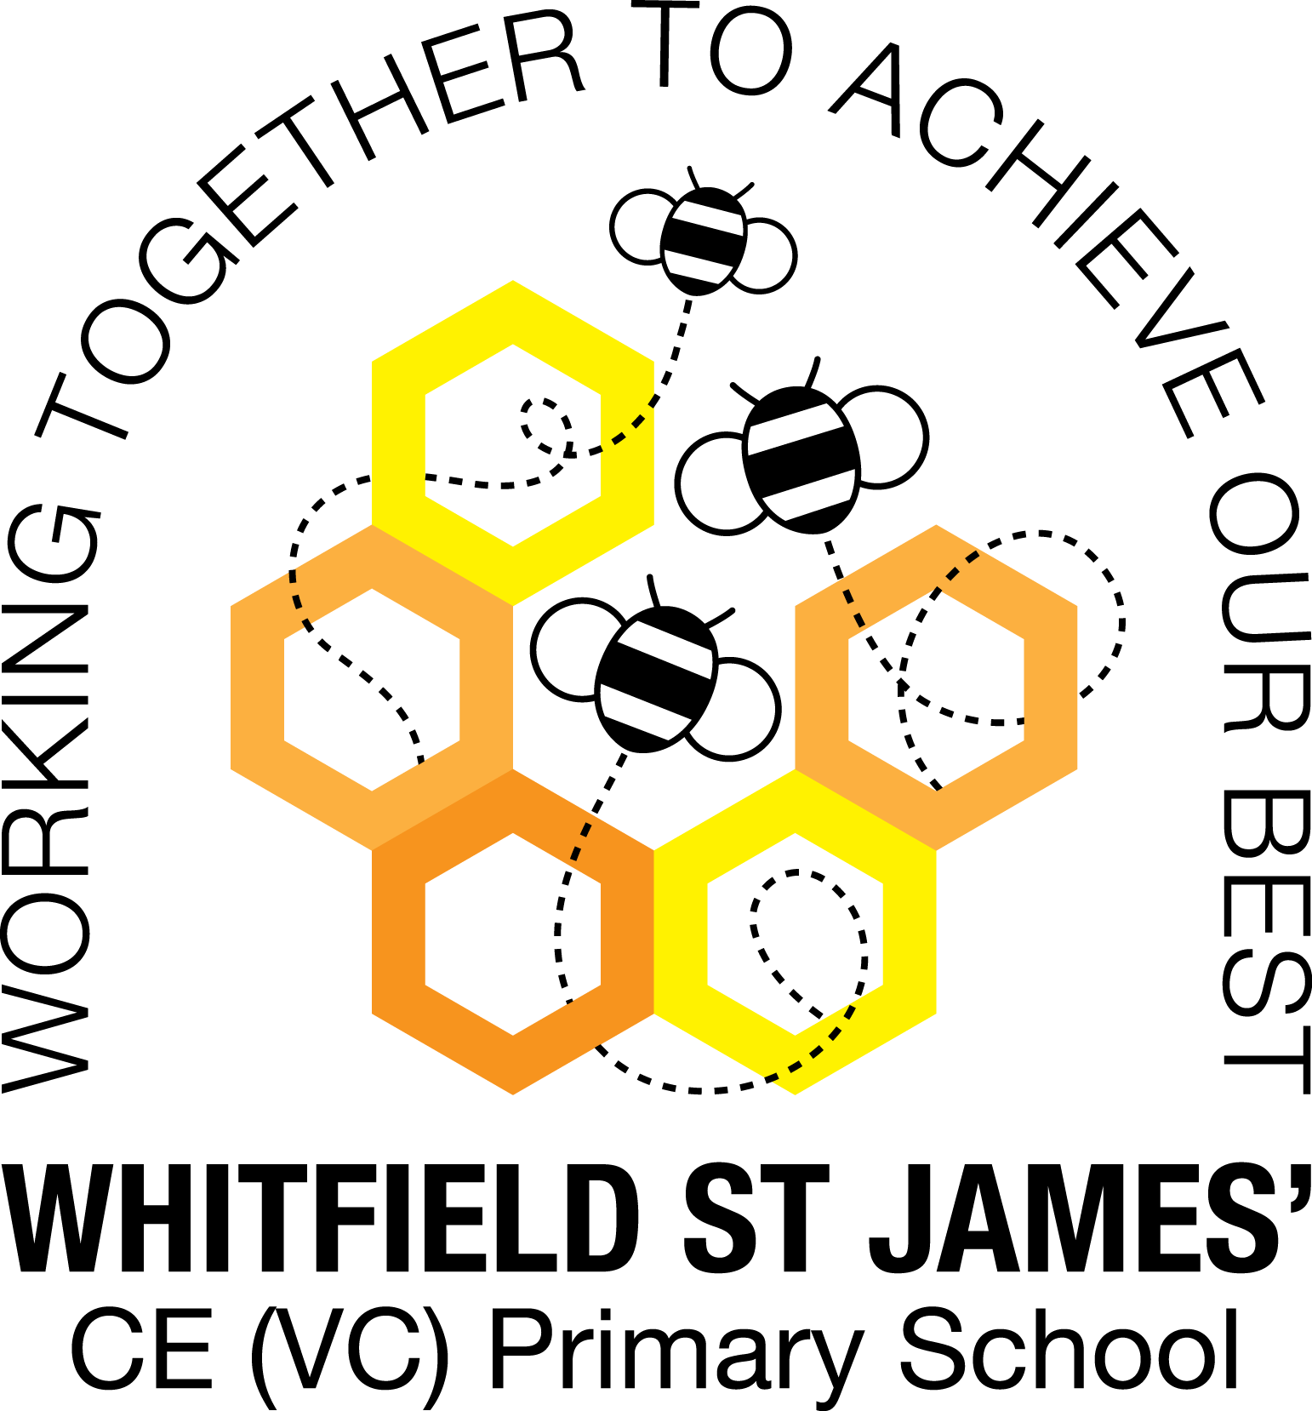Peonies snapshot of the week
Here is a snapshot of some of the activities we have completed in our class this week. This snapshot may not contain all of the lessons and activities the children have been involved in, but will provide you with an idea of what we have done this week in Orchid class!
If you have any questions or need anything, please don’t hesitate to email me on the class email – orchid@st-james.derbyshire.sch.uk
Miss Kuczaj
Topic: Groundbreaking Greeks | Week commencing: 23rd May 2022
Class book: Who Let the Gods Out? By Maz Evans
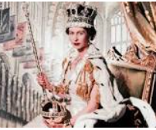
English
This week our English lessons have involved some cross-curricular research in to the Queen’s life and her 70 year reign, to mark our Jubilee Week. After we had done our research, we wrote biographies. The children did a beautiful job of these, taking sure time and care to ensure they were showing off their writing skills.

Other lessons  We have really enjoyed our Jubilee Week! As well as learning all about the Queen, we have learned about the importance of our British Values and what they mean to us. We conducted a science investigation in to which shape of tea bag makes the best cup of tea and we painted portraits of the Queen. We also really enjoyed our street party, despite the disappointing weather!  End of year play & costumes  All children now know which parts they are playing in Pirates of the Curry Bean. Please could you help your child to put together a costume for the play? The script should give you an idea of what they will need to wear, but if you are not sure, please just ask, or look on YouTube for videos of other school who have done this play! If you don’t think you will be able to find a costume for your child, please let us know as soon as possible so that we can find them one in school.  Our dress rehearsals to the rest of the school will be on Friday 15th July and Monday 18th July, so could we please ask that costumes are in school no later than Monday 11th July, in a named bag. We will store them on a clothes rail so that they are safe.  Thank you for your support in helping us put on a fabulous end of year show!  Star of the week: Kate  Value of the week: Lainey | Other information  Y6 Homework  This week, the homework I have set the children is to learn their lines for the end of year play. Those children who chose not to have a part in the play will still need to be familiar with the script as they will need to know when to sing and when to put props and scenery on and off the stage, as this is the job that many of these children will have, so it is just as important that they read and familiarise themselves with the script.  Y5 and 6 Homework:  Children will be tested on the UKS2 100 words list in the first couple of weeks back after the half term break, so it’s a good idea for them to practise any they don’t know. (The spellings are included in this document). I would also like to see children reading at home over half-term – remembering to try to read 5 times a week.  Revision guides  Please could the year 6 revision guides be returned to school (as long as they haven’t been written in) so that we can use them again next year? Many thanks.  Mrs Walker and I wish everybody a lovely half-term – fingers crossed for some nice weather!
