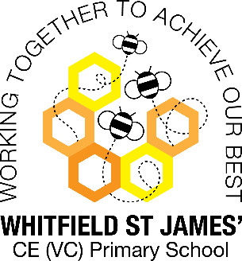Azaleas snapshot of the week

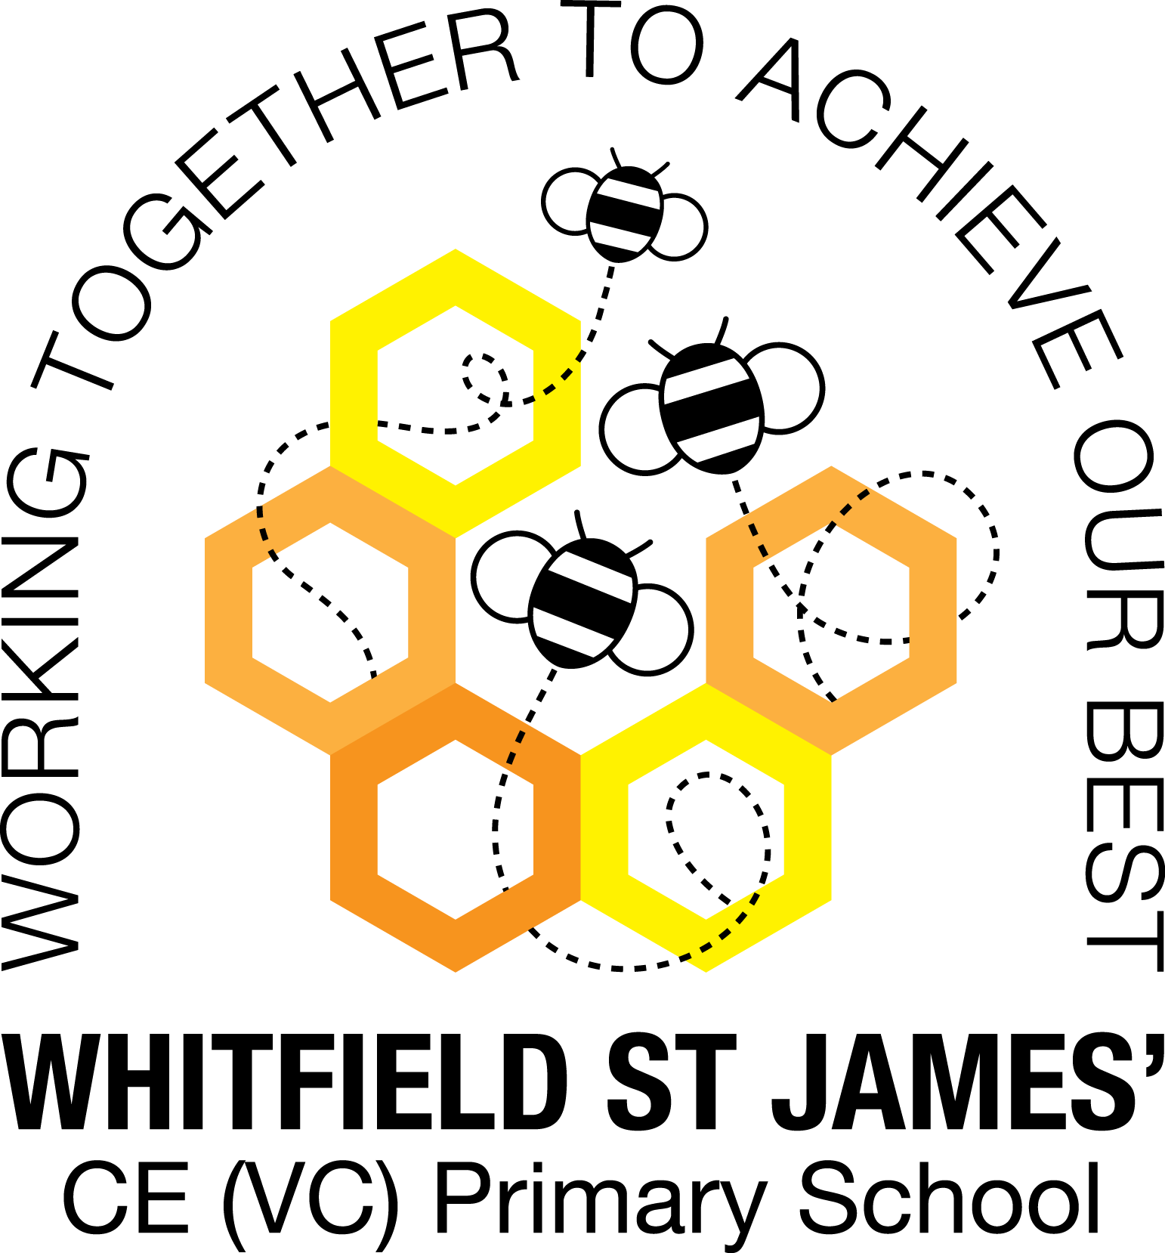

Here is a snapshot of some of the activities we have completed in our class this week. This snapshot may not contain all of the lessons and activities the children have been involved in, but will provide you with an idea of what we have done this week in Azalea class!

If you have any questions or need anything, please don’t hesitate to email me on the class email – [azalea@st-james.derbyshire.sch.uk](mailto:azalea@st-james.derbyshire.sch.uk) Mr Hannan

|  |  |
| --- | --- |
| **Topic**: Time traveller | **Week commencing**: 23rd May 2022 |
| **Class book**: The Boy Who Swam With Piranhas |  |
| **Maths**  Continuing our work on angles. This week we have looked at angles within a straight line and angles around the point. The children understood the importance of 180 and 360 degrees and used this knowledge to tackle some tricky reasoning questions. | **English**  As we have been celebrating The Queen’s platinum jubilee this week, the children have been hard at work. We have been able to research and gather information as well as write a biography about The Queen. |
| **Other lessons**  This week in science we completed some experiments. We investigated which products would be good for cleaning 1p and 2p coins. We were shocked to find that salsa and lemon juice were a great cleaning product due the citric acid.  We also investigated which tea bag shape makes the strongest cup of tea!  We also had our street party, it was a very wet day but we all really enjoyed ourselves. | **Any other information**  A special thank you to Mrs Rimmer and her hard work this year working with the class. We will all miss her and hope she has a fantastic journey across America.  The children **will not** need to dress up for the first day back.  The first Tuesday back (7th June) is bring a plant to school day.  Have a great break! |
| **Star of the week:** Elsie  **Christian Value Award**: Declan (achievement) |