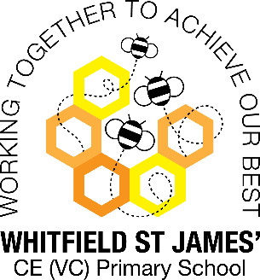Daisy class snapshot of the week

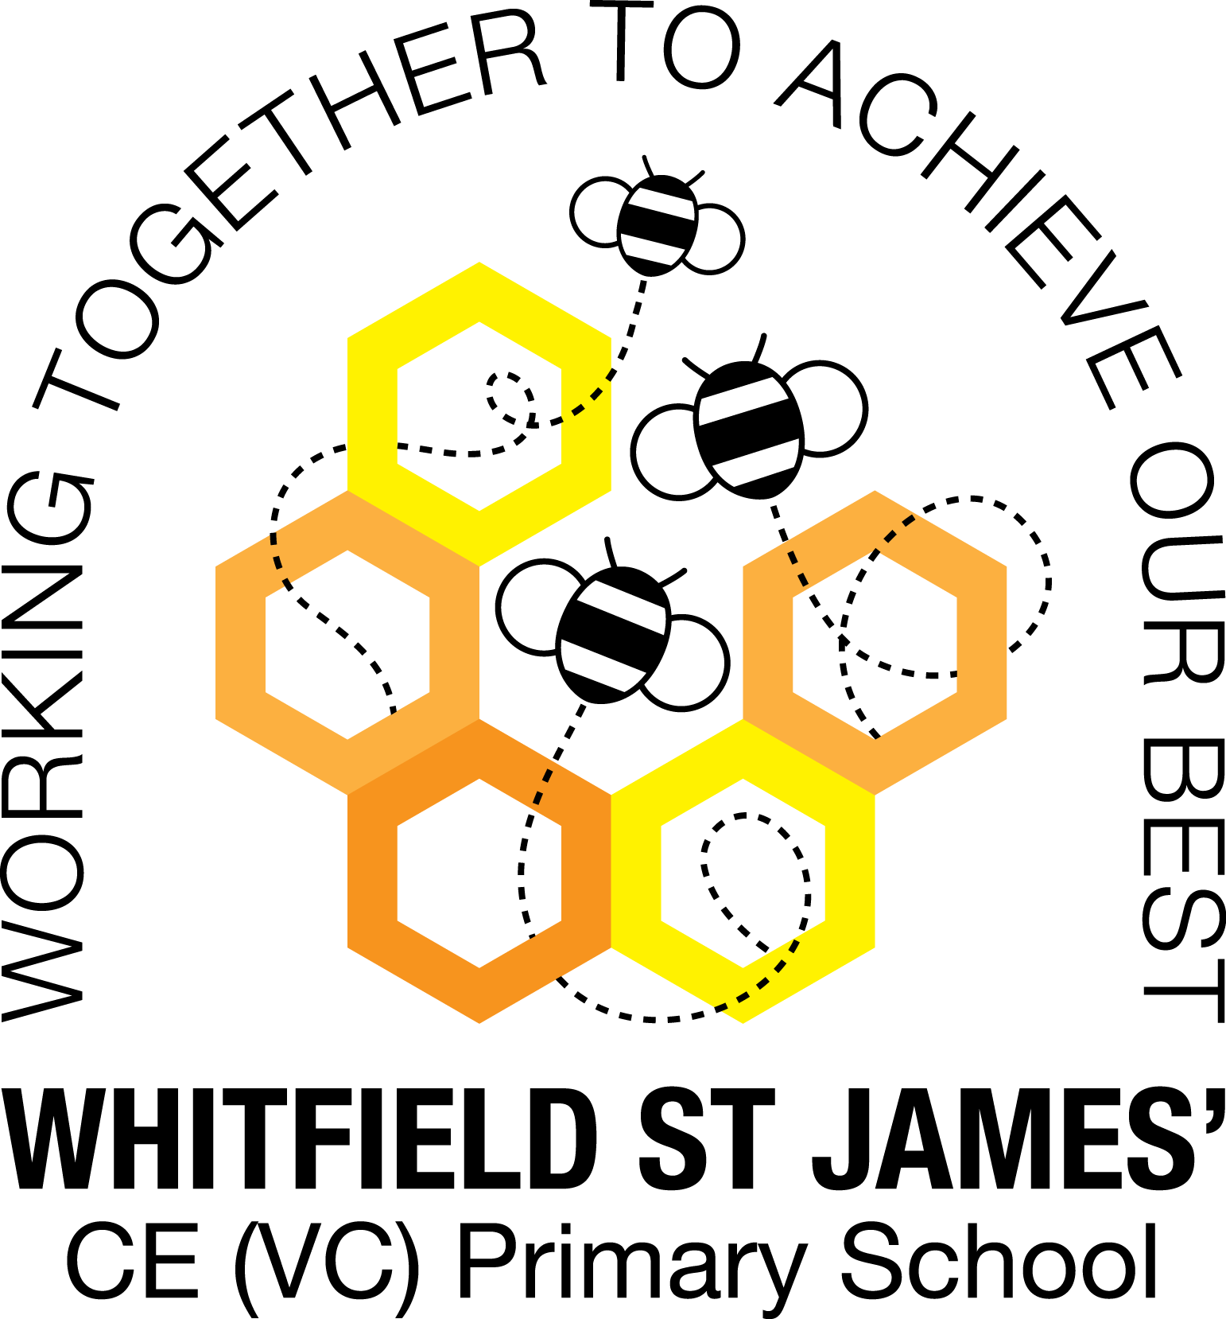

Here is a snapshot of some of the activities we have completed in our class this week. This snapshot may not contain all of the activities the children have been involved in. If you have any questions or need anything, please don’t hesitate to email us on the class email – [daisy@st-james.derbyshire.sch.uk](mailto:daisy@st-james.derbyshire.sch.uk)

|  |  |
| --- | --- |
| Topic: Magnificent Monarchs | Week commencing: 09.03.2022 |
| This week’s class books:  Traditional fairy tales.  The Queens Hat by Steve Antony  Little Elizabeth by Pauline Reeves  Horrible Histories | |
| **English**  This week we have been reading the story ‘The Queen’s hat’ by Steve Antony. The story takes us on a journey through London visiting lots of landmarks to find the Queens hat which flew off in the wind.  The children have thoroughly enjoyed this story so we decided to plan and write our own version of the story, by simply changing the object/thing that the Queen lost. We looked closely at writing interesting and detailed setting descriptions and openers and using exciting language to make our story interesting. We also looked at putting onomatopoeias within our story. The children’s stories have ended up brilliantly. | **Maths**  We have had a very busy week in maths. We have look working through reasoning problems. This is very broad and covers the whole of the maths curriculum. The children have to remember how to tackle many different problems. They have worked extremely hard and done very well.  We finished our maths SATs tests on Friday. Everyone tried their very best and focussed on the questions.  Year 1 have been doubling amounts to 20. You could help them at home by using dried pasta, knives and forks or peas! Help the children to make two equal groups and then count them up to see how much they make. Good luck! |
| **Topic**  This week in topic we have looked at maps of London and different landmarks. The children have really enjoyed learning interesting and historic facts about these Landmarks. They have also been able to locate and place the landmarks on a simple map.  We have also started to sketch a portrait of the Queen and designed some bunting for our Jubilee party.  In Computing we have been learning how to edit a document. The children have been learning about some new functions in a word processing document – bold, italic and underline. They embrace their computing learning and we are very proud of them.  In RE we have been looking at some ways Christians celebrate important festivals. | |
| **Other news:**   * Please make sure you write your child’s name in their jumpers and cardigans to help them to look after their belongings. * Please remember to bring appropriate clothing as the weather is very interchangeable at the moment. * Please do not bring toys into school as we do not want anything to get damaged or broken- we have lots to play with at school. * Please do not bring snack into school. | **Important dates/events coming up:**  Year 2’s will be doing their End of KS1 Assessments (SATS) during this half term. Please don’t worry about them and you do not need to do anything extra- they are all working really hard.  Year 1’s phonics screening check will be week commencing 6th June.  Jubilee tea party during school time- Thursday 26th May.  Bring a plant to school day is on Tuesday 7th June (letter/leaflet to follow) |
| **Star of the week:** **Isaiah**- for diligently approaching his learning in every lesson.  **Christian Value Award (Spr term 2): Joseph-** Joseph is always ready to help his friends and adults in the classroom. |