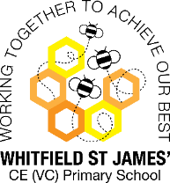Bluebells Snapshot of the Week

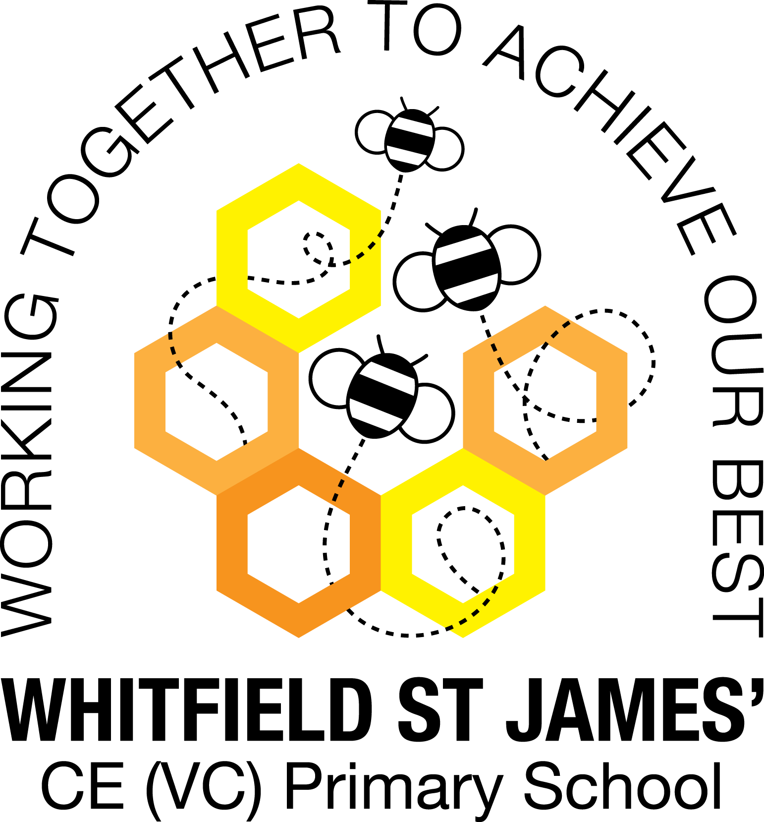

Here is a snapshot of some of the activities we have completed in our class this week. This snapshot may not contain all of the activities the children have been involved in. If you have any questions or need anything, please don’t hesitate to email us on the class email – [bluebell@st-james.derbyshire.sch.uk](mailto:bluebell@st-james.derbyshire.sch.uk)

|  |  |
| --- | --- |
| Topic: The Jubilee | Week commencing: 23.5.2022 |
| Class book: The Queen’s Knickers |

|  |  |
| --- | --- |
| **Phonics and Reading**  **Please continue to read every night and sign and date yellow reading record books. In phonics we have been learning about words ending in ing/ed/est.** | Literacy/Topic  What a great party we all had on Thursday despite the weather the children had a fabulous time. |
| Maths  This week we have been learning about subtraction and learning to solve first, then, now subtraction stories.    We can write this as a number sentence using the subtraction sign – and equals sign =  9 – 3 = 6 | **Other Information**  **Wow Day**  Our "Wow Day" will take place in school on Monday 6th June; we are asking the children to bring their bikes, balance bikes, scooters or trikes to school. Children will need a helmet (named). Please speak to Mrs Allan or Mrs Cox if your child does not have any suitable vehicle and we will arrange for them to borrow one. We will be going on a fantastic journey around the school grounds! Children will need to wear normal school uniform top half but may wear trainers, tracksuit bottoms/leggings (will be easier than skirts & dresses) if you wish.  **Homework for half term!**  During the half term holiday I would really like it if you could buy a postcard following any day trip, short break or holiday you may be lucky enough to go on. This could be a day trip to Buxton park, a day at the seaside or even a walk to manor park as I have seen "Glossop" postcards at the craft shop near M&S. You do not need to physically post these back to school so no need to buy a stamp. Please bring in on our first day back, Monday 6th June. Encourage your child to write it independently. Talk about what sorts of things people write on postcards and why they might send them. On our return to school, we will explore them with the children and look at each side, use them to create a display and look at UK and World maps of where they have come from.  Plea for junk modelling materials – clean yoghurt pots, cardboard boxes, toilet & kitchen roll tubes please. |
| **Star of the week: Enya**  **Christian Value Award**: Elise |