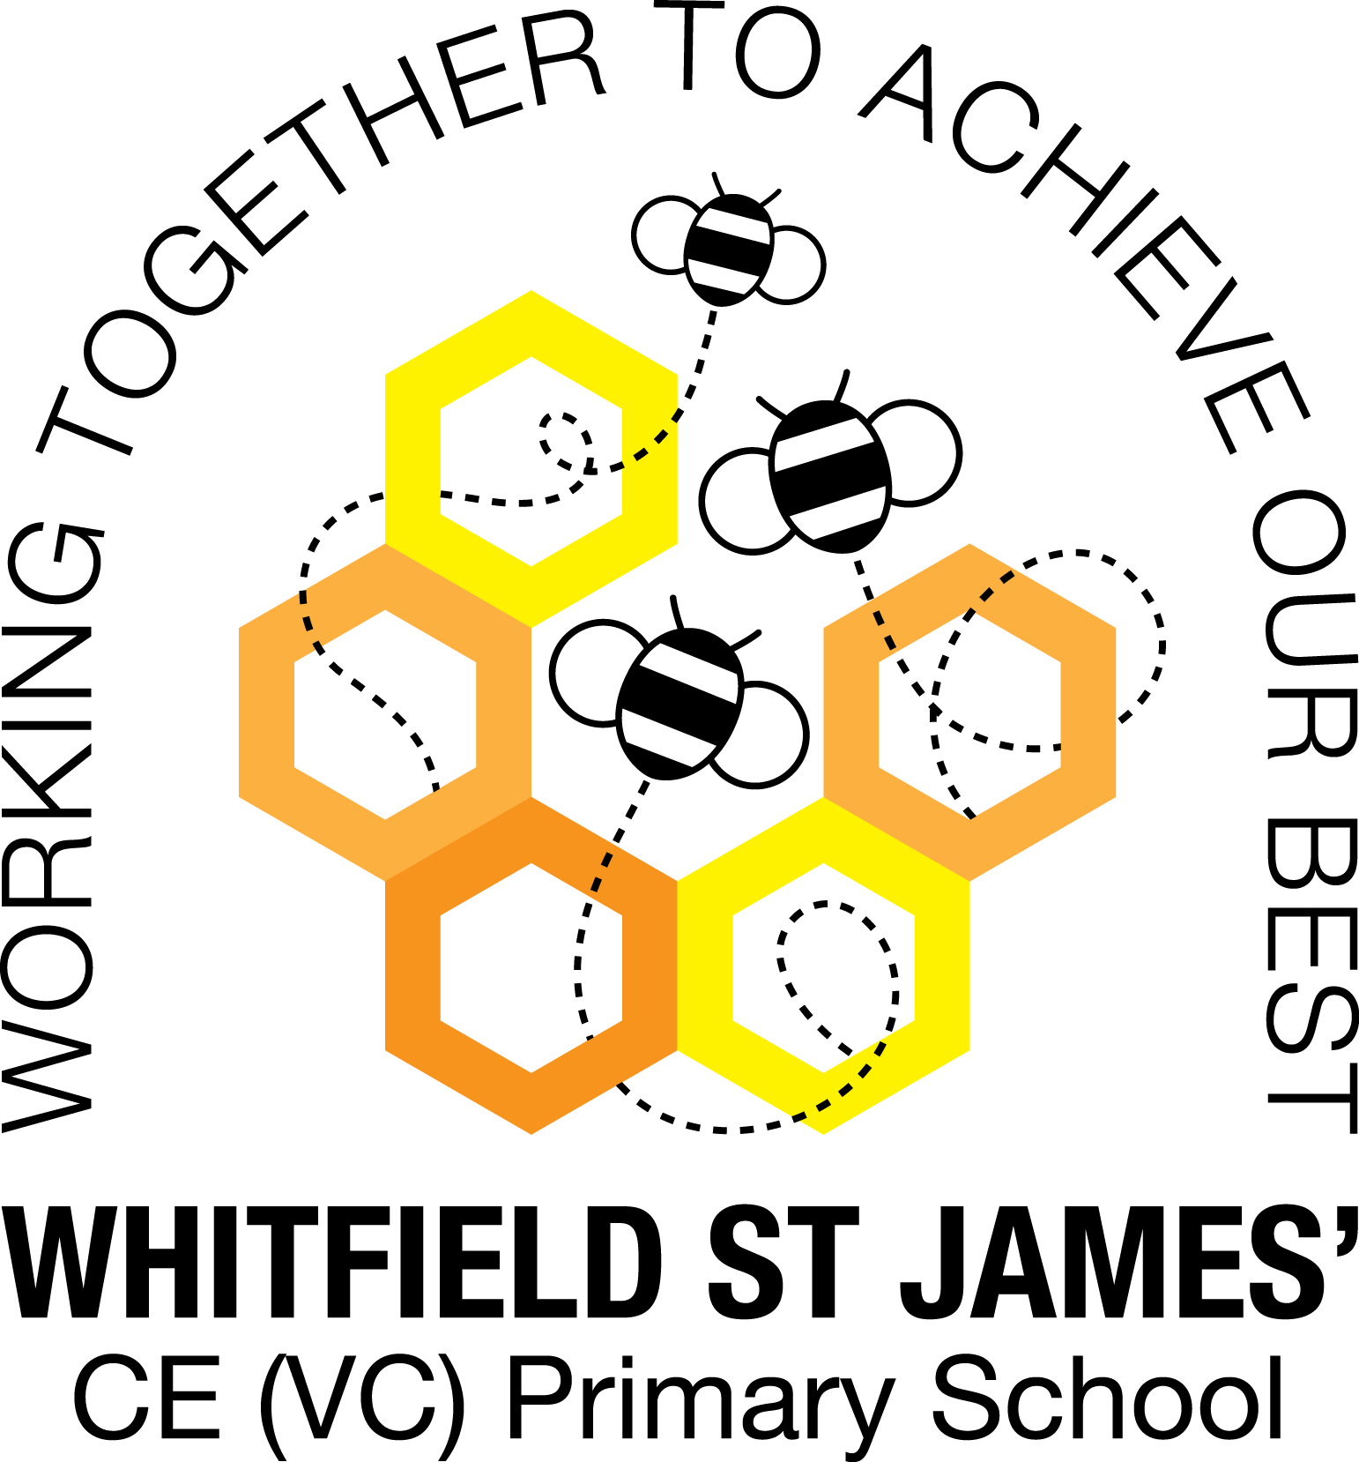

WHITFIELD ST JAMES’ CE (VC) PRIMARY SCHOOL

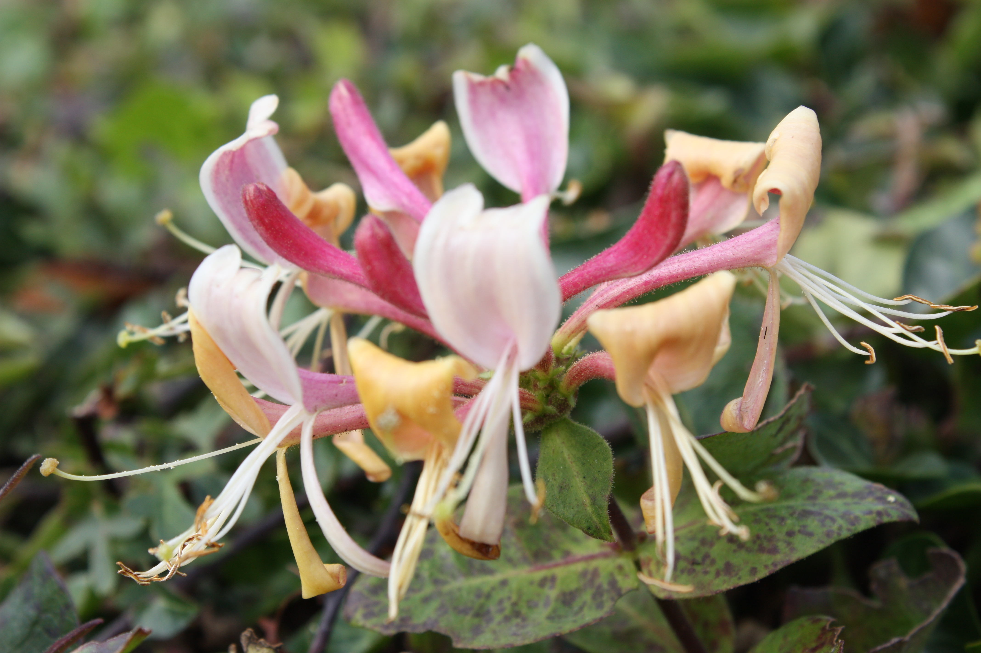

25th April 2022
Dear parents and carers of Honeysuckles class,
I hope that you have all had a lovely Easter Break and the children feel rested and ready to learn!.
English and maths
This term most of our English lessons will be based around our topic ‘Beast Creator’. The children will be learning how to write a fantasy narrative about a mini beast, a non-chronological report and some instructions about how to make a mini beast hotel. The children will also listen, read and create some poetry linked with mini beasts.
The children will also be listening and responding to our class text – ‘Charlotte’s Web’ by E. B White. We will start the term by working on a reading and writing unit based on the book ‘Harry and the Poisonous Centipede’ by Lynn Reid- Smith. The children will explore the text using their viper skills and they will use the text to plan and write their own story about a mini beast.
We will also continue to develop our knowledge of SPAG (spelling, punctuation and grammar rules) and will apply this to our writing.
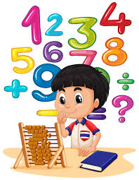
In maths, we will continue to learn about decimal numbers and then will move on to measurement, money and time. The children will continue to be encouraged to log on to TT Rockstars to help them to learn their times tables or to keep working on their speed of recall of the multiplication facts. Please encourage your children to do this, as a secure knowledge of the tables helps the children in all areas of maths. Thank you for your support!
Topic
Our new topic is called Beast Creator. The children will be learning all about categorising mini beast invertebrates and investigating their habitats. They will learn about food chains and different life-cycles, comparing the life-cycles of vertebrates and invertebrates. Here is some more information about our topic:
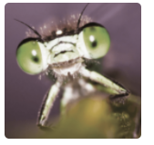
A bug, a creepy-crawly, a beast. He’ll tickle your skin then go in for the sting. Arachnids, insects, molluscs and myriapods, hiding in nooks and beneath darkened rocks. Come search for these minibeasts, and let’s sort them out.
How many legs? How many wings? Who does it eat and who eats it? Can you classify it? Can you draw it or make it? Build a bug hotel or a wonderful wormery, then watch them wriggle and burrow, mixing earth as they go. Discover where in the world you’ll find the deadliest beasts.
Perhaps the Vespa mandarinia japonica is the one that you fear? Why not become a beast creator? Selectively breed a killer predator that saves the world from the super strong aphid. You’ll be a hero. ‘There was an old lady who swallowed a fly. I don’t know why she swallowed a fly. Perhaps she’ll die?’
Accompanying this newsletter is a home learning guide, which contains some suggested activities that your child can do at home. Any work done can be returned to school on the last Monday of term, so that we can look at it over the last few days of term.
Other subjects

Honeysuckles will continue to be taught by Mrs Purdy on Tuesday afternoons, which is my afternoon out of class. She will be teaching them Indoor PE, German and some PSHE.

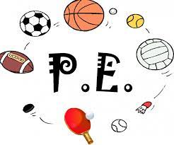
PE

Your child will need to come in to school in their PE kit on Mondays and Tuesdays each week. Please could their kit be in line with our uniform policy, which is a plain white t-shirt or polo shirt, plain black shorts, plain black jogging bottoms and trainers. It may be a good idea for anyone with pierced ears to leave their earrings out on PE days to save them having to take them out or if your child struggles to remove their earrings, they can tape them over (tape will not be provided by school).

WOPPS (wider opportunities whole class music instrument lessons)
The children will continue to have a music lesson on Thursday afternoons. Please remember to look after the instrument at home and bring it in to school every Thursday.
Homework
We will continue with our homework routine – which is working well. Remember homework will be given out on a Friday and will be due in on the following Thursday when children will bring their homework books in to school for their work to be marked. Children will be provided with maths homework, spelling homework and they will also be expected to read at least five times a week, and for their reading to be recorded in their reading record. Many thanks with your support with this.
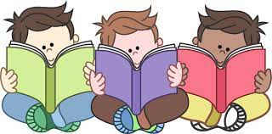
Reading
Your child will continue to be provided with a reading book in line with their reading age. In class, children will have access to books off our reading shelves as well as library books (which are brought in to the classroom for children to access) and we will also have our 50 Reads Challenge books in our reading treasure chest. These books are specific to Y4/5, and the children are encouraged to read as many, ideally all, of the books during their time in Y4/5. Thank you for your support in encouraging your child to read! Please encourage your child to tick off the treasure chest books they have read on the list in their homework book.
I hope that you have found this information useful. I am sorry that some of it is repeated. If you ever need to contact me, please don’t hesitate, you can phone school or can email me directly on honeysuckle@st-james.derbyshire.sch.uk
Thank you for your support.
Best wishes,
Mrs Collins

