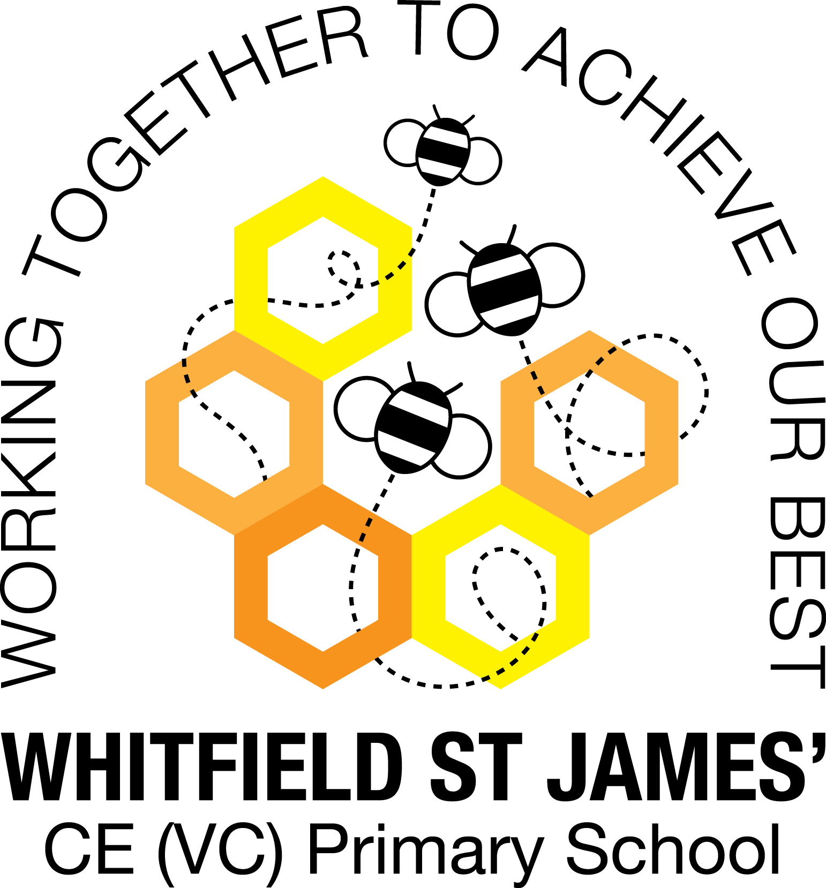

WHITFIELD ST JAMES’ CE (VC) PRIMARY SCHOOL

Year 4 Statutory Multiplication Tables Check

28th February 2022
Dear parents and carers of year 4 children,

This year, in June, your child will be participating in a statutory multiplication tables check. It is an on-screen check consisting of 25 times table questions. Your child will be able to answer 3 practice questions before taking the actual check, and they will then have 6 seconds to answer each question. On average, the check should take no longer than 5 minutes to complete. All year 4 children are required to participate in the check, and the purpose of it is to determine whether your child can fluently recall their times tables up to 12, which is essential for future success in mathematics, and also a National Curriculum requirement.
As you will see on the attached information leaflet from the Standards and Testing Agency, there is no pass mark for the check, but scores will be used for your child’s class teacher to identify next steps and any support needed, where necessary.
Through their daily maths lessons this year (and in previous school years), children have been working hard to prepare for the multiplication check, and will continue to do so. It would be useful if you could help your child to learn/practise their times tables up to 12 x 12, so that they feel confident and well-prepared for the check. TT Rock Stars is an excellent way of doing this, particularly the ‘Sound Check’ game, which is very closely matched to the check. TT Rock Stars log in details are in children’s homework books, but please contact your child’s class teacher if you can’t find them! Please also refer to the WSJ Parents’ Guide to Times Tables leaflet, which accompanies this letter, for ideas for helping to support your child at home with their times tables, including useful games and websites.
If you have any further questions, please don’t hesitate to contact myself, or your child’s class teacher.

Thank you for your support.

Kind regards,
Miss Warburton (KS2 Leader) and the Y4 teachers (Mr Ford, Mrs Mackey and Mrs Collins)

