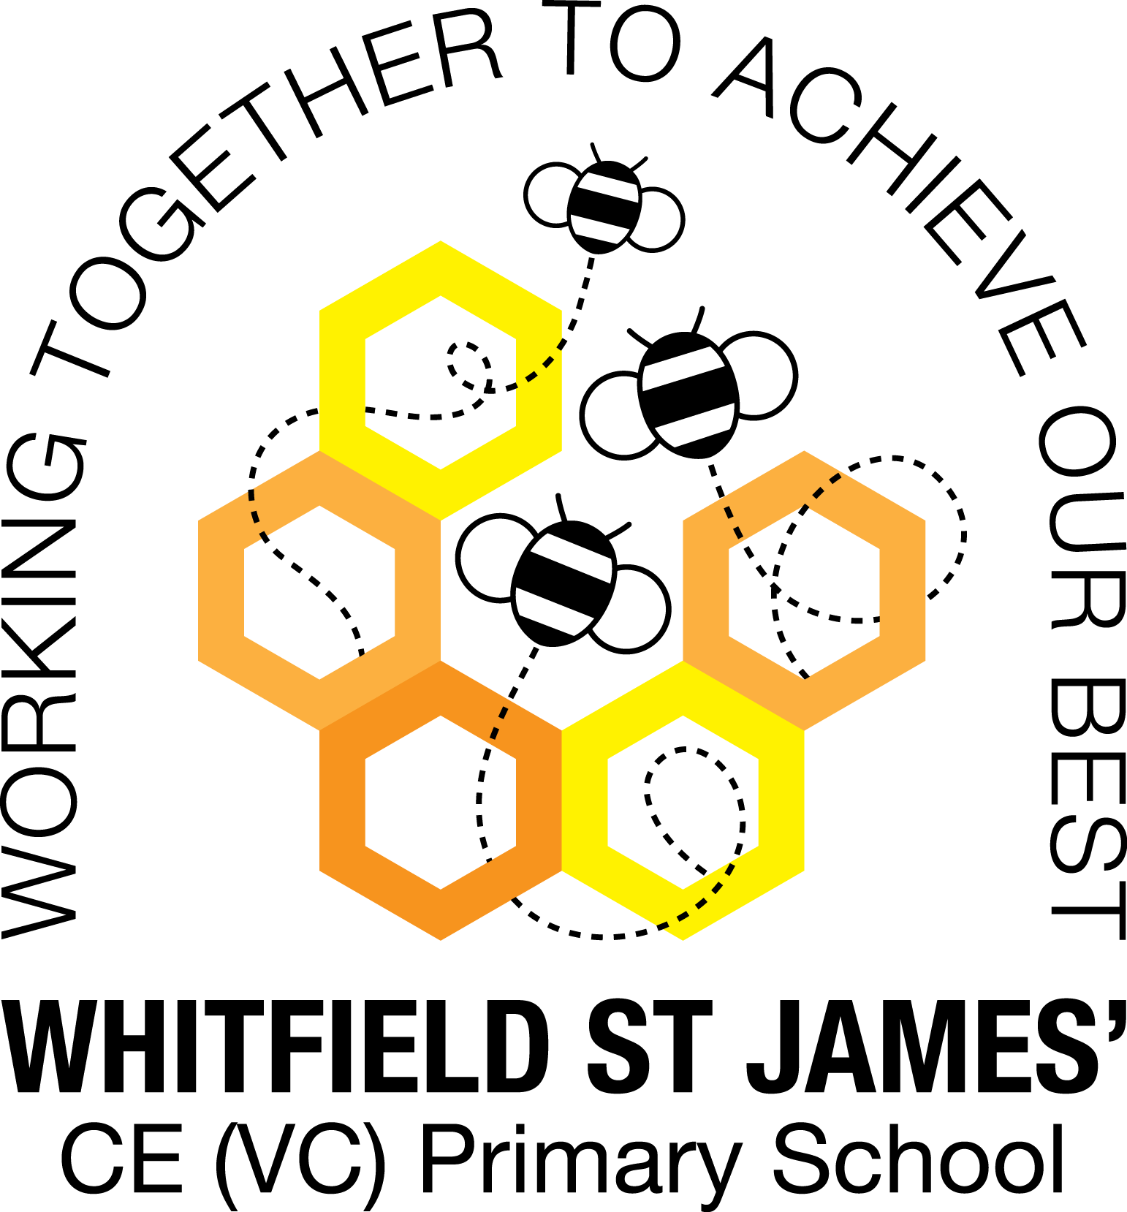

WHITFIELD ST JAMES’ CE (VC) PRIMARY SCHOOL

8th April 2022
Dear parents and carers of Tulip class,
We hope you had a great Easter break. We have got lots of exciting things planned for this half term!
English and maths
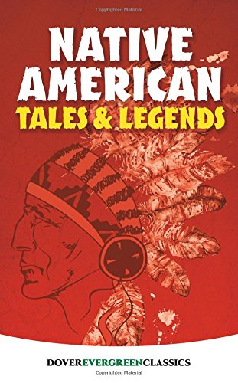
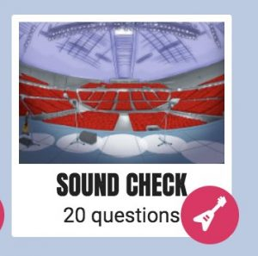
This term our English lessons will be based around our new topic ‘Road Trip USA’. We will be learning to write: myths and legends, emails, diaries and poetry. In maths, we will continue to use White Rose to structure our lessons and we will be focusing on decimals, measure and money. Thank you for continuing to encourage your children to log on to TT Rockstars, this will help them to learn their times tables and work on their speed of recall of the multiplication facts. Please can all children (especially Year 4 children), practise using the ‘Sound Check’ game on TT Rockstars weekly. Additionally, in class, the children complete times tables booklets. These include pages of division facts to give the children opportunities to apply their times tables knowledge in a more challenging format.

Topic

Buckle up and put your sunglasses on, as this half term we’re going on a road trip across the USA! We’ll start by ‘visiting’ the states where Native American tribes settled. We’ll use travel brochures and the internet to research New York and write postcards to family members. Using maps, we’ll locate the USA and find the names of the states. We’ll look at the amazing lights of Times Square, make circuits and create a program for a tourist trip around New York. We'll write diaries and explore Native American myths. After learning about their cultural significance, we’ll weave beautiful dreamcatchers. Looking at aerial views of natural landmarks, we’ll think about how they might have been formed. We’ll create travel brochures and make illuminated models of different landmarks. Then we’ll cook delicious dishes - would anyone like a corn dog?

Help your child prepare for their project
The USA is an incredible place, with a varied landscape and culture. Why not choose a state to research together and create a scrapbook of exciting locations? You could also make a playlist of American songs from different genres that you could listen to on your road trip. Alternatively, visit the supermarket together to see if you can identify any foods associated with the USA. You might even try some of them!

Other lessons
Our PE days continue to be on Thursdays and Fridays. Could you please ensure your child comes into school in their PE kit on these days. Please could their kit be in line with our uniform policy, which is a plain blue jumper or school jumper, a white t-shirt or polo shirt, plain black shorts or plain black jogging bottoms and trainers. It may be a good idea for anyone with pierced ears to leave their earrings out on PE days to save them having to take them out, or if your child struggles to remove their earrings, they can tape them over (tape will not be provided by school). It would also be good if children with long hair could have it tied up on all days (but especially PE days) to prevent it getting caught. We will also continue to learn German and children will continue to be taught RE weekly. This term we will be learning about the festival of Pentecost. Thank you to the parents who have given permission for their children to be in anonymous photos and videos to use in our correspondence to our twin schools in Africa. We will be writing to them soon via email.

Homework
Homework will be given out on a Friday and will be due in on the following Thursday, although the book can be brought in before and placed in the homework box in the classroom. Children will be provided with maths and spelling homework and they will also be expected to read at least five times a week, and for their reading to be recorded in their reading record. The homework sent home is a piece of work your child should be able to complete independently as it is based on spelling patterns or maths that has been taught during the week.
Reading
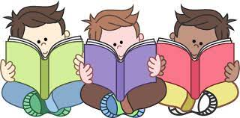
Your child will continue to be provided with a reading book in line with their recently assessed reading age. In class, children will have access to books off our classroom reading shelves, library books and also our 50 Reads Challenge books. The children are encouraged to read as many, ideally all, of these books during their time in Y3 or Y4. It is essential that those children who are free readers are reading books that are challenging enough for their age, and that they are accessing a wide range of genres and authors, and the 50 Reads Challenge is perfect for this! Thank you for your support in encouraging your child to read!
If you ever need to contact us, please don’t hesitate, you can phone school or can email us directly on tulip@st-james.derbyshire.sch.uk
We are also lucky enough to have Miss McGreary joining us until June! She will be supporting the teaching and learning in our class.
Thank you for your support.
Best wishes,
Mr Ford and Mrs Mackey.

