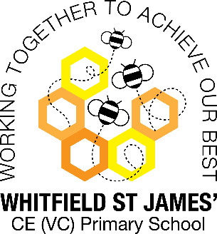Snapdragon snapshot of the week

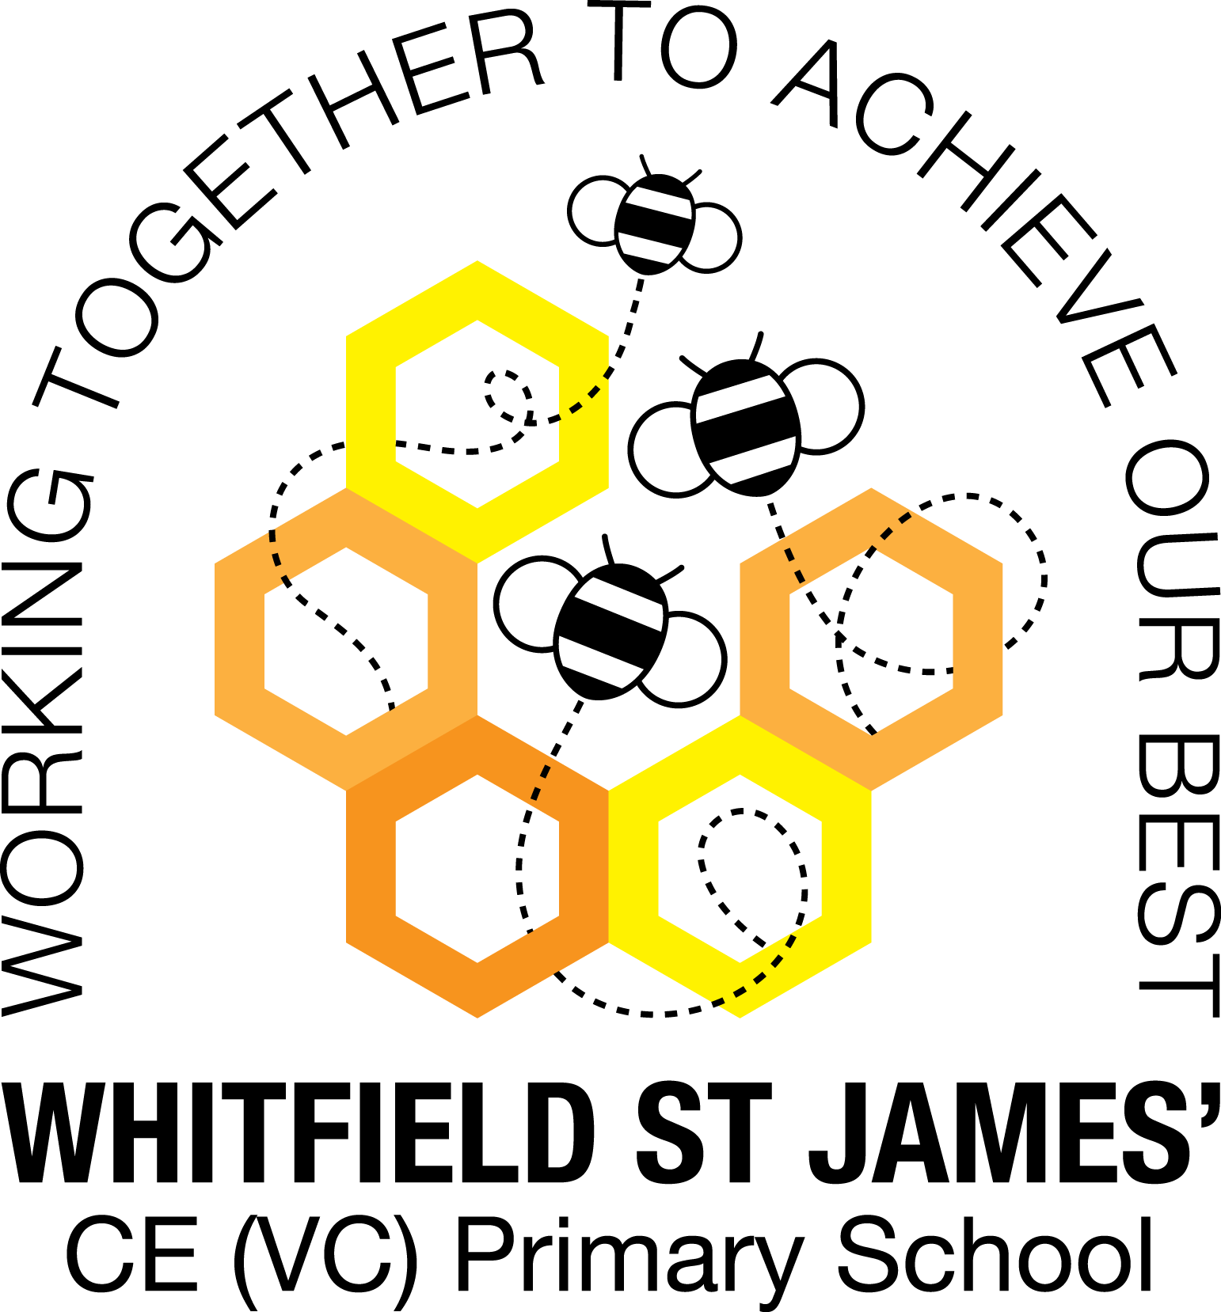

Here is a snapshot of some of the activities we have completed in our class this week. This snapshot may not contain all of the activities the children have been involved in. If you have any questions or need anything, please don’t hesitate to email us on the class email –

|  |  |
| --- | --- |
| Topic: Easter | Week commencing: 4th April 2022 |

|  |
| --- |
| **This week:**  In maths this week we have been continuing our work of measurement using cubes to measure and compare the mass of different objects in the classroom. In English we have been writing Easter cards and practicing writing using our phonics. |
| **Any other information:**  We have had a lot of fun this week learning Easter songs, joining in with the Easter parade, and doing some Easter activities.  The first day back after term (25th April) will be our WOW afternoon. Our next topic will be Magnificent Monarchs and we will be learning about six British Monarchs throughout history. The first afternoon back we will be having a royal party. Children can dress as a Prince, Knight, Princess or anything else royal. Please do not worry if children do not have a costume as we can make crowns in class.  Have a lovely Easter,  Miss Fortune |