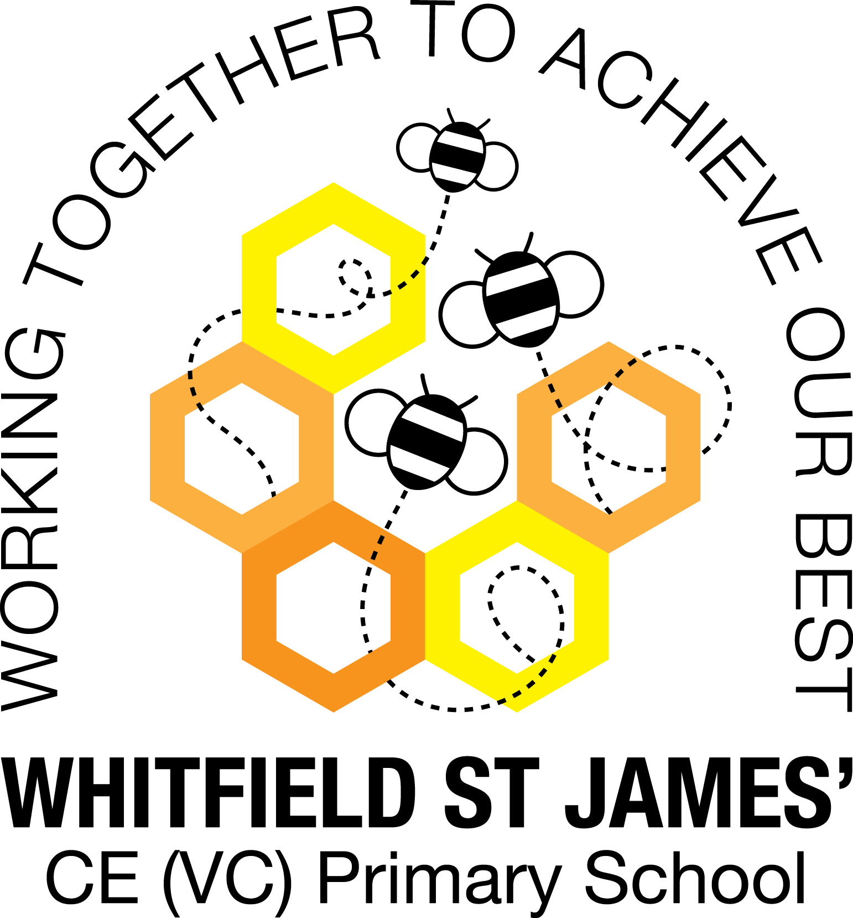

WHITFIELD ST JAMES’ CE (VC) PRIMARY SCHOOL

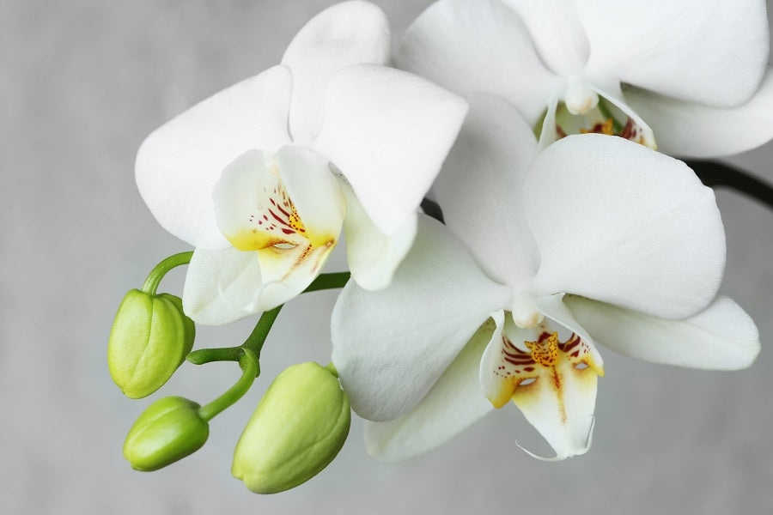

25th April 2022
Dear parents and carers of Orchid class,
I hope that you have all had a wonderful Easter break. We have a very busy term ahead with lots of exciting things for the children to look forward to!
SATs – w.b. 9th May
As you know, the Y6 children will be doing their end of KS2 assessments (SATs) during w.b. 9th May. During this week, the children will sit assessments in maths, reading and SPAG (spelling, punctuation and grammar). Over the next couple of weeks, we will prepare for these through our daily maths and English lessons. The children also have their revision guides which were sent home at the beginning of the Spring term to help to prepare them. ‘SATs Companion’ is also a fantastic tool for revision where the children can use the practise section to revise – all children were asked to stick their login into their homework books earlier on in the year. Children will continue to have weekly spelling rules to practise, and reading five times a week is as important as ever. Thank you for all of your support.
Homework will continue to be set each week after SATs, but we will collect in any empty study guides after the assessments are completed if the children have used the exercise book to write down answers. Although we are working hard preparing for the assessments, we want the children to be as relaxed as possible and not to worry about them. We have reassured them that there will be nothing in the assessment papers that we haven’t covered in class and that the most important thing of all is that the children try their hardest. We are SO proud of them all for the excellent progress they have made this year.
During the Monday – Thursday of SATs week (there is no assessment on the Friday), children are welcome to come in to school at 8:30am for toast and a chat in the classroom. This is to relax them in to the day and to allow them time to settle before we start our assessments. There will be plenty of ‘outside time’ during this week, when the children can have free time in the fresh air to relax and switch off for a while after their tests. If they wish to join us at the usual registration time that is fine too, but they are more than welcome to join us from 8:30!
English and maths
This term we will begin our English lessons by revising our SPAG knowledge and doing lots of short burst writing, using thesauruses to improve our vocabulary. The rest of our English lessons will be based around our topic ‘Ground-breaking Greeks’ and we will be studying myths and a variety of non-fiction texts. We will also continue to develop our knowledge of SPAG (spelling, punctuation and grammar rules) and will apply this to our writing. In maths, we will be learning about angles rules and shape, coordinates, translation and applying our knowledge to reasoning questions. We shall continue with our weekly arithmetic practise. Children will continue to be encouraged to log on to TT Rockstars to help them to learn their times tables or to keep working on their speed of recall of the multiplication facts. Please encourage your children to do this, as a secure knowledge of the tables helps the children in all areas of maths. Thank you for your support!
Topic
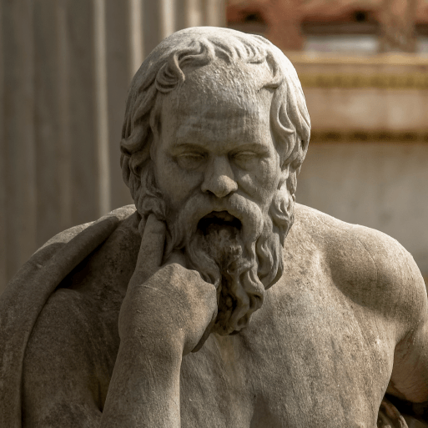
Our new topic is called ‘Ground-breaking Greeks’ and we will have our WOW day for this topic on Monday 16th May, after Y6 have completed their assessment week. ‘Ground-breaking Greeks’ teaches children about developments and changes over six periods of ancient Greek history, focusing on the city state of Athens in the Classical age, and exploring the lasting legacy of ancient Greece. Accompanying this newsletter is a knowledge organiser about the topic, which you can read with your child, to find out what we are going to be learning about over the course of the term. Also accompanying the newsletter is a home learning guide, which contains some suggested activities that your child can do at home, as well as recommended reading around this topic. Any work done can be returned to school on the last Monday of term, so that we can look at it over the last couple of days of term.
Other subjects
Orchids will continue to be taught by Mr Doyle on Friday afternoons. He will be teaching them PE and RE. In our RE lessons, we will continue to follow the Derbyshire Agreed Syllabus for RE and also the diocese-recommended scheme ‘Understanding Christianity’ and this term we are looking at the key question ‘How can following God bring freedom and justice?’ We will also be exploring special days, festivals and significant people during our lessons and daily collective worship in class. In computing we will be learning how to make variables in games. For PSHE, we will be following Derbyshire’s recommended scheme ‘PSHE Matters’ and our focus this term is on Zones of Regulation. We shall also continue to learn enjoy music and German lessons.
PE
For the rest of the school year, your child will need to come in to school in their PE kit on Friday and on Thursday they will need to bring in their swimming kit, but be dressed in their school uniform. Please could their PE kit be in line with our uniform policy, which is a plain white t-shirt or polo shirt, plain black shorts, plain black jogging bottoms and trainers. It may be a good idea for anyone with pierced ears to leave their earrings out on PE days to save them having to take them out, or if your child struggles to remove their earrings, they can tape them over (tape will not be provided by school).
Reading
Your child will continue to be provided with a reading book in line with their reading age. In class, children will have access to books off our reading shelves as well as library books (which are brought in to the classroom for children to access) and we will also have our 50 Reads Challenge books in our reading treasure chest. These books are specific to Y6, and the children are encouraged to read as many, ideally all, of the books during their time in Y6. It is essential that those children who are free readers are reading books that are challenging enough for their age, and that they are accessing a wide range of genres and authors, and the 50 Reads Challenge is perfect for this! It is lovely to see how much the children are enjoying reading these books. Thank you for your support in encouraging your child to read!
Transition to Y7
Over the summer term, secondary schools will be contacting us regarding transition activities to prepare the children for their move to year 7. We will keep you informed of any arrangements as soon as we find out about them.
So far, we have the following dates from Glossopdale School:
Tuesday 17th May 2:00-3:30pm: Assembly (for the children, not parents) with Mrs Gilbert from Glossopdale School.

After school on Tuesday 3rd & Wednesday 4th May: Staff from Glossopdale will be at our school gates to chat to parents and children and to answer any questions you may have regarding transition. Please come and say hello to them!
Residential
The residential trip to the White Hall Centre will soon be upon us! As you know, the trip is on Wednesday 29th June – Friday 1st July. Over the coming weeks we will receive information from White Hall including our programme of events, and we will keep you informed as and when we receive information. Included with our programme of events will be a kit list so that children know what to take with them. In the meantime, White Hall have sent us a general kit list so that you can start to think about what you may need to get together for your child. As the children will be getting dirty during their activities, it is recommended that they take old clothes where possible, rather than new ones that could spoil! The general kit list is available on the school website.
End of year 6 events
At the end of the school year, years 5 and 6 will be taking part in a production, in which there will be acting and singing parts. We are currently choosing a play and will give you more information, including a date when you can come and watch it, in due course.
There will also be a leavers’ party at the end of the school year. Again, we will be in touch very soon with a date for this.
Leavers’ hoodies are on order and further information about these will follow.

I hope that you have found this information useful. If you ever need to contact me, please don’t hesitate, you can phone school or can email me directly on orchid@st-james.derbyshire.sch.uk
Thank you for your support.
Best wishes,
Miss Kuczaj

