WHITFIELD ST JAMES’ CE (VC) PRIMARY SCHOOL

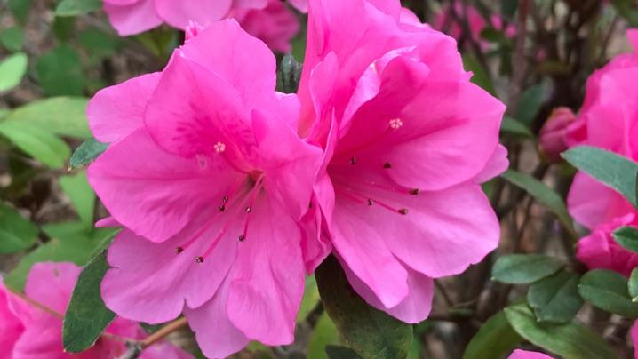

25th April 2022
Dear parents and carers of Azaleas class,
I hope that you have all had a lovely Easter. Last term was fantastic, everybody worked extremely hard and showed great maturity with assessment week. It was so nice to see their hard work paying off and they’re all definitely getting year 6 ready! I hope this term will be just as enjoyable!
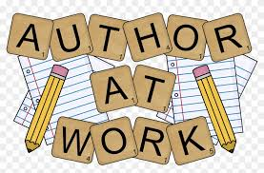
English and maths
This term our English lessons will be based around our topic ‘Time Traveller”. We have such a short half term but we will be using our knowledge to write leaflets, poetry and a time traveller adventure narrative. We will also continue to develop our knowledge of SPaG (spelling, punctuation and grammar rules). SPaG is definitely something I have noticed we struggle with as a class, especially implementing it in our writing. Any quick fire questions at home would be really beneficial, such as: word class, punctuation marks (how to use them) and clause types such as subordinate and relative clauses.
In maths, we will be looking at decimals and percentages. This will include looking at the place value columns, ordering and comparing as well as rounding decimals and percentages. We will then use this knowledge to convert between the two, along with fractions. We have had a long slog with fractions already so I think the children will do really well with this! We will end the half term by adding, subtracting, multiplying and dividing decimals and if we are feeling confident, numbers with different decimal places.
The children will continue to be encouraged to log on to TT Rockstars to help them learn their times tables or to keep working on their speed of recall of the multiplication facts. I saw an increase of children using TT Rockstars last half term and it makes a great difference. Well done everyone who has logged on and thank you for your support at home!s
Topic
Our new topic is called ‘Time Traveller’. Within this topic we’ll meet people from different generations to find out what life was like in the past and we’ll predict how things might change in the future. Using real portraits from the past for inspiration, we’ll write character descriptions about the people in them. We’ll create a timeline of our lives and watch a time-lapse of human development. By taking close-up photographs, we’ll be able to create our own Andy Warhol style prints and experiment to see how photographs can be changed and enhanced. Our science work will focus on puberty and why hygiene is important. We’ll also create clock artwork based on the style of Salvador Dali.
Accompanying this newsletter is a knowledge organiser about the topic, which you can read with your child to find out what we are going to be learning about over the course of the half term. We are going to study this as a class, as the knowledge organiser really helps to extend vocabulary and understanding. Also accompanying the newsletter is a home learning guide, which contains some suggested activities that your child can do at home, as well as recommended reading around this topic. Any work done can be returned to school on the last Monday of term, so that we can look at it over the last couple of days of term.
Other subjects
Azaleas will continue to be taught by Mrs Purdy on Wednesday afternoons, which is my afternoon out of class. She will be teaching RE and German. For PSHE, we will be following Derbyshire’s recommended scheme - PSHE Matters. Throughout the year, we will be looking at friendships, money, relationships, keeping mentally and physically healthy as well as taking responsibility and exploring emotions. In our RE lessons, we will be following the Derbyshire Agreed Syllabus for RE and also the diocese-recommended scheme ‘Understanding Christianity’. We will also be exploring special days, festivals and significant people during our lessons and in daily collective worship in class.
PE
Children should continue to come to school in their PE kit on a Monday and Friday. Please could their kit be in line with our uniform policy, which is a plain white t-shirt or polo shirt, plain black shorts, plain black jogging bottoms and trainers. It may be a good idea for anyone with pierced ears to leave their earrings out on PE days to save them having to take them out, or if your child struggles to remove their earrings, they can tape them over (tape will not be provided by school).
Homework
Homework will be given out on a Friday and will be due in on the following Thursday, when children will bring their homework books in to school for their work to be marked. Children will be provided with maths homework, spelling homework and they will also be expected to read at least five times a week, and for their reading to be recorded in their reading record. I urge the children to continue logging into TT Rockstars, I can track their progress online and it is really making a huge difference to their times table knowledge.
Reading
Your child will continue to be provided with a reading book in line with their reading age. In class, children will have access to books off our reading shelves as well as library books (which are brought in to the classroom for children to access) and we will also have our 50 Reads Challenge books in our reading treasure chest. These books are specific to Y5, and the children are encouraged to read as many, ideally all, of the books during their time in Y5. It is essential that those children who are free readers are reading books that are challenging enough for their age, and that they are accessing a wide range of genres and authors, and the 50 Reads Challenge is perfect for this! It is lovely to see how much the children are enjoying reading these books. Thank you for your support in encouraging your child to read!
I hope that you have found this information useful. Thank you to all the parents that came to parents evening or arranged a phone call, it was lovely to meet you. If you ever need to contact me, please don’t hesitate, you can phone school or can email me directly on azalea@st-james.derbyshire.sch.uk
Thank you for your support.
Best wishes,
Mr Hannnan

