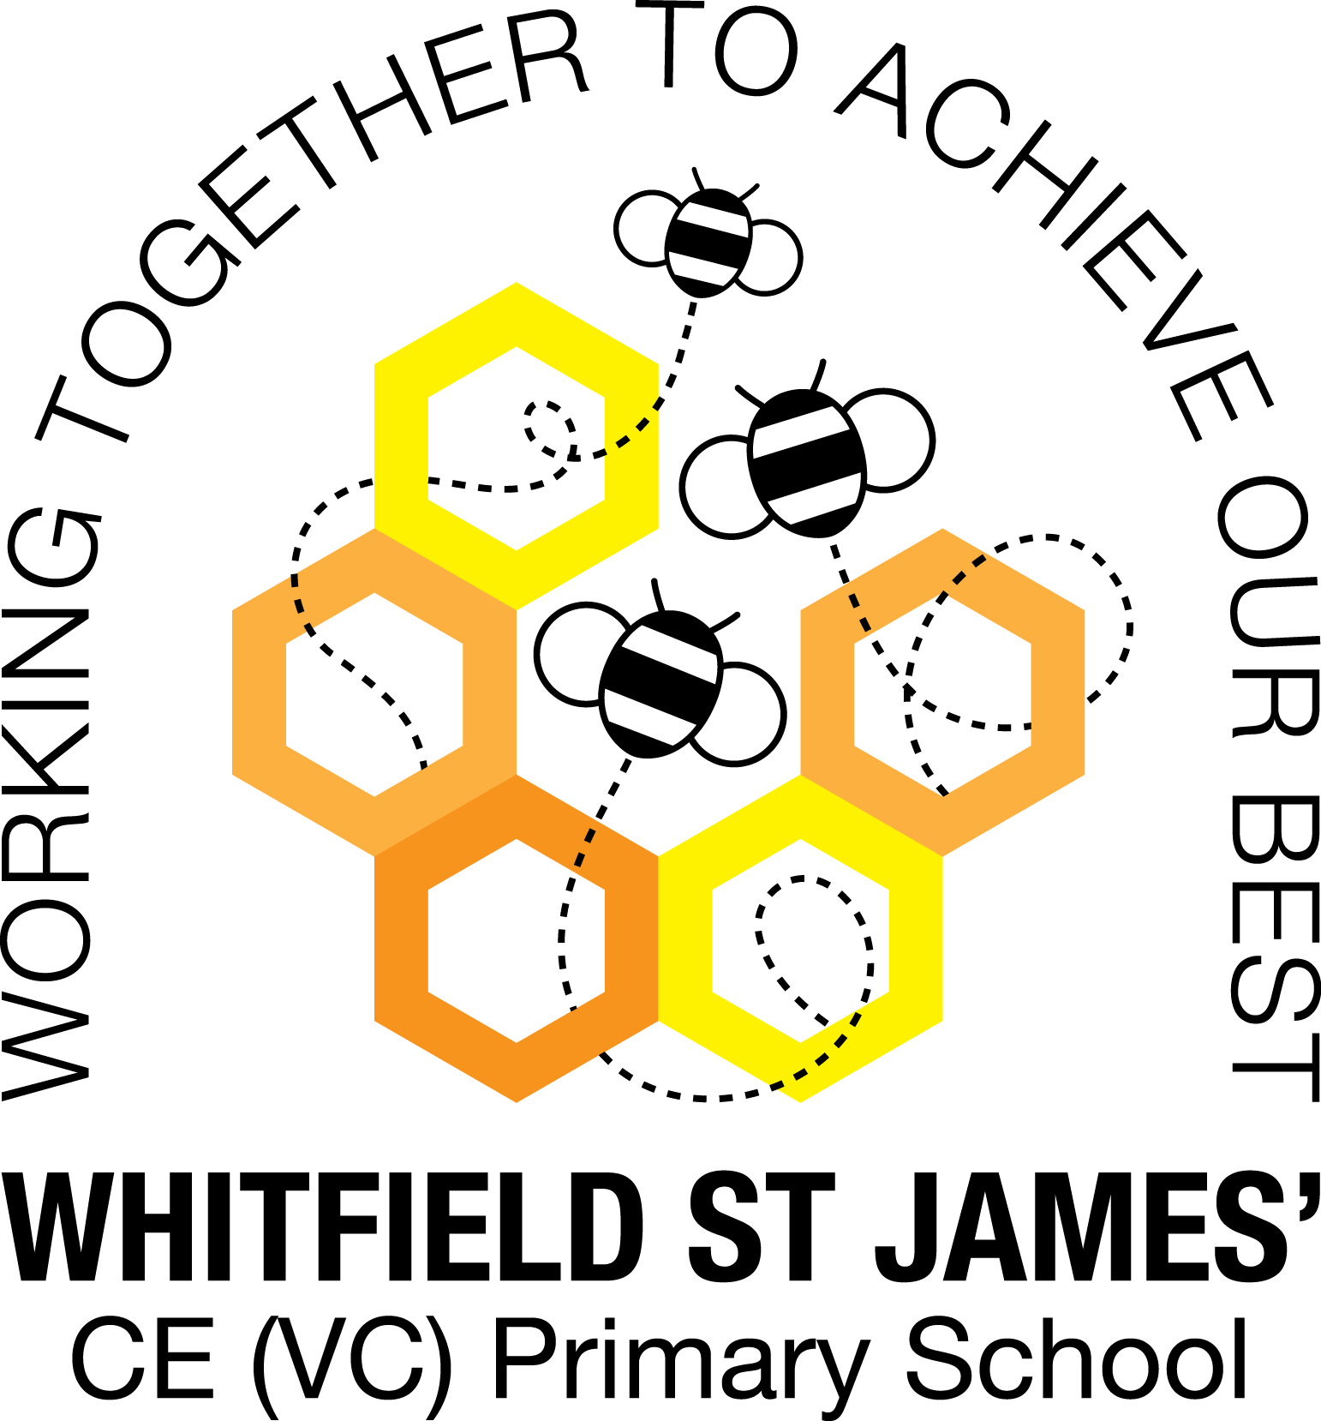

WHITFIELD ST JAMES’ CE (VC) PRIMARY SCHOOL

25th April 2022

Dear parents and carers of Aloe Vera class,

I hope that you have all had a lovely Easter and have managed to enjoy the brighter weather.
Below is some general information as well as some more class-specific information to prepare you and your children for the Summer term. I apologise if some of this information is repeated.

English and maths
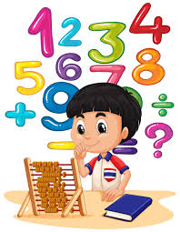
This half term we will be linking our English lessons to our new topic, Urban Pioneers. We will be writing an information leaflet about our local area, having a go at free-verse poetry, writing an autobiography, composing emails and creating signs and slogans. The children will also listen and respond to our class novel Emil and the Detectives by Erich Kastner, which is linked to our topic. In addition to this, we will continue with guided reading (beginning a unit on Grandad’s Secret Giant), handwriting and spelling, punctuation and grammar for your child’s year group.
In maths, we will all begin by learning about fractions, followed by time. Both groups will then have a unit on geometry followed by measurement, but with different focal points and outcomes depending on the year group. The children will continue to be encouraged to log on to TT Rockstars to help them to learn their times tables or to keep working on their speed of recall of the multiplication facts. I would be grateful if you could encourage your children to do this at home, as a secure knowledge of the tables helps the children in all areas of maths.

Topic
Our new topic is called ‘Urban Pioneers’ and it looks at a variety of different towns and cities, important buildings and how areas adapt and change over time. This topic incorporates many subjects such as: Art (photography and graffiti), Geography (fieldwork) and Computing (digital maps). Accompanying this newsletter is a knowledge organiser, which you can read with your child, to find out more about what we are going to be learning. There is also a home learning guide and workbook, which contains some suggested activities that your child can do at home. Any work done can be returned to school on the last Monday of this half term, so that we can look over it together.

Other subjects
Aloe Vera class will no longer be taught by Mrs Eccles on a Tuesday afternoon; instead, Mrs Lockett will be doing this. Mrs Purdy will continue to teach the class on a Thursday afternoon. On Tuesdays, Mrs Lockett will be teaching the class PE, RE and some PSHE and on Thursdays Mrs Purdy will be teaching the class MFL (German) and PE. In our RE lessons, we will continue to follow the Derbyshire Agreed Syllabus for RE and also the diocese-recommended scheme. We will also be exploring special days, festivals and significant people during our lessons and daily collective worship in class. In computing, we will be continuing with the unit of work we started in the Spring term.

PE
As mentioned above, your child will need to come in to school in their PE kit on Tuesday and Thursday each week. Please could their kit be in line with our uniform policy, which is a plain white t-shirt or polo shirt, plain black shorts, plain black jogging bottoms and trainers. It may be a good idea for anyone with pierced ears to leave their earrings out on PE days to save them having to take them out, or if your child struggles to remove their earrings, they can tape them over (tape will not be provided by school).

Home Learning
I gave the children a break from formal homework over the holidays; however, I did send home some fun Easter ideas for them to have a go at. Please feel free to email anything your child completed during the break. We will continue with the previous routine of setting homework every Friday and collecting it in the following Thursday from the first week back. Your children will receive one piece of maths and one piece of SPAG related homework per week. This is always linked to the learning done in class.
Children are also expected to read at least five times a week at home and for this to be recorded in their reading record.
As mentioned above, please see the home learning guide for ideas on supporting your child’s topic learning at home.

Parents of children in Year 2 will receive more information on the upcoming SATs in due course.
Thank you all for your continued support with home learning!

Reading
Your child will continue to be provided with a reading book in line with their reading age. In class, children will have access to books off our reading shelves as well as library books (which are brought in to the classroom) and we also have our 50 Reads Challenge books in our reading treasure chest. These books are specific to Y2/3, and the children are encouraged to read as many, ideally all, of the books during their time in Y2/3. It is lovely to see how much the children are enjoying reading these books. Thank you for your support in encouraging your child to read! Please encourage your child to tick off the treasure chest books they have read on the list in their homework book. Also a reminder that it is the children’s responsibility to change their book once they have finished it; this isn’t done by an adult.

I’m sure you are all now aware that Mrs Lockett will be taking over the class once I start my maternity leave at some point this half term. This will be really positive for the class as Mrs Lockett knows all of the children really well.

I hope that you have found this information useful. If you ever need to contact me, please don’t hesitate. You can phone school or can email me directly on aloevera@st-james.derbyshire.sch.uk
As always, thank you for your support.

Best wishes,
Miss Graham

