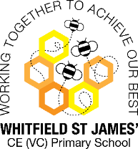Bluebells Snapshot of the Week

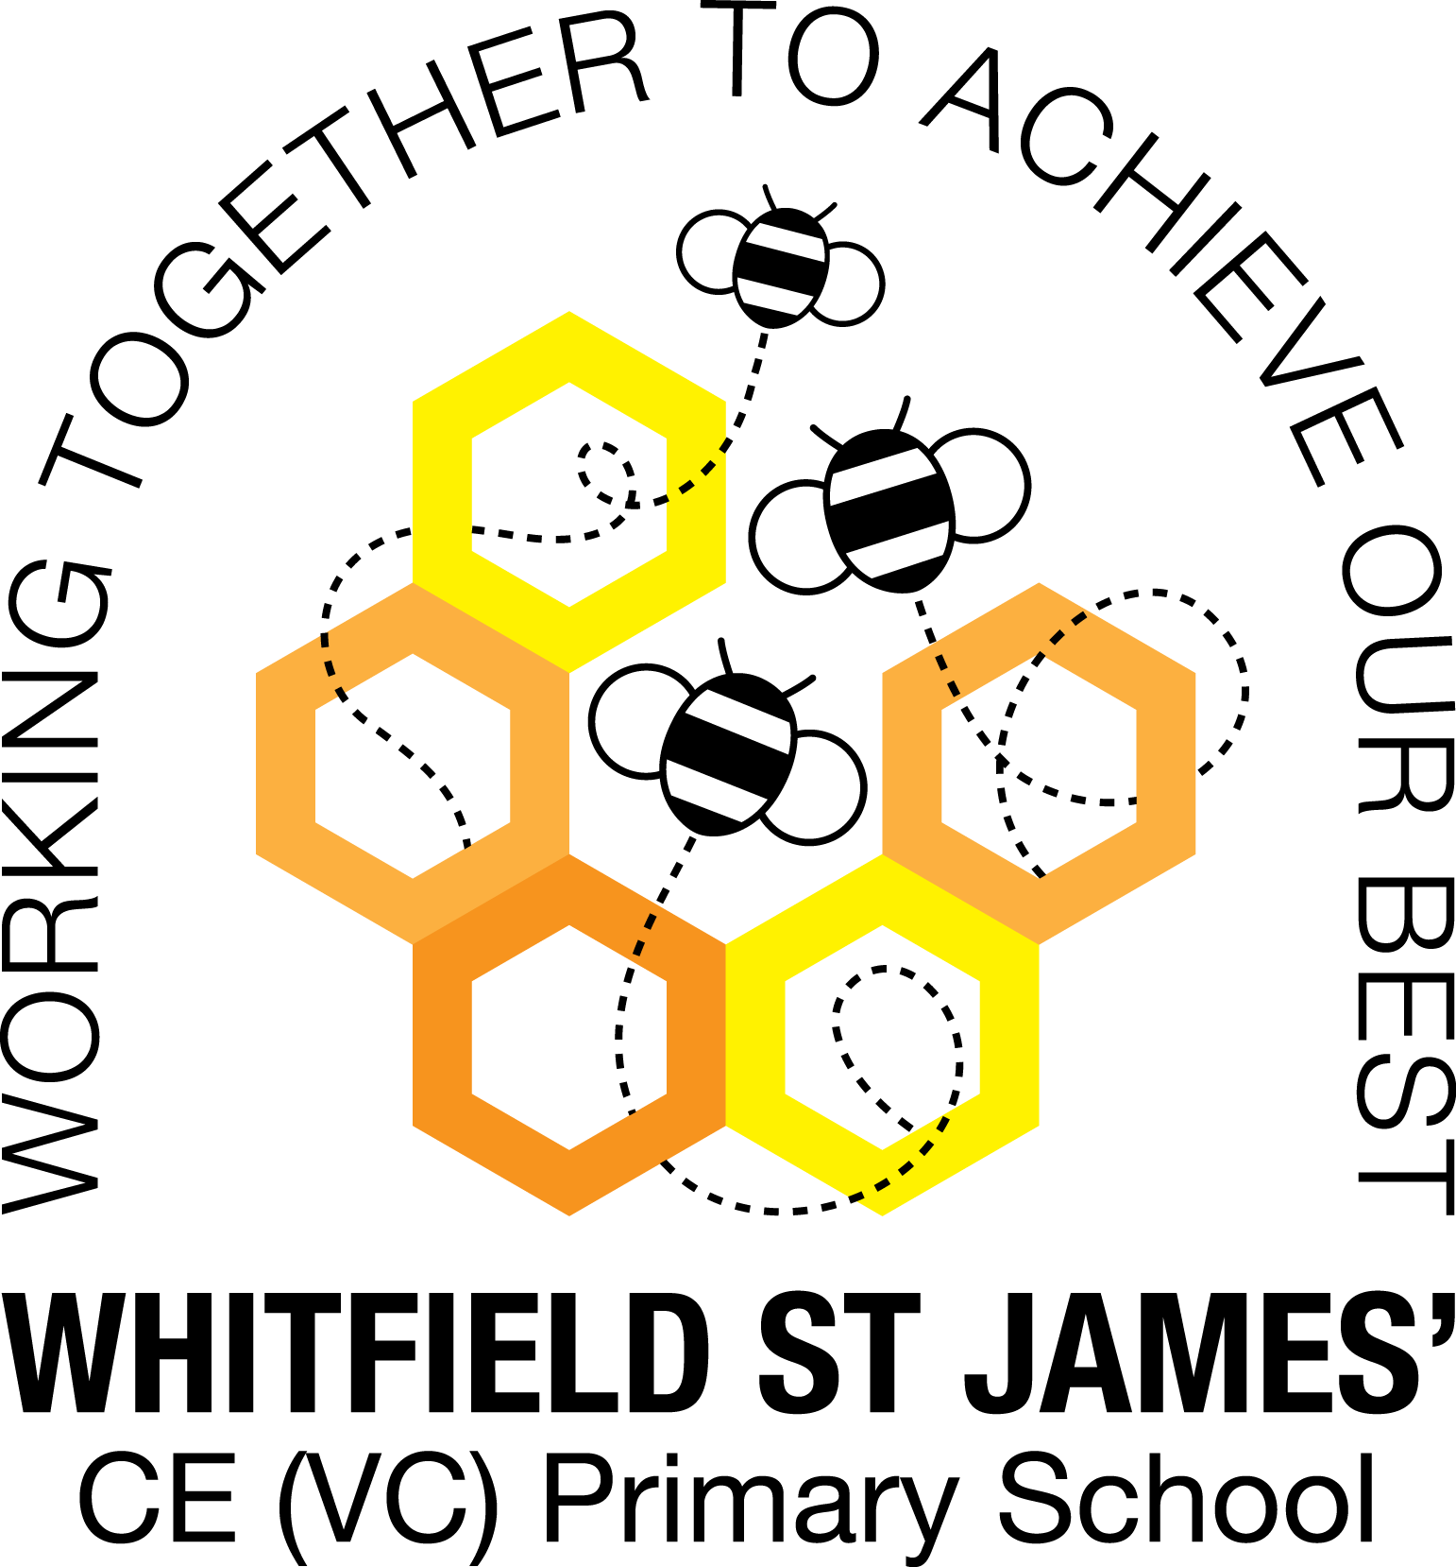

Here is a snapshot of some of the activities we have completed in our class this week. This snapshot may not contain all of the activities the children have been involved in. If you have any questions or need anything, please don’t hesitate to email us on the class email – [bluebell@st-james.derbyshire.sch.uk](mailto:bluebell@st-james.derbyshire.sch.uk)

|  |  |
| --- | --- |
| Topic: Sunshine and Sunflowers | Week commencing: 25.04.2022 |
| Class book: Eddie’s Garden |

|  |  |
| --- | --- |
| **Phonics and Reading**  This week we have started phase 4 phonics and we have been learning to read cvcc words (Consonant, vowel, consonant, consonant) such as best, went, help, wind and lost. Based on the phonics assessments at the end of last term, the children have been given a decodable reading book to match their phonic ability. Please don’t worry if your child has a book that they have already had, it just means that they need a little bit more practise to read with fluency. | Literacy/Topic  Our Wow day was great fun and the children really enjoyed being scientists for the day! |
| **Maths** We have been learning about numbers within 20. In particular we are learning that numbers beyond 10 are composed on one full set of 10 and part of the next ten. For example 11 is made up of 1 full 10 and 1 more, 15 is 1 lot of 10 and 5 more. 20 is 2 lots of ten. Number cards to 20 will be sent home in book bags on Friday. Please cut these out and practise ordering these numbers, counting forwards and back. Take one away and find the missing number, represent these teen numbers using raisins/counters/felt tips etc. Encourage 1:1 counting by physically touching and saying the number as you count each object. | **Other Information**  We are looking for rolls of paper for large scale art activities. If you have any leftover rolls of wall paper at home that you longer need we can make great use of them in school. Thank you! |
| **Star of the week: Elise**  **Christian Value Award**: Taylor |