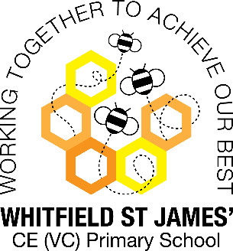Daisy class snapshot of the week

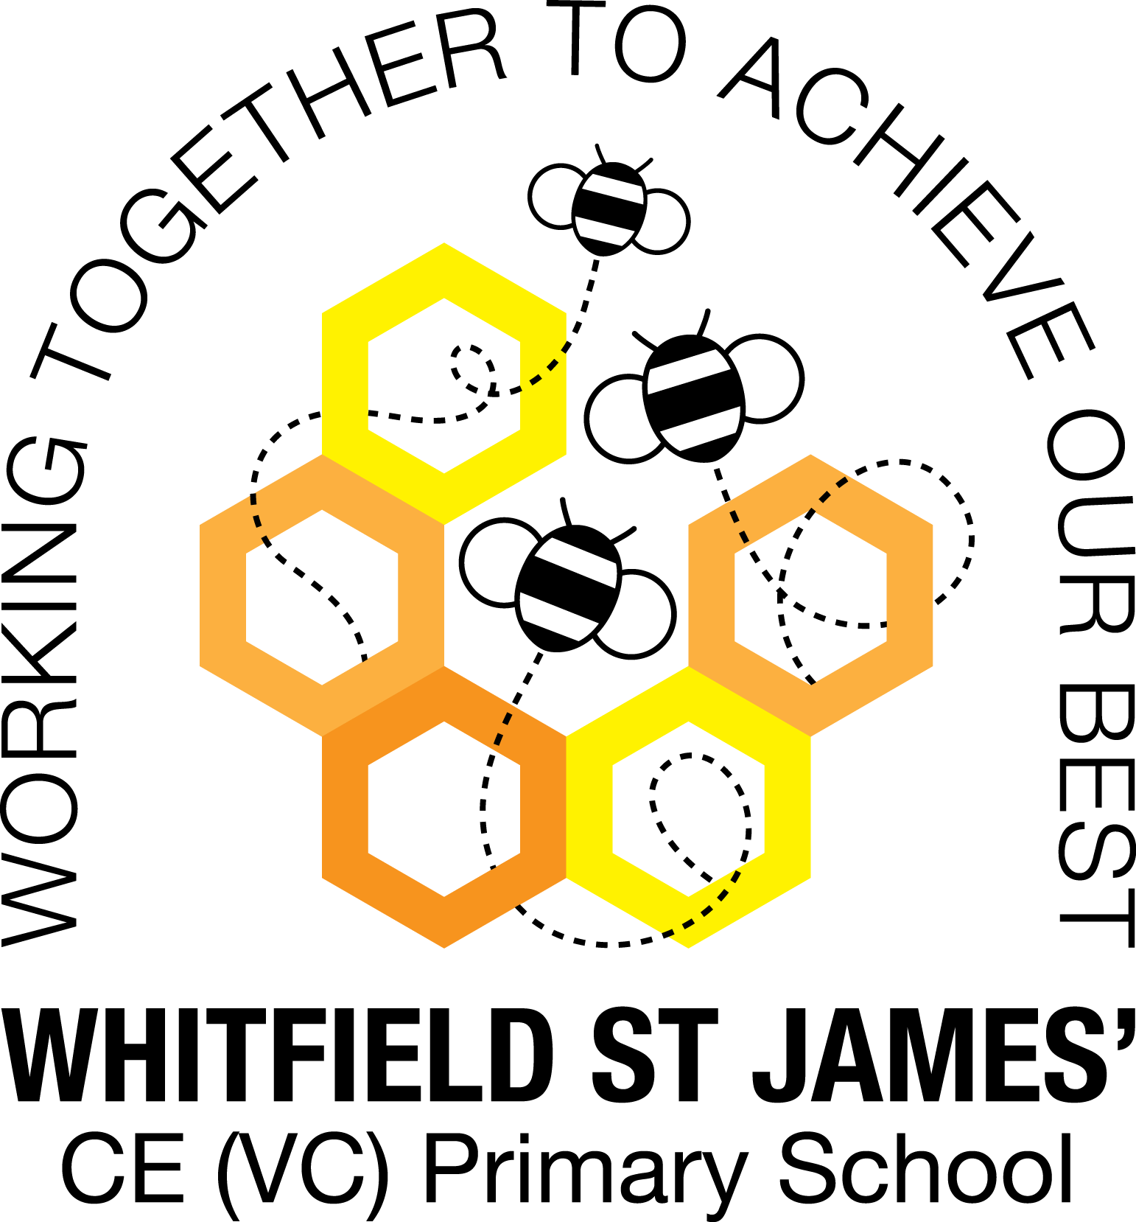

Here is a snapshot of some of the activities we have completed in our class this week. This snapshot may not contain all of the activities the children have been involved in. If you have any questions or need anything, please don’t hesitate to email us on the class email – [daisy@st-james.derbyshire.sch.uk](mailto:daisy@st-james.derbyshire.sch.uk)

|  |  |
| --- | --- |
| Topic: The Scented Garden | Week commencing: 28.02.2022 |
| This week’s class books:  **Avocado Baby** by John Burningham  **Badger’s Parting Gift**- Susan Varley  **Jim and the Beanstalk**- Raymond Briggs  Non- fiction texts about plants and trees. | |
| **English**  This week we have been learning all about signs of spring. We have read and written about things that happen in spring. We have learnt about spring bulbs, plants and trees, that many baby animals are born during this season as well as the importance of insects such as bees and butterflies to help pollinate.  We have also written a recount of our special WOW day at Manor Park. Describing and explaining what we saw as well as giving instructions on out journey.  We have also begun to look at an alternative story of ‘Jack and the Beanstalk’ called ‘Jim and the Beanstalk’ by Raymond Briggs. We have compared the two texts and then summarised the story. | **Maths**  We have been working very hard on our understanding of factions. In Year 1, we have been finding a quarter of shapes and amounts up to 20. They have also been finding a third of amounts to 20.  Our Year 2 pupils have been finding a quarter of shapes and amounts. They have been learning to recognise a third or shapes and amounts. Going further, they have been learning about Unit Fractions. |
| **Topic/Science**  We had a fantastic day at Manor Park on Tuesday and the weather was also lovely. We saw lots of amazing things such as, bulbs growing on plants and trees, flowers such as crocuses, daffodils, grape hyacinths, primroses, bluebells and snowdrops. We explored our senses in the sensory garden where we smelt the mint, rosemary and lavender. We also ran our hands through the heather and stroked the ‘lambs ear’ (Stachy’s byzantine) plants. We watched bees pollinate the flowers and birds building their nests ready to lay their eggs. We saw male and female ducks swimming around in pairs in search to find somewhere safe to build their nests. The children had lots of fantastic questions about Spring and new life.  We have also been learning all about the season Spring and what we will be beginning to see over the next few weeks. We’ve discussed changes in animals we might see (as well as baby animals being born such as lambs, chicks, ducklings), plants and the weather.  We have continued to practise yoga and movement as part of our PE sessions this week. We have worked on breathing and stretches which encourage mindfulness. We have also been working on agility and doing collaborative games/ activities such as relays and teamwork activities (sports day style activities).  In RE, the children have been learning about Palm Sunday and Jesus riding into Jerusalem on a donkey. We learnt about what happened on this day and why it is important to Christians.  In our Computing session, we have been continuing with our Digital Painting lessons. This week we created our own versions of Piet Mondrian’s artwork. We used the shape tools, fill tools and applied primary colours. | |
| **Other news:**   * Please make sure you write your child’s name in their jumpers and cardigans to help them to look after their belongings. * Please remember to wrap up warm as the weather is still very cold. * Please do not bring toys into school as we do not want anything to get damaged or broken- we have lots to play with at school. | **Important dates/events coming up:**    Parents evening:  Tuesday 22nd March  Thursday 24th March |
| **Star of the week:** **Dolly**- This week Dolly created a marvellous Piet Mondrian inspired piece of art work in our Computing lesson.  **Christian Value Award (Spr term 2): Ava- Rose –** Ava always has a piece of wisdom she shares with us, no matter what the topic is we are discussing. |