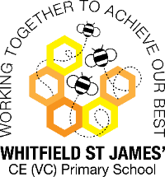**Buttercups snap shot of the week**

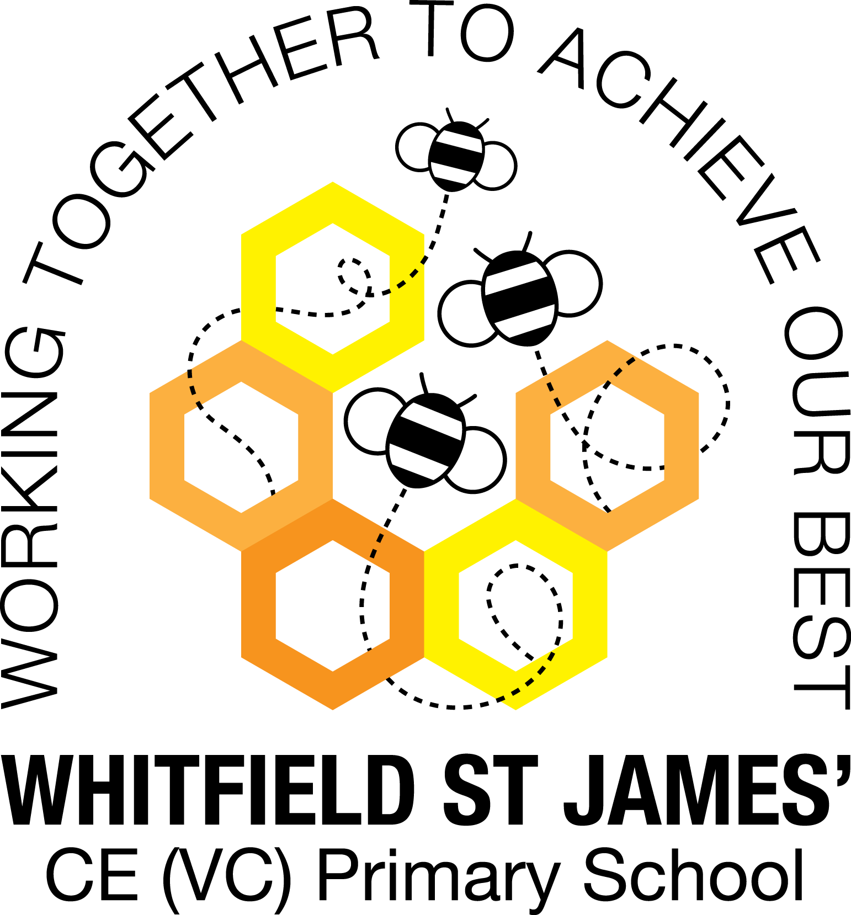

Here is a snapshot of some of the activities we have completed in our class this week. This snapshot may not contain all of the activities the children have been involved in. If you have any questions or need anything, please don’t hesitate to email us on the class email – buttercup@st-james.derbyshire.sch.uk

|  |  |
| --- | --- |
| **Topic**: Paws, Claws and Whiskers | **Week commencing**: 14th March 2022 |
| **Class book**: The Tiger Who Came to Tea By Judith Kerr |  |

|  |  |
| --- | --- |
| **Topic**  We have been doing lots of science this week. The children have learnt about camouflage and mimicry, discussed similarities and differences between different species of animal as well as researching tiger facts!  The children have produced some brilliant non-fiction writing this week which I am looking forward to sharing with you on parents evening. | **Maths**  **Rec:** This week the children have continued exploring number bonds to 10 by using a part whole model and counters. The children are able to recite some number bonds to 10 by rote.  **Year 1:** This week the children have been introduced to length and height. Children use and understand the language of length such as long, longer, short, shorter, tall, taller. They recognise this language will change depending on what type of length they  are describing and comparing. Children understand that height is a type of length. |
| **Other areas of learning.**  You won’t believe who visited our classroom this week!!!  The children were excited to discover that the tiger from our class book came into our classroom for a tiger tea party! It was great fun. | **Any other information**  **Parents Evening – Tuesday 22nd March and Thursday 24th March.**  **Please sign up to a 10 min appointment via the school email address.**  Children no longer need to bring a water bottle to school, drinks are provided in class and are available throughout the day. |
| **Star of the week: Alex**  **Christian Value Award: Mya** |