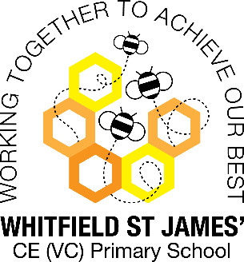**Buttercups snap shot of the week**

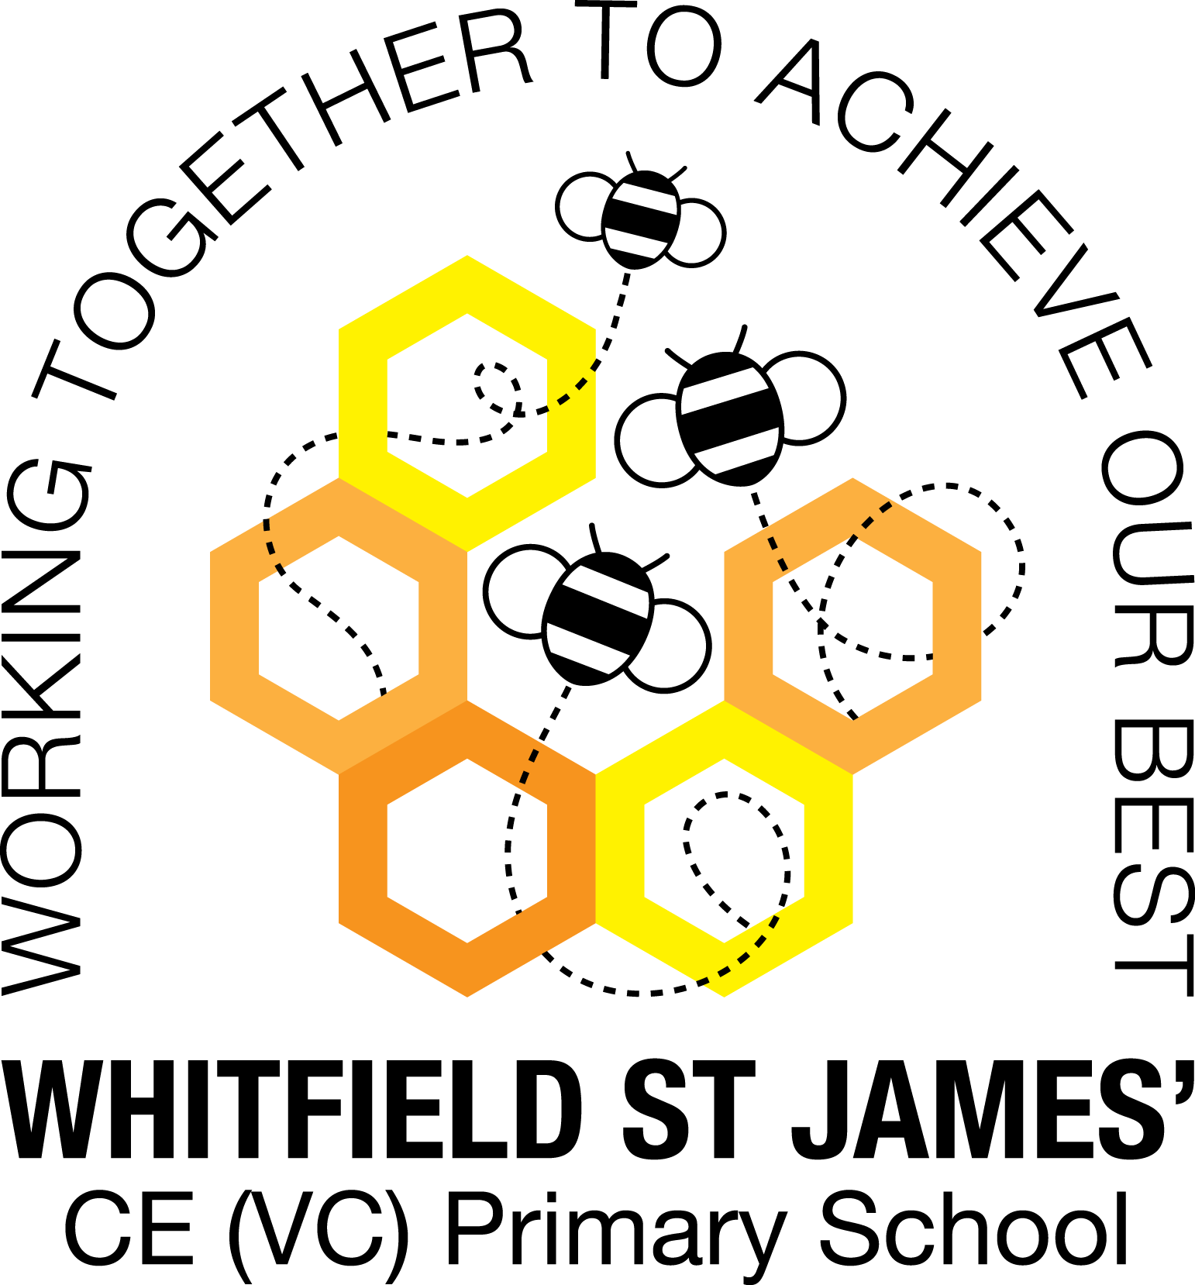

Here is a snapshot of some of the activities we have completed in our class this week. This snapshot may not contain all of the activities the children have been involved in. If you have any questions or need anything, please don’t hesitate to email us on the class email – buttercup@st-james.derbyshire.sch.uk

|  |  |
| --- | --- |
| **Topic**: Our super selves. Children’s Mental Health Week. | **Week commencing**: 7th February 2022 |
| **Class book**: Dragons in the City |  |

|  |  |
| --- | --- |
| **Chinese New Year**  This week we learnt about Chinese New Year. It is the year of the Tiger.  We looked on the globe to find China and discussed how we might travel there. We discussed China being in Asia which led to a discussion and a song (obviously) about the 7 continents. I have included a link to the song below. Can your child share some of the things they have learnt?  [**https://www.youtube.com/watch?v=K6DSMZ8b3LE**](https://www.youtube.com/watch?v=K6DSMZ8b3LE) | **Maths**  **Reception:** This week the children have been exploring the composition of numbers 6, 7 and 8. We used dominoes and ladybirds to see how many ways we could make 6, 7 and 8. I have asked the children to look out for different ways these numbers might be represented at home. E.g. An egg box represents 6. Please post any important discoveries to Tapestry.  **Year One:** For the first time, children have been introduced to subtraction where they have to cross ten. This small step focuses on the strategy of partitioning to make ten. The Children have been representing this using concrete manipulatives to begin with. |
| **Other areas of learning.**  This week the children have been taking part in a range of activities as part of Children’s Mental Health Week. The theme of this year’s Children’s Mental Health week is Growing Together.  <https://www.childrensmentalhealthweek.org.uk/parents> | **Any other information**  Thank you to those parents who have returned the children’s topic/maths books. There are still some books yet to be returned. It is important that we have the work books back in school as soon as possible.  There has been lots of great feedback from parents who have already downloaded the White Rose Maths app. If you haven’t already, give it a try.  <https://play.google.com/store/apps/details?id=com.whiterosemaths.oneminutemathsks1> |
| **Star of the week: Teddy**  **Christian Value Award: Joseph** |