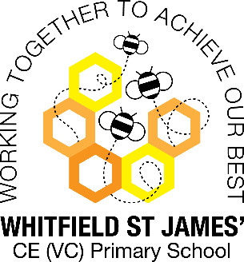**Buttercups snap shot of the week**

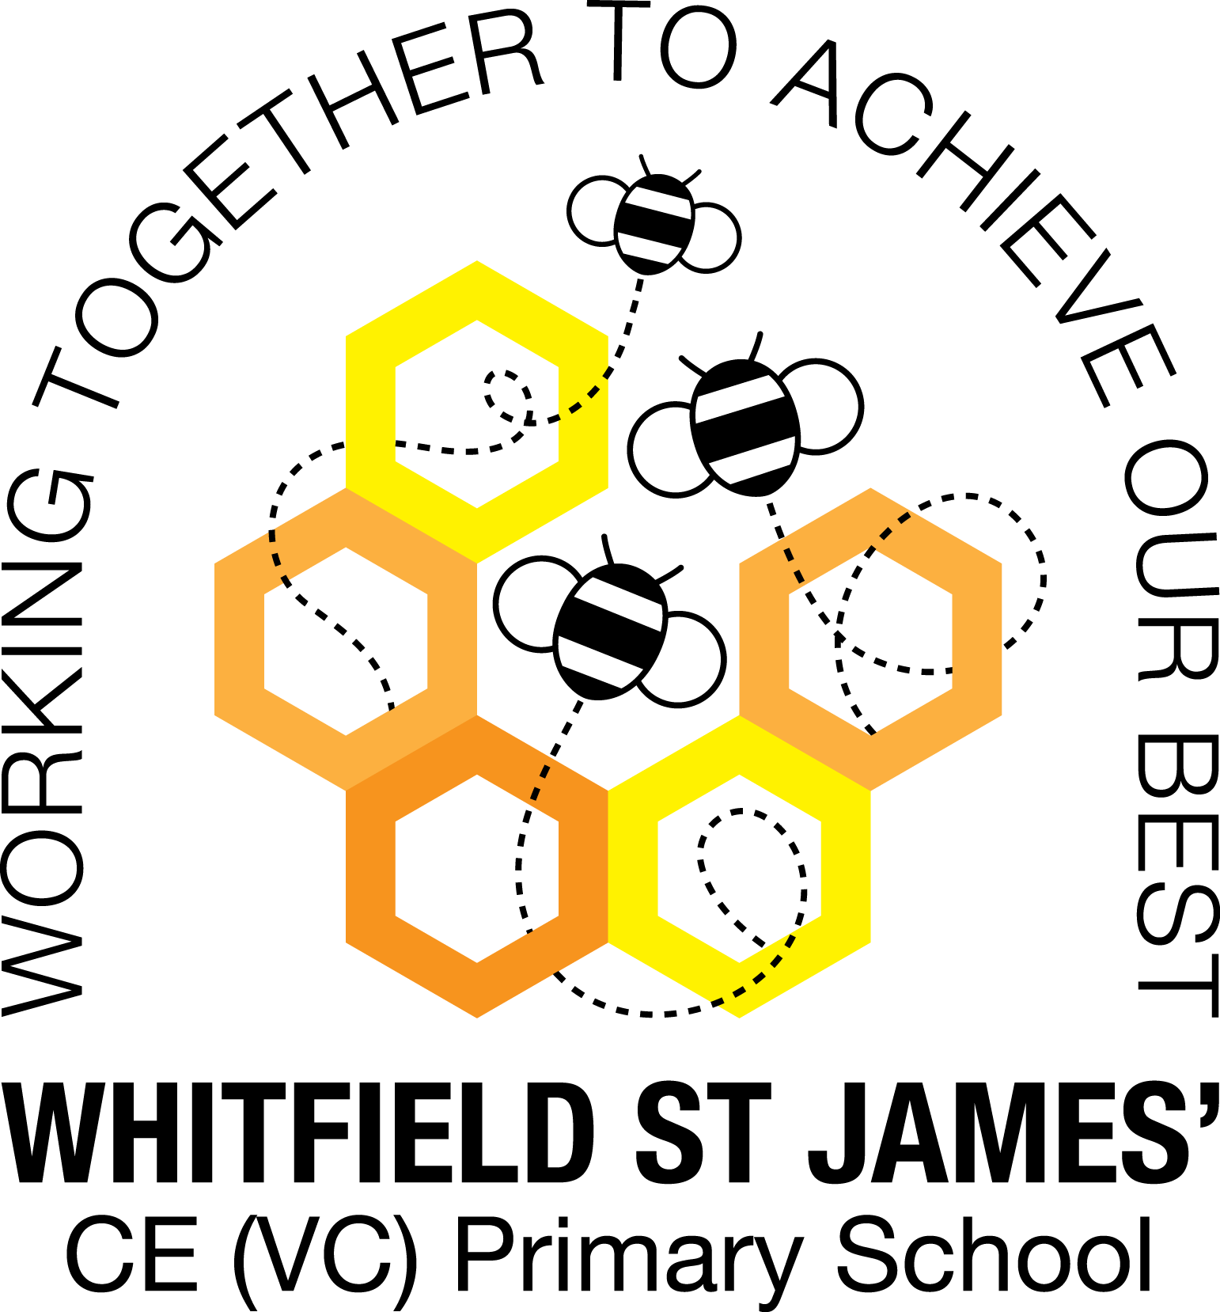

Here is a snapshot of some of the activities we have completed in our class this week. This snapshot may not contain all of the activities the children have been involved in. If you have any questions or need anything, please don’t hesitate to email us on the class email – buttercup@st-james.derbyshire.sch.uk

|  |  |
| --- | --- |
| **Topic:** Superheroes | **Week commencing**: 14th February 2022 |
| **Class book**: |  |

|  |  |
| --- | --- |
| **Our Topic Next Term**  We’re going to discover that animals come in all shapes and sizes!  **Help your child prepare for the Topic.**  Animals are amazing!  Why not take photos of a favourite pet together and describe their habits, likes and dislikes?  You could also put bird food in the garden and visit a local park or nature reserve for a spot of bird watching. Make a note of their markings and features then use a simple spotting book or app to identify different species. Alternatively, visiting the local pet shop or petting zoo would allow you to observe a wide range of different animals.  More Topic information to follow on our class page on the school website. | **Maths**  **Reception:** This week the children have been learning about matching pairs. Through various practical activities the children have learnt that 2 make a pair and practiced counting in 2’s up to 10. I have challenged the children to find examples of pairs at home. Please upload this to Tapestry.  **Year One:** The children have been using practical equipment to represent numbers to 50  They continue to build their understanding that ten ones can be grouped into one ten. The children have practiced grouping equipment (straws, cubes, lolly sticks, 10 frames) into tens themselves It is important that children understand how a number is made  up of tens and ones, e.g. 34 = 3 tens and 4 ones. |
| **Other areas of learning.**  WOW day – Monday 28th February 2022  Children to come to school dressed as an animal. Spend time finding out some information or key facts about your chosen animal. | **Any other information**   * After the half term children no longer need to bring a water bottle to school. Drinks will be provided in class. * White Rose Maths App <https://play.google.com/store/apps/details?id=com.whiterosemaths.oneminutemathsks1> |
| **Star of the week: Olivia**  **Christian Value Award: Rohan** |