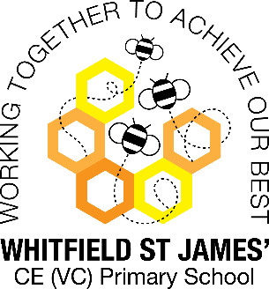Peonies snapshot of the week

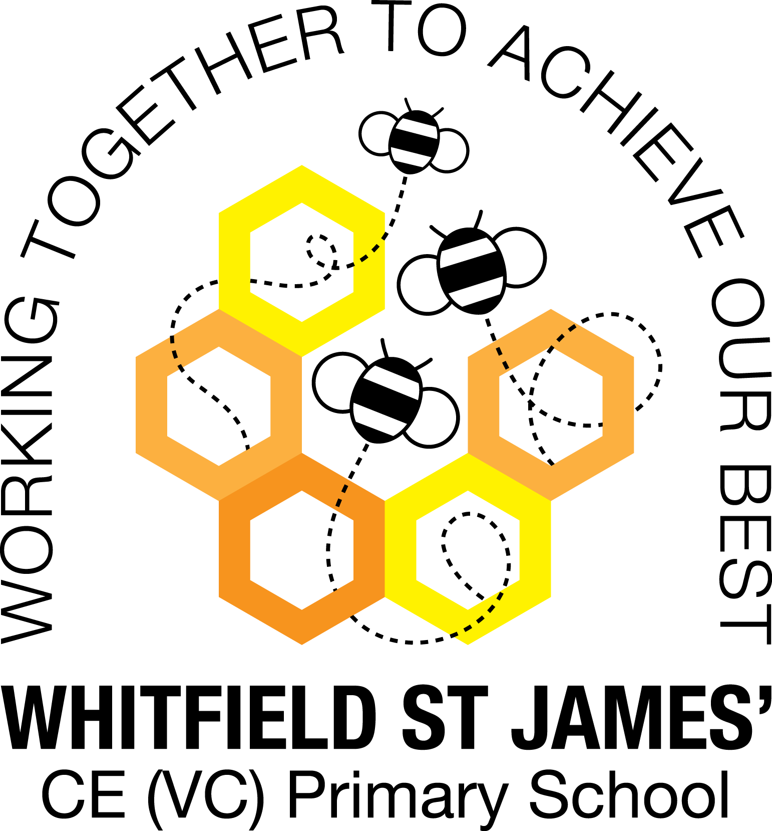

Here is a snapshot of some of the activities we have completed in our class this week. This snapshot may not contain all of the lessons and activities the children have been involved in, but will provide you with an idea of what we have done this week in Peonies class!

If you have any questions or need anything, please don’t hesitate to email me on the class email – [peonies@st-james.derbyshire.sch.uk](mailto:peonies@st-james.derbyshire.sch.uk) Miss Warburton

|  |  |
| --- | --- |
| **Topic**: Frozen Kingdoms | **Week commencing**: 31st January 2022 |
| **Class book**: The Wolf Wilder by Katherine Rundell |  |
| **Maths**  This week we continued our work on decimals and fractions and we have also learned how to compare them to percentages.  In our daily TT Rock Stars lesson we have been focusing on the 7, 8, 9 and 10 times tables.  **Challenge**: Ask your child to recall the following fraction/decimal/percentage equivalents. If they can learn them, it will really help them in problem solving and fluency work!  ½ = 0.5 = 50% ¾ = 0.75 = 75%  ¼ = 0.25 = 25% 1/5 = 0.2 = 20% | **English**  This week we have started to learn about non-chronological reports and their features. We have also been learning how to use hyphens and semi-colons effectively so that we can include them in our writing.  In our guided reading lessons and as a link to our Frozen Kingdoms topic, we have continued to read about Ernest Shackleton’s journey across Antarctica in 1914. We also continue to enjoy Wolf Wilder, our class novel, and we are half way through it now.  **Challenge**: Ask your child to explain the difference in meaning between ‘man eating shark’ and ‘man-eating shark’, and ‘three year-old children’ and ‘three-year-old children’. We have discussed this in our work on hyphens to avoid ambiguity this week! |
| **Other lessons**  The children have been enjoying reading a newspaper which I print and leave in the classroom every week. It is called ‘News Shed’ and is aimed at primary school children. The crossword page and the sports news are popular! It has also been nice for them to read articles about explorers visiting the Polar regions, and linking it to our topic.  In science we have enjoyed classifying animals and plants this week, and looking at classification keys to identify them by their features and characteristics. | **Other information**  Peonies class will start their swimming lessons after the half term break, on Thursday 3rd March. A letter will be sent out in due course!  Next week in school it is Mental Health Week and we will be doing some activities linked to this important topic.  Homework: This week homework has been set on SATs Companion. There is a reading, spelling and maths task for the children to do, linked to this week’s learning. Login details are in children’s homework books. Please encourage them to log in and complete their tasks. Thank you for your support.  Thank you to Priya for bringing in some delicious prawn crackers this week, in celebration of Chinese New Year, and for talking to us about how it is celebrated. We learned a lot from you, and the crackers were delicious and we enjoyed them very much! |
| **Star of the week:** Lewis  **Christian Value Award:** Priya |