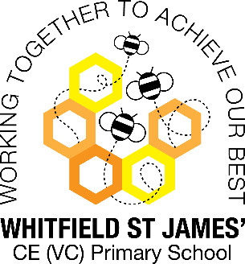 Orchid Class snapshot of the week

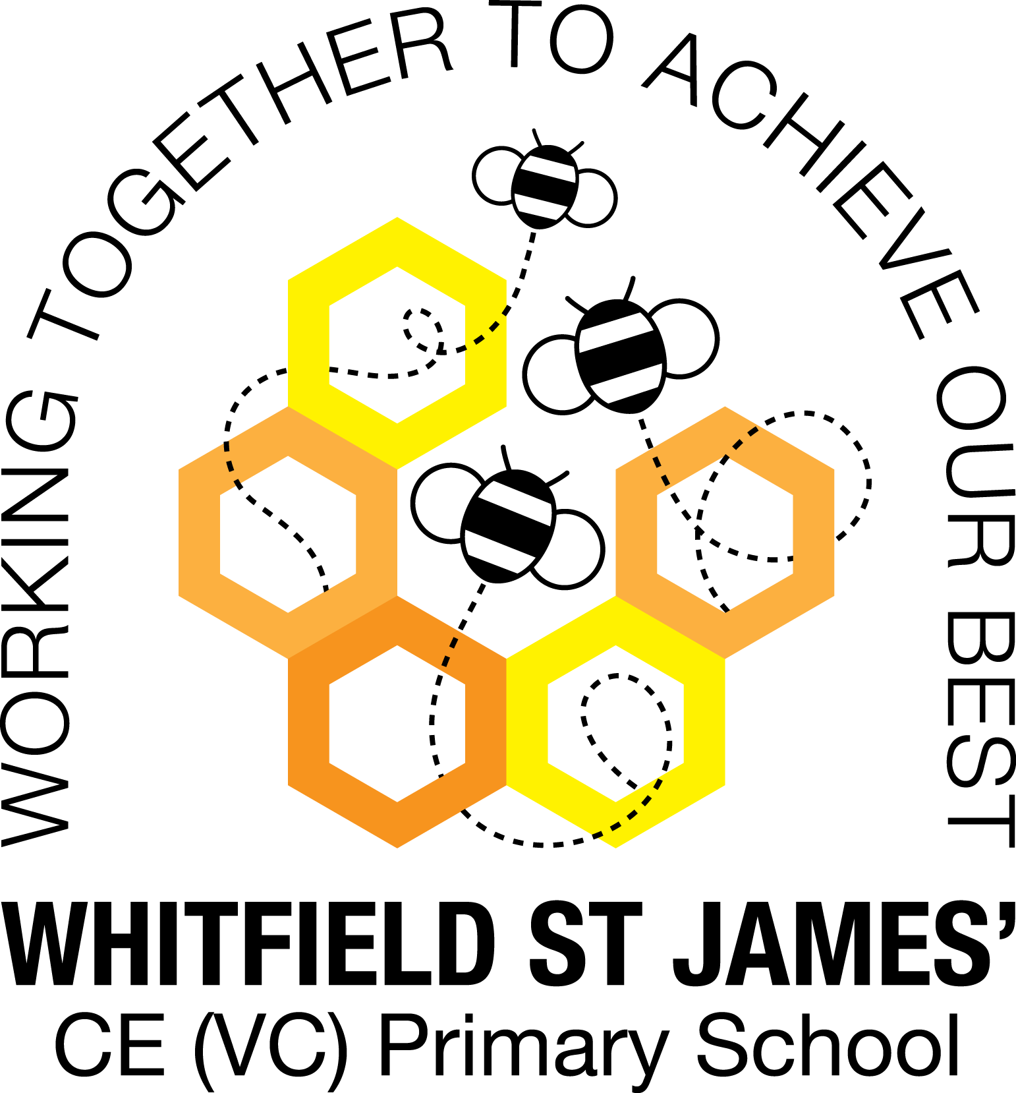

Here is a snapshot of some of the activities we have completed in our class this week. This snapshot may not contain all of the activities the children have been involved in. If you have any questions or need anything, please don’t hesitate to email us on the class email – orchid@st-james.derbyshire.sch.uk

|  |  |
| --- | --- |
| Topic: Darwin’s Delights | Week commencing: 1st February |
| Class book: Darwin’s Dragons |  |

|  |  |
| --- | --- |
| **English:**  This week we have been working on making notes from non-fiction sources. Because of the vocabulary work the children did last week, they were able to independently research all about human evolution and make notes ready for their report. | **Maths**  We are nearly at the end of our fractions unit. Orchid Class have worked really hard on multiplying fractions this week and will be progressing to dividing fractions and fractions of amounts. Please continue to revise times tables ☺. |
| **Other subjects:**  Our topic lessons have been science focussed this week; we have conducted an experiment to see how animals on the Galapagos had adapted based on the food source available.  During PSHE, we looked at what it is like to feel embarrassed and how we can overcome this emotion. | **Any other information**  Please continue to collect coins for the smarties tube (or any other change!) so that we can try and win a class treat.  Children should be reading 5 x a week and completing weekly homework tasks to consolidate their learning.  Y6: please continue to use the revision books at home. Small burst of revision will help to keep all those plates spinning!  Have a lovely weekend ☺. |
| **Star of the week: Benji**  **Christian Value Award: Leah** |