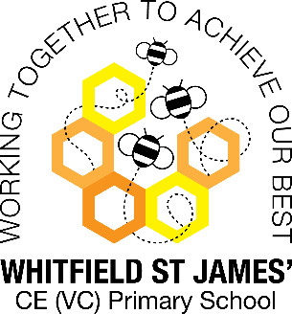 Orchid Class snapshot of the week

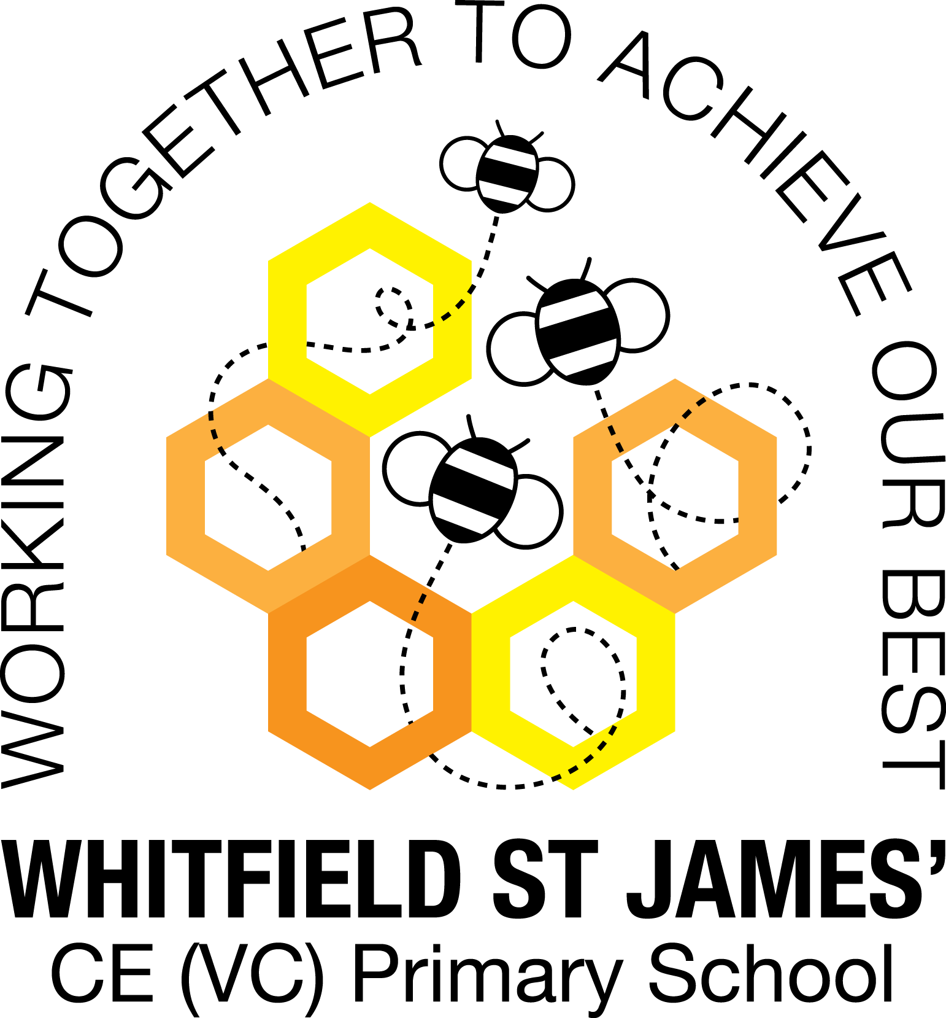

Here is a snapshot of some of the activities we have completed in our class this week. This snapshot may not contain all of the activities the children have been involved in. If you have any questions or need anything, please don’t hesitate to email us on the class email – orchid@st-james.derbyshire.sch.uk

|  |  |
| --- | --- |
| Topic: Darwin’s Delights | Week commencing: 14th February 2022 |
| Class book: Darwin’s Delights |  |

|  |  |
| --- | --- |
| **English**  During our English lessons this week, we have researched endangered animals and have created fantastic fact files on them. Orchid Class worked so hard on these and put so much effort into making sure they were presented beautifully. | **Maths**  We have continued with our decimal unit this week and have looked at comparing and ordering decimals and converting between decimals and fractions.  To help at home, asking questions like, “Which is bigger, 1.3 or 1.08?” would be really useful. |
| **Other subjects**  We had a great afternoon on Tuesday making salt dough fossils as a result of studying Mary Anning earlier on last week.  We also finished off our cricket sessions on Wednesday which I know has inspired some children to join a cricket club outside of school ☺. | **Any other information**  Our first swimming lesson is the 3rd March, which is also World Book Day. Children are still able to dress up; however, please ensure sure it is a costume that is easy enough to get in and out of.  Please make sure that if you haven’t already hand in your letter that you do so.  Have a wonderful half term ☺ |
| **Star of the week:**  **Bella H**  **Christian Value Award:**  **Alex** |