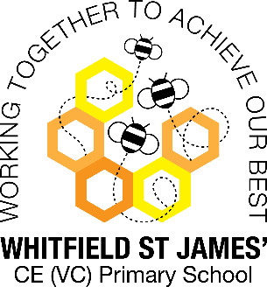Azaleas snapshot of the week

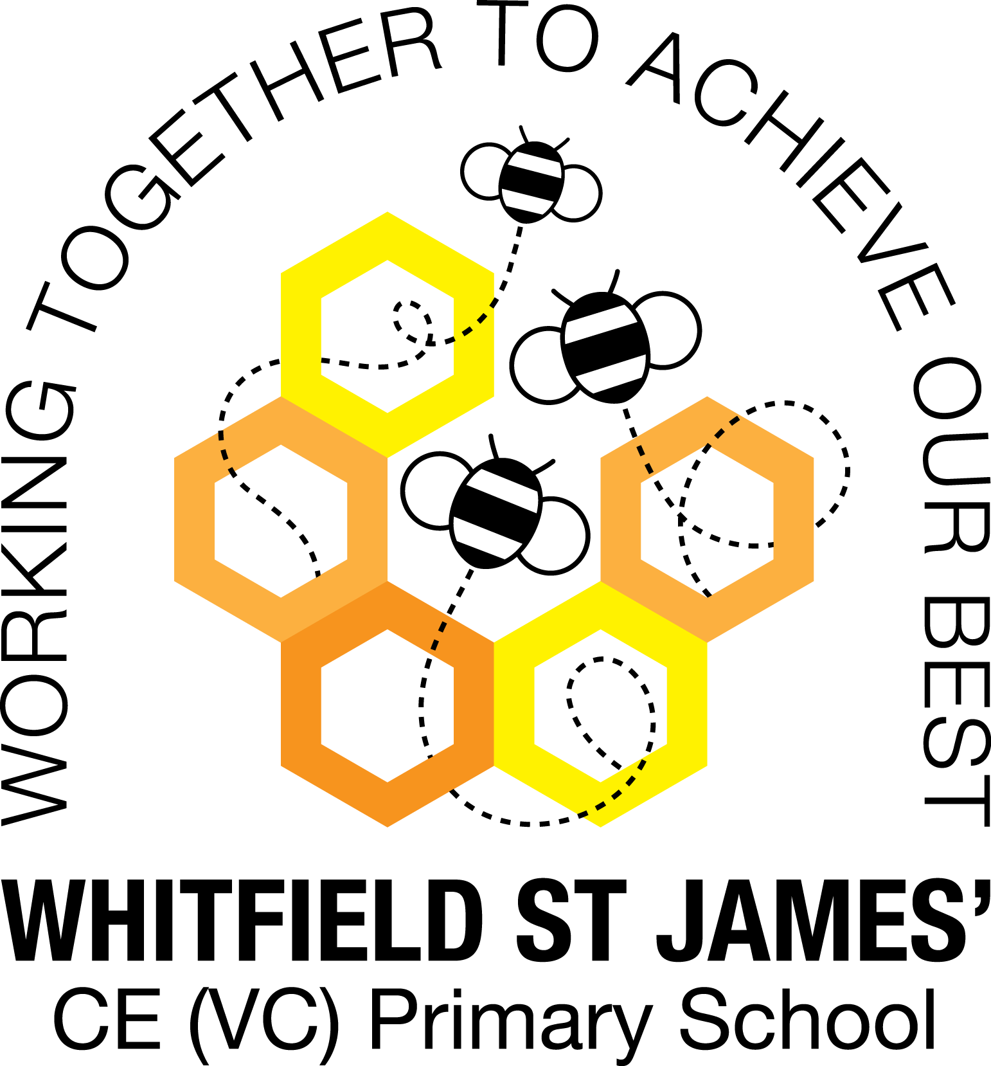

Here is a snapshot of some of the activities we have completed in our class this week. This snapshot may not contain all of the lessons and activities the children have been involved in, but will provide you with an idea of what we have done this week in Azalea class!

If you have any questions or need anything, please don’t hesitate to email me on the class email – [azalea@st-james.derbyshire.sch.uk](mailto:azalea@st-james.derbyshire.sch.uk) Mr Hannan

|  |  |
| --- | --- |
| **Topic**: Beast creator | **Week commencing**: 14th February 2022 |
| **Class book**: The Secret Garden |  |
| **Maths**  We have had another tricky fractions week in maths but everybody is doing so well and trying so hard. We have been sequencing fractions on a number line and realised it gets quite difficult when crossing over a whole number. We have also been ordering fractions below 1 and the children have demonstrated their knowledge of equivalent fractions and changing a denominator brilliantly. Well done everyone! | **English**  We have finished our poetry unit by writing a kennings poem about ourselves and also a character from out class book “Charlotte’s web”. We also continued our SPaG work by looking at compound adjectives and how mistakes in punctuation can cause ambiguity. We really enjoyed looking at real life mistakes on signs and using our grammar knowledge to correct them. |
| **Other lessons**  Finishing off our Beast creator topic. We have looked at food chains and food webs and created our own. We also looked at metamorphosis and different between complete and incomplete metamorphosis. | **Any other information**  We have now finished our swimming lessons and I would like to say how proud I am to have watched everyone improve so much, and more importantly gain confidence in the water. Well done everyone! This now means we will have 2 PE lessons a week; children must come in PE kit on Monday and Friday.  The first day back after the half-term break will not be a WOW day. Instead we will celebrate World book day on Thursday 3rd March where the children can come dressed as character from a book. |
| **Star of the week:** Jake  **Christian Value Award**: Koda (Wisdom) |