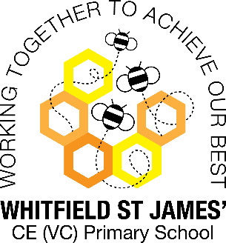Azaleas snapshot of the week

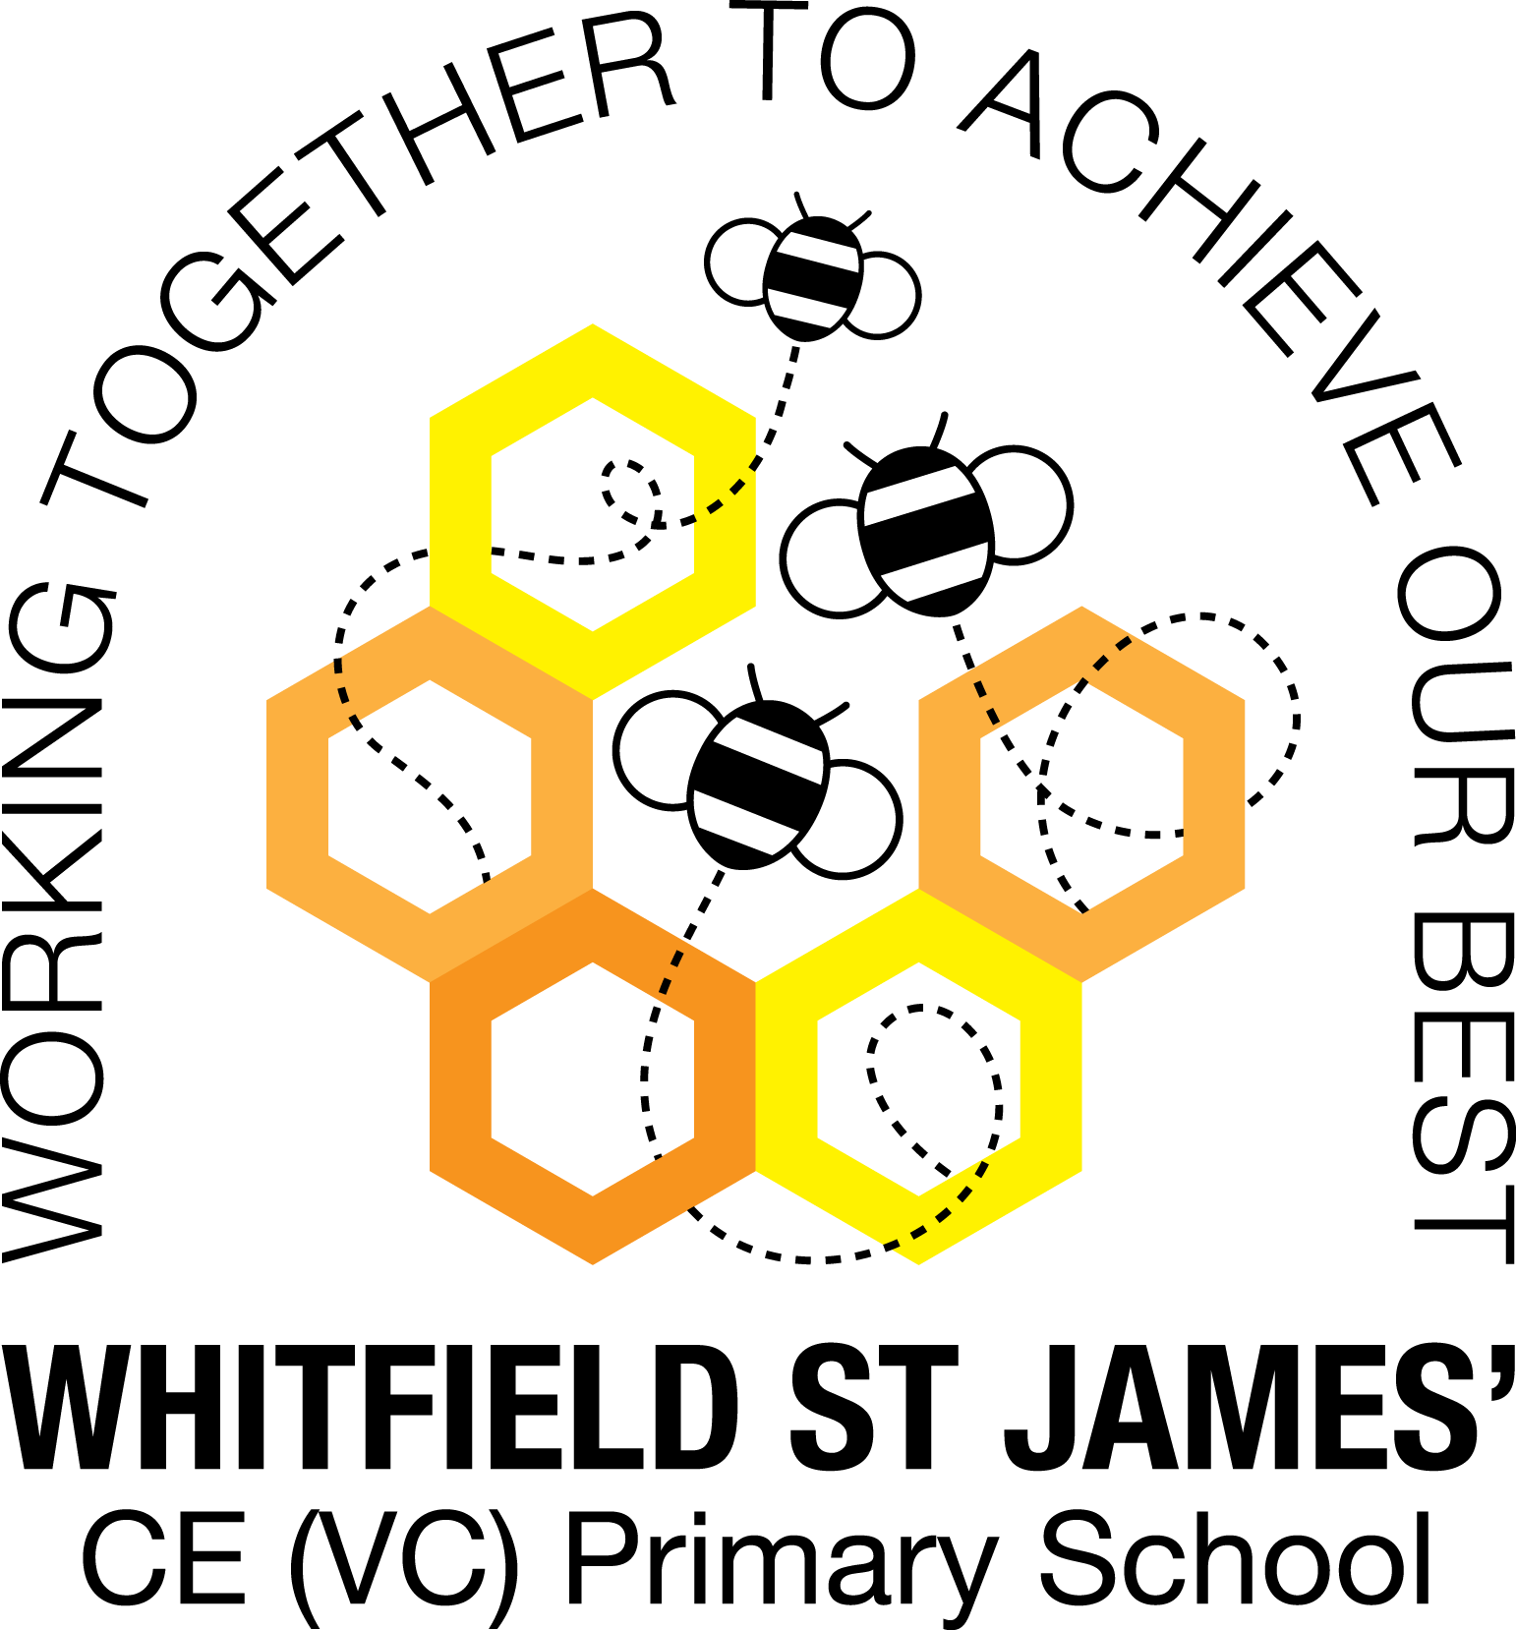

Here is a snapshot of some of the activities we have completed in our class this week. This snapshot may not contain all of the lessons and activities the children have been involved in, but will provide you with an idea of what we have done this week in Azalea class!

If you have any questions or need anything, please don’t hesitate to email me on the class email – [azalea@st-james.derbyshire.sch.uk](mailto:azalea@st-james.derbyshire.sch.uk) Mr Hannan

|  |  |
| --- | --- |
| **Topic**: Beast creator | **Week commencing**: 31st January 2022 |
| **Class book**: Charlotte’s web |  |
| **Maths**  We have now completed our block of learning on multiplication and division. This week the children really wowed me with their division skills (including remainders) and then we finished with a variety of reasoning challenges on both division and multiplication. We have just begun our fractions unit and the children have started recapping their knowledge. | **English**  This week with have been looking at limericks. We have been identifying the features/rules of a limerick and how it compares to other poems. The children are now writing their own limericks of their selected mini-beast and hopefully will be able to recite these to people at home once finished. |
| **Other lessons**  We continued looking at deadly mini-beasts and identified their locations using an atlas, something we found quite tricky. We then looked at why these animals are suited to their climate.  As February 1st was the Lunar new year, we have completed lots of work around the traditions seen around this time of year and learnt about the zodiac animals. | **Any other information**  Well done everyone for bringing in their smarties tubes! As a whole we are doing really well, keep it up!  A reminder that there are only 2 weeks left of this half term, meaning only 2 more swimming lessons. Once we come back in March our PE days will be Monday and Friday.  Thank you |
| **Star of the week:** Zack  **Christian Value Award**: Esmie (achievement) |