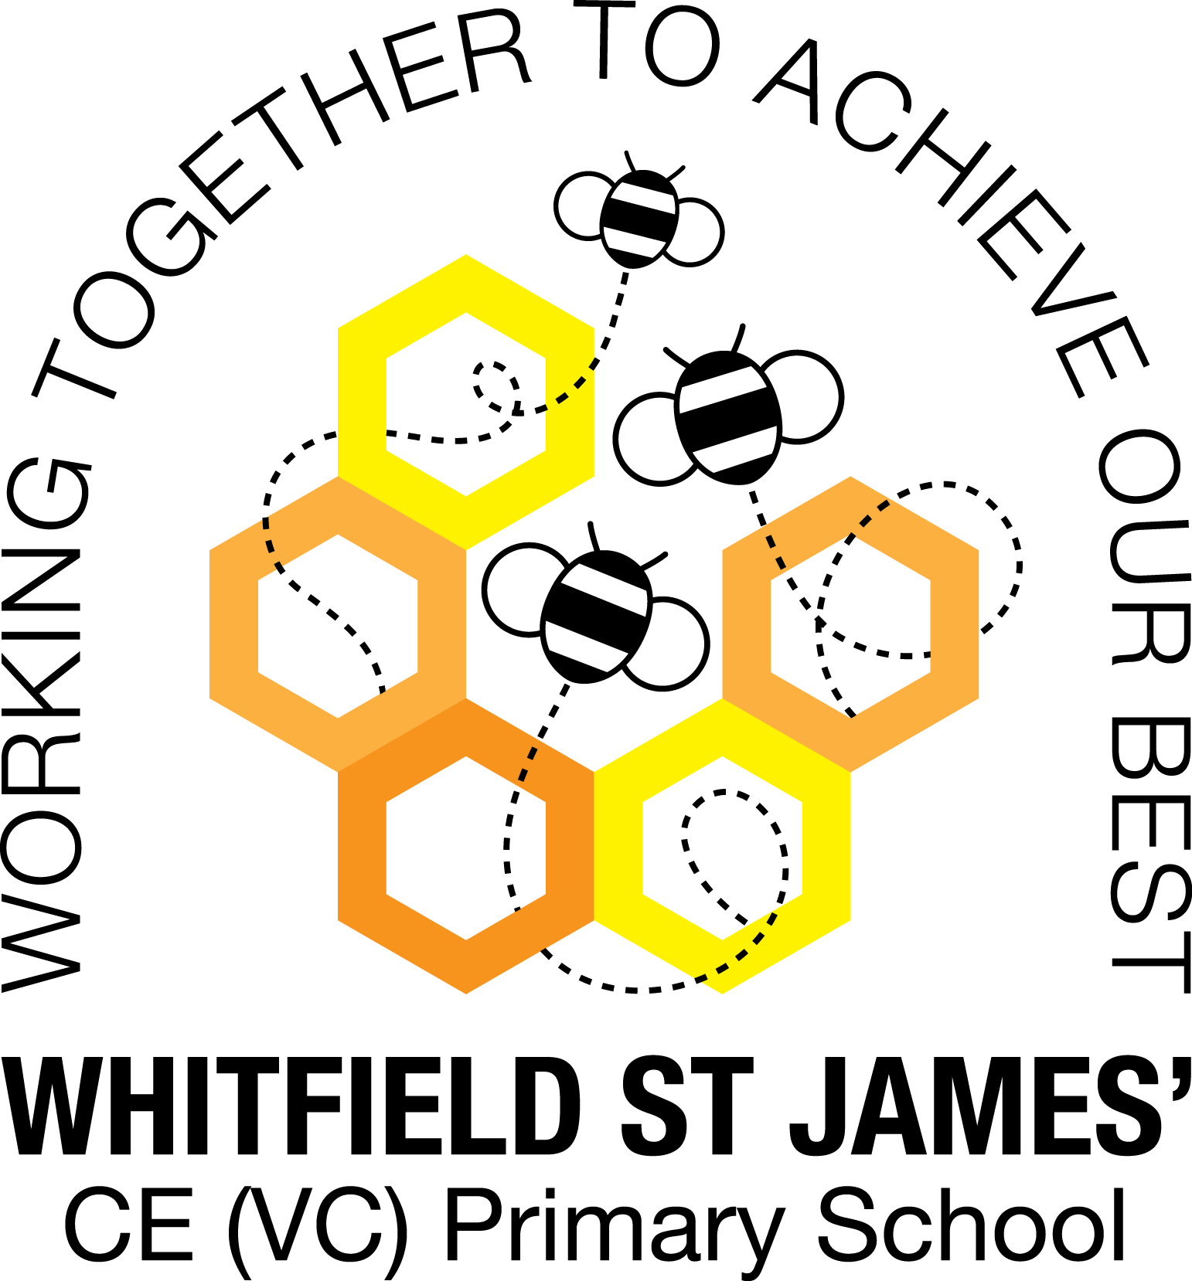

WHITFIELD ST JAMES’ CE (VC) PRIMARY SCHOOL

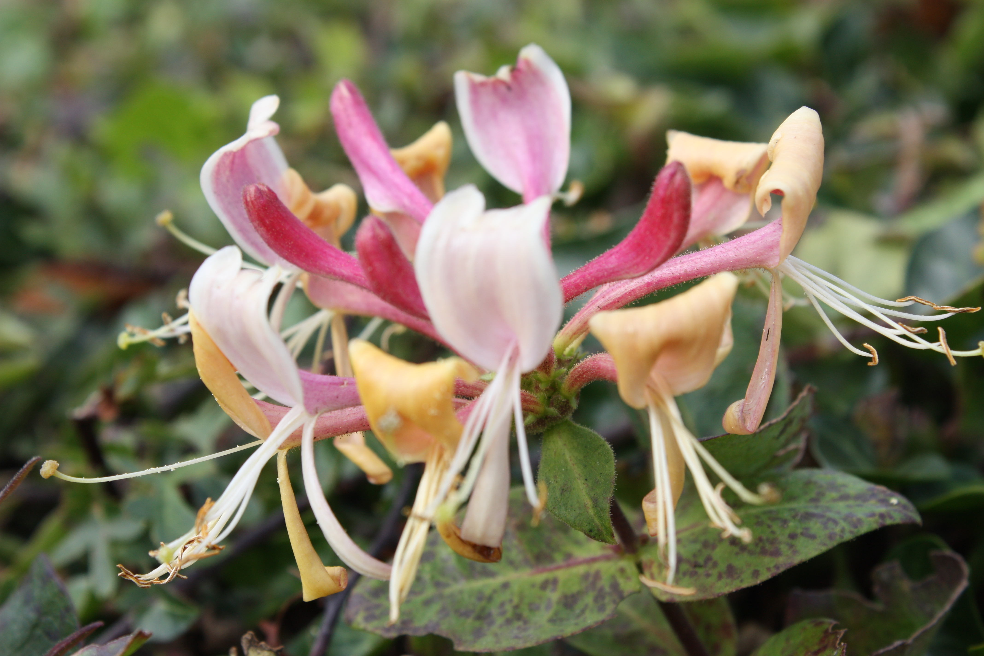

10th January 2022
Dear parents and carers of Honeysuckles class,
Happy new year to you all!
I hope that you have all had a lovely Christmas break and the children feel rested and ready to embrace 2022!
English and maths
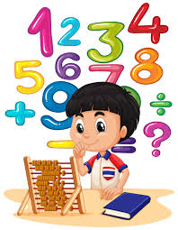
This term most of our English lessons will be based around our topic Bottoms, Burps and Bile. The children will be learning how to write a toothy fact file. They will also learn about idioms related to teeth and they will also be planning and writing a fantasy narrative based on a journey through the digestive system.
The children will be listening and responding to our class text ‘Demon Dentist’ by David Walliams.
We will start the term by working on a reading and writing unit based on the book ‘The Iron man’ by Ted Hughes. The children will explore the text and their writing outcomes will involve character description, action sequences, diary writing and instructions.
We will also continue to develop our knowledge of SPAG (spelling, punctuation and grammar rules) and will apply this to our writing.
In maths, we will be learning all about multiplication and division, particularly the formal methods to calculate using bigger numbers. Then the children will recap on finding the area of shapes and following this, we will begin to learn about unit and non-unit fractions.
Children will continue to be encouraged to log on to TT Rockstars to help them to learn their times tables or to keep working on their speed of recall of the multiplication facts. Please encourage your children to do this, as a secure knowledge of the tables helps the children in all areas of maths. Thank you for your support!
Topic
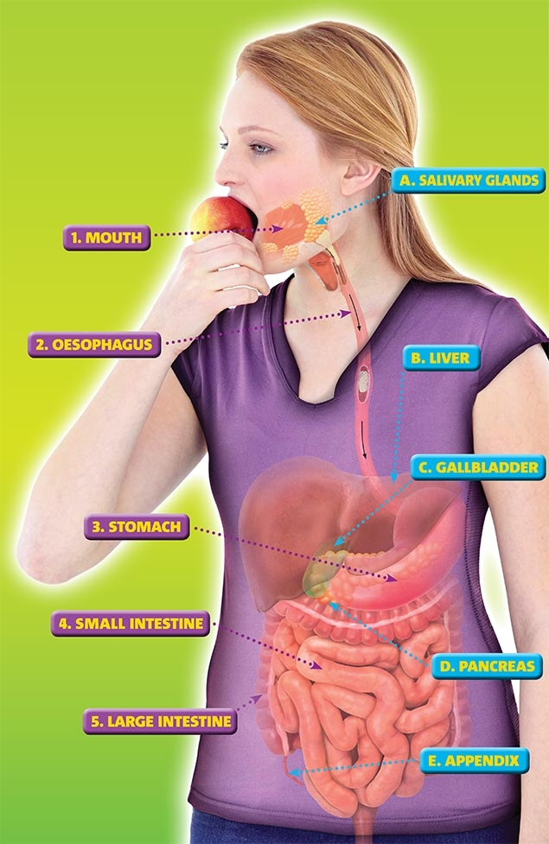
Our new topic is called Bottoms, Burps and Bile. It is a Science based topic where the children will be learning all about the digestive system, starting with teeth. Here is some more information:
Open wide – let’s take a look inside. We’re on a voyage of discovery to investigate the busy world inside your body. Do you have a toothy grin or a winning smile? Take dental impressions and test the effects of sugary substances on your pearly whites. Follow a tasty morsel as it makes its way through your digestive system, helped by some mouth-watering saliva ... and don’t forget the importance of good hygiene at both ends. And whilst we’re talking business, could you recognise an animal just by its poo? Are you brave enough to take the challenge? Make a working model of the digestive system and use it to persuade others to eat healthily. Learn how to look after this marvellous belching, squelching, mixture making machine we call our body.
I am looking forward to our wow day to launch the topic on Monday 10th January! Accompanying this newsletter is a knowledge organiser about the topic, which you can read with your child, to find out what we are going to be learning about over the course of the term. Also accompanying the newsletter is a home learning guide, which contains some suggested activities that your child can do at home, as well as recommended reading list around this topic. Any work done can be returned to school on the last Monday of term so that we can look at it over the last couple of days of term.
Other subjects
Honeysuckles will continue to be taught by Mrs Purdy on Tuesday afternoons, which is my afternoon out of class. She will be continuing to teach them RE, German and some PSHE.
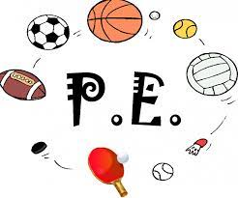
PE
Your child will still need to come in to school in their PE kit on Monday each week. Please could their kit be in line with our uniform policy, which is a plain white t-shirt or polo shirt, plain black shorts, plain black jogging bottoms and trainers. It may be a good idea for anyone with pierced ears to leave their earrings out on PE days to save them having to take them out or if your child struggles to remove their earrings, they can tape them over (tape will not be provided by school). We will continue to swim on Thursday mornings.
The first session will be on Thursday 20th January and the final session will be on the 17th February. (The children will not need to come in their PE kit on any other day in the first week of term as we will squeeze in a session outside in our uniform and coats.)
Thank you for your support with getting your children to school a little earlier each Thursday. We will continue our good routine of walking down and getting changed quickly. Please continue to make sure your child has a warm/ waterproof coat and sensible walking shoes and a healthy snack and drink.
Homework
We will continue with our homework routine - remember homework will be given out on a Friday and will be due in on the following Thursday, when children will bring their homework books in to school for their work to be marked. Children will be provided with maths homework, spelling homework and they will also be expected to read at least five times a week, and for their reading to be recorded in their reading record.
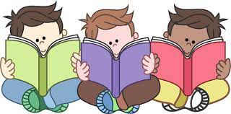
Reading
Your child will continue to be provided with a reading book in line with their reading age. In class, children will have access to books off our reading shelves as well as library books (which are brought in to the classroom for children to access) and we will also have our 50 Reads Challenge books in our reading treasure chest. These books are specific to Y4/5, and the children are encouraged to read as many, ideally all, of the books during their time in Y4/5. It is lovely to see how much the children are enjoying reading these books. Thank you for your support in encouraging your child to read! Please encourage your child to tick off the treasure chest books they have read on the list in their homework book.
I hope that you have found this information useful. I am sorry that some of it is repeated. If you ever need to contact me, please don’t hesitate, you can phone school or can email me directly on honeysuckle@st-james.derbyshire.sch.uk
Thank you for your support. Best wishes,
Mrs Collins

