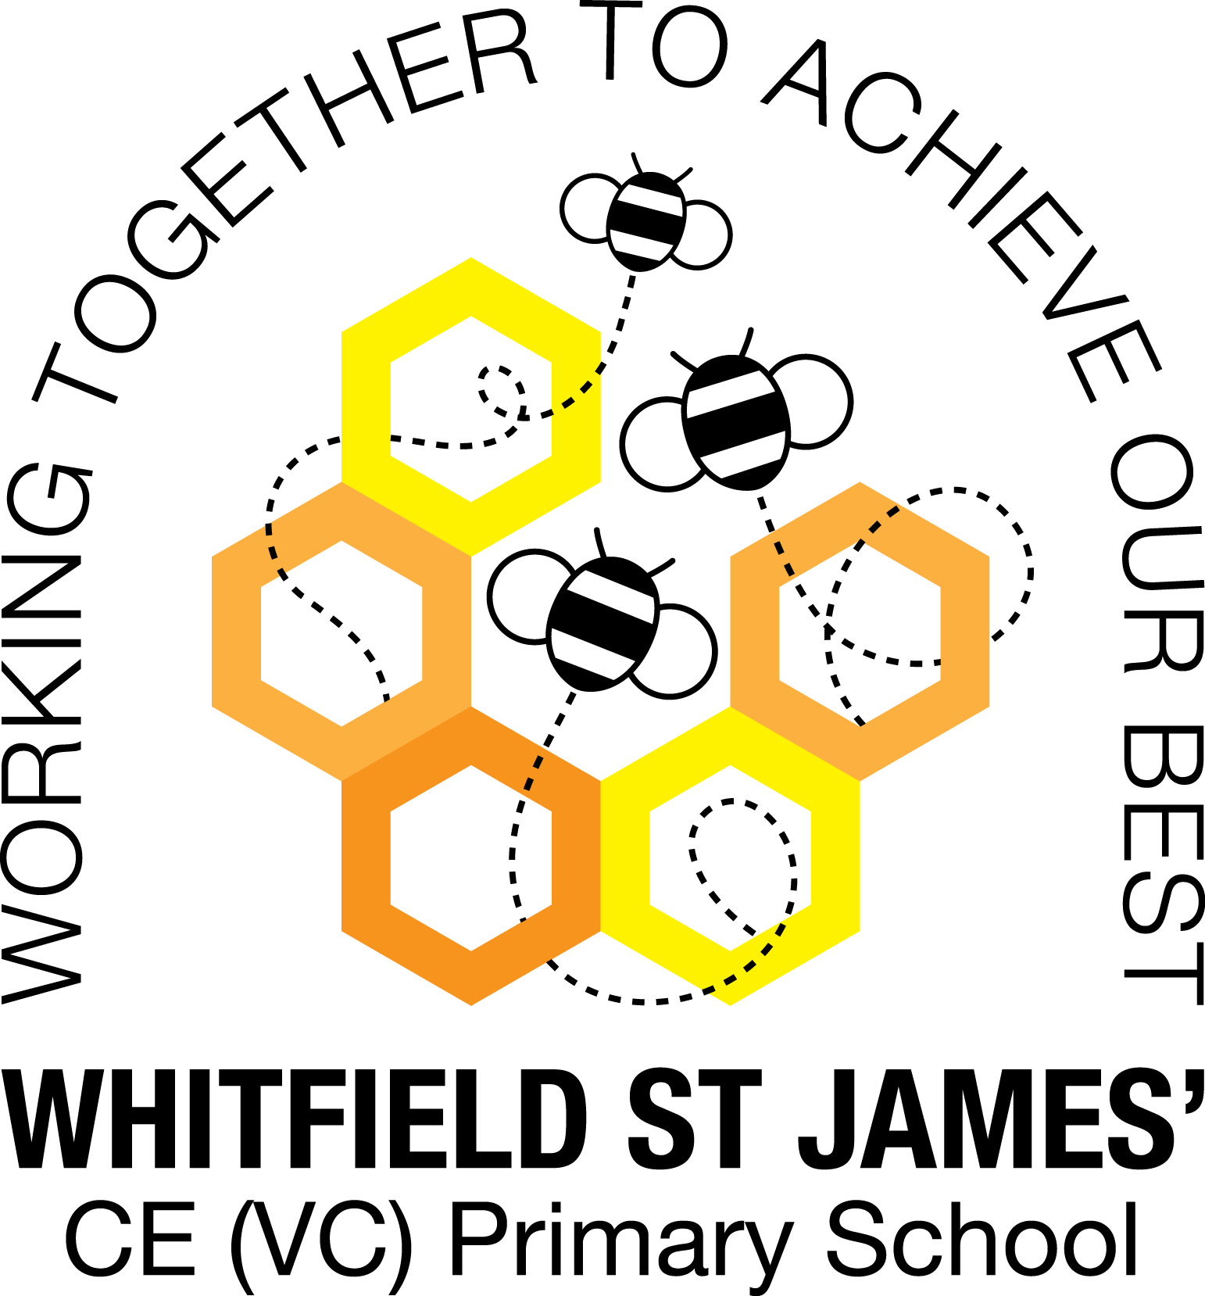

WHITFIELD ST JAMES’ CE (VC) PRIMARY SCHOOL

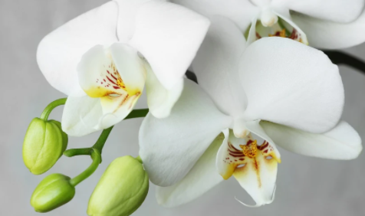

10th January 2021
Dear parents and carers of Orchid class,
I hope that you have all had the most wonderful Christmas break. We had such a lovely Autumn term here in Orchid class and I can’t wait to see what the Spring term brings.
English and maths
This term our English lessons will be based around our topic ‘Darwin’s Delights’.
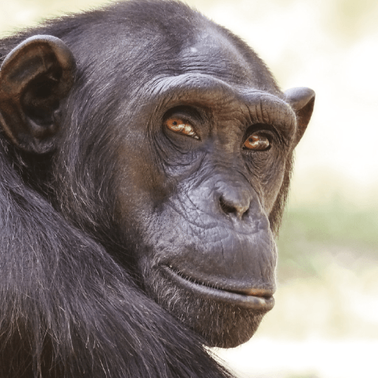
We’re off on an exciting expedition with Charles Darwin and his crew on HMS Beagle. Can you trace his route across the vast ocean? Stop at the magical Galápagos Islands to see the amazing species that helped Charles Darwin to develop his theory of evolution by natural selection. Do you know what’s so special about a lava lizard, or why the blue-footed booby has blue feet? See how animals adapt to their environments over time and meet some of the world’s greatest explorers and naturalists. Imagine how humans will evolve in millions of years. It’s a scary thought. Ready to trace the origin of species? Let’s set sail.
We will be studying diaries, letters and explanation texts in our English lessons. We will also continue to develop our knowledge of SPAG (spelling, punctuation and grammar rules) and will apply this to our writing. In maths, we will finish our unit of work about fractions, focusing on adding, subtracting, multiplying and diving fractions. We will then go on to learn about decimals and percentages. I have seen a huge improvement in Orchid Class’ speed in recalling times tables but children will continue to be encouraged to log on to TT Rockstars to help them to learn their times tables or to keep working on their speed of recall of the multiplication facts. Please encourage your children to do this, as a secure knowledge of the tables helps the children in all areas of maths. Thank you for your support!
Topic
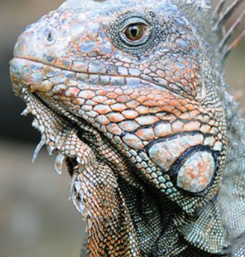
Our new topic is called ‘Darwin’s Delights’ and it teaches children about the man himself; the Galapagos Islands which he visited; the fascinating animals that he studied there along with the theories he concluded. This topic follows nicely on from our last topic as we delve a little further into evolution and inheritance. Accompanying this newsletter is a knowledge organiser about the topic, which you can read with your child, to find out what we are going to be learning about over the course of the term. Also accompanying the newsletter is a home learning guide, which contains some suggested activities that your child can do at home, as well as recommended reading around this topic. Any work done can be returned to school on the last Monday of term so that we can look at it over the last couple of days of term.

Other subjects
Orchid Class will continue to be taught by Mr Doyle on Friday afternoons. For PSHE, we will be continuing to follow Derbyshire’s recommended scheme - PSHE Matters. Throughout the year, we will be looking at friendships, money, relationships, keeping mentally and physically healthy as well as taking responsibility and exploring emotions. In our RE lessons, we will be following the Derbyshire Agreed Syllabus for RE and also the diocese-recommended scheme ‘Understanding Christianity’. We will also be exploring special days, festivals and significant people during our lessons and daily collective worship in class. We will also continue to learn German.
PE
As mentioned above, your child will need to come in to school in their PE kit on Monday and Friday each week. Please could their kit be in line with our uniform policy, which is a plain white t-shirt or polo shirt, plain black shorts, plain black jogging bottoms and trainers. It may be a good idea for anyone with pierced ears to leave their earrings out on PE days to save them having to take them out, or if your child struggles to remove their earrings, they can tape them over (tape will not be provided by school).
Homework
Homework will be given out on a Friday and will be due in on the following Thursday, when children will bring their homework books in to school for their work to be marked. Children will be provided with maths homework, spelling homework and they will also be expected to read at least five times a week, and for their reading to be recorded in their reading record. Homework will sometimes be set on SATs Companion, which is an online programme which offers maths and English support for Y6 children (your child’s login details are in their homework book). We will increase our usage of this over the year as we head closer to the SATs window (May), to provide the children with support with their learning.
In January, we will be sending the children home with SATs revision booklets that they can use to help them to prepare for their end of key stage assessments. SATs are due to take place on w.b. 9th May and they consist of SPAG (spelling, punctuation and grammar), reading and maths papers. It will be the first time in two years that the assessments have taken place due to the pandemic, but we are expecting them to go ahead! Scores are released to schools around mid-July and will be recorded in your child’s report, which will be sent home around this time. There is no formal test for writing, instead year 6 teachers moderate the children’s work that they produce in their books and we teacher assess them from this. Your children will be well prepared for their end of key stage assessments from their daily teaching from the experienced year 6 staff. There is nothing for them to worry about!
Reading
Your child will continue to be provided with a reading book in line with their reading age. In class, children will have access to books off our reading shelves as well as library books (which are brought in to the classroom for children to access) and we will also have our 50 Reads Challenge books in our reading treasure chest. These books are specific to Y5/6, and the children are encouraged to read as many, ideally all, of the books during their time in Y5/6. It is essential that those children who are free readers are reading books that are challenging enough for their age, and that they are accessing a wide range of genres and authors, and the 50 Reads Challenge is perfect for this! It is lovely to see how much the children are enjoying reading these books. Please encourage your child to read at home 5 times a week and write this into their reading diary. I noticed a huge difference in understanding and using vocabulary last term as a result of the texts that children have been reading .Thank you for your support in encouraging your child to read!
I hope that you have found this information useful, and I look forward to getting to know you and to meeting you all at parents’ evening. If you ever need to contact me, please don’t hesitate, you can phone school or can email me directly on orchid@st-james.derbyshire.sch.uk
Thank you for your support.
Best wishes,
Miss Kuczaj

