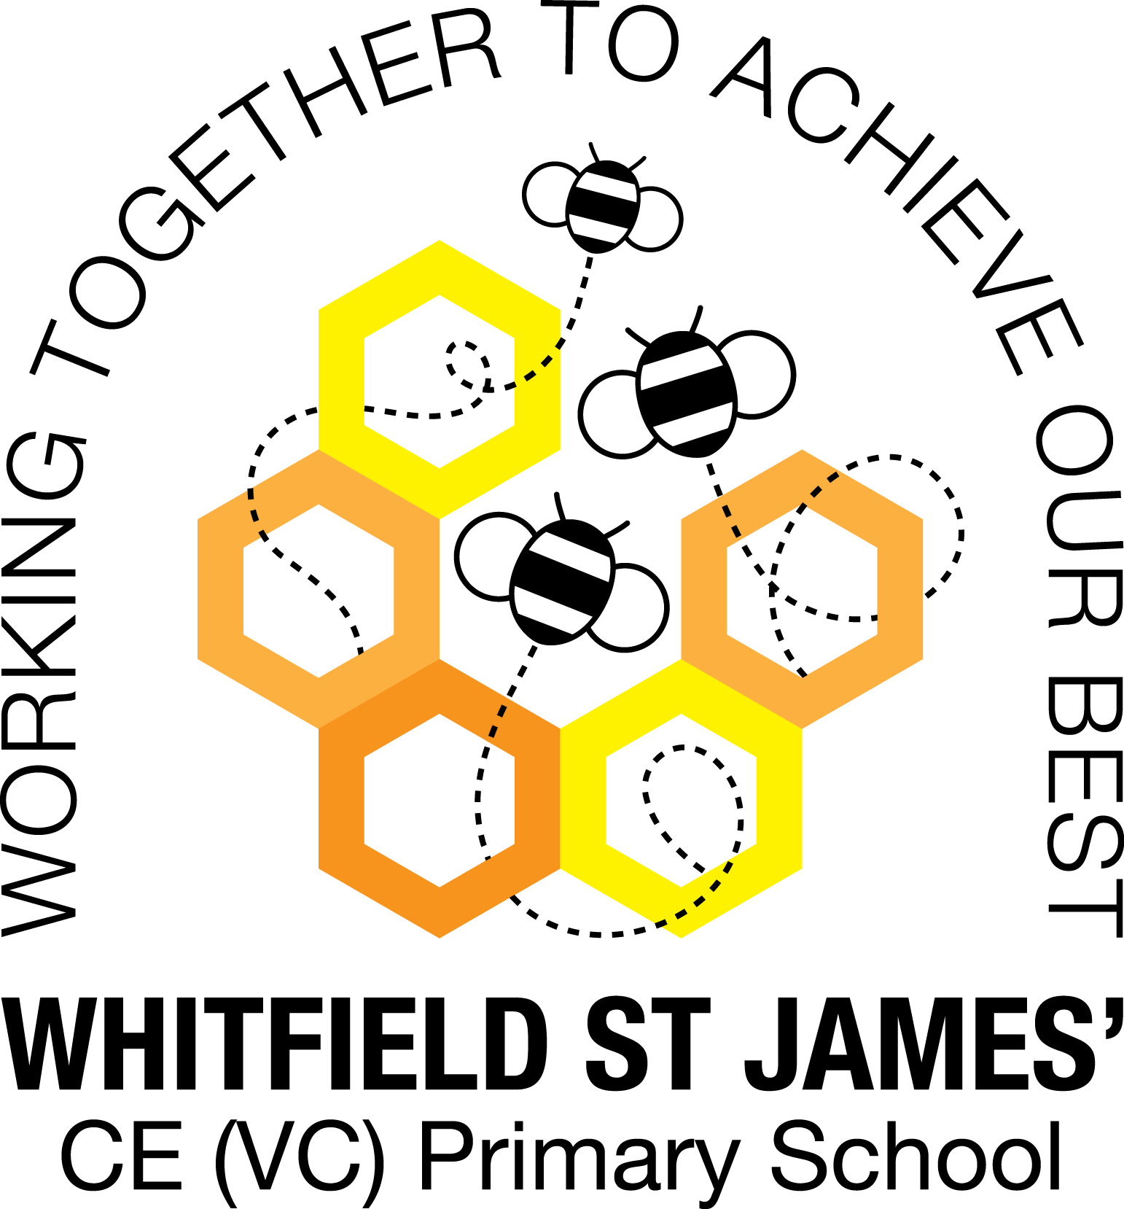

WHITFIELD ST JAMES’ CE (VC) PRIMARY SCHOOL

Whitfield St James’ Maths Context Statement

At Whitfield St James’ Primary School we shape our maths curriculum to ensure it is fully inclusive to every child regardless of their learning needs. We strive to embed the vocabulary, knowledge, skills and processes that children require to allow them to use and apply their mathematics learning. We endeavour to not only develop the skills and understanding that are required for later life, but also to foster an enthusiasm and fascination about maths itself.

Intent
The 2014 National Curriculum for maths aims to ensure that all children:

• Become fluent in the fundamentals of mathematics, including through varied and frequent practice with increasingly complex problems over time, so that pupils develop conceptual understanding and the ability to recall and apply knowledge rapidly and accurately.
• Reason mathematically by following a line of enquiry, conjecturing relationships and generalisations, and developing an argument, justification or proof using mathematical language.
• Can solve problems by applying their mathematics to a variety of routine and non-routine problems with increasing sophistication, including breaking down problems into a series of simpler steps and persevering in seeking solutions.

At Whitfield St James’ Primary School our aim is to increase pupil’s confidence in maths, allowing them to express themselves and their ideas using the language of maths with confidence and assurance.

Implementation
At Whitfield St James’ Primary School we teach maths in a way that:

• Creates a nurturing and exciting environment in which children want to learn maths.
• Promotes the acquisition of vocabulary, concepts and skills in a carefully structured way, allowing children to build on prior learning.
• Allows time for conversations in order to develop mathematical vocabulary, thus strengthening reasoning skills.
• Challenges children, encouraging them to take risks in their learning.
• Develops mental calculation strategies.
• Delivers maths in line with the National Curriculum guidelines.

To ensure consistent coverage across the curriculum we use the White Rose Maths Hub Scheme of Learning, and supplement it with resources from Classroom Secrets and TT Rockstars.

EYFS – The Early Years curriculum is followed and children develop number skills through studying the Specific Area Maths – Number. Children are taught to count reliably with numbers from one to 20. They are taught to place them in order and say which number is one more or one less than a given number. They learn about quantities of objects. They add and subtract two single-digit numbers. They learn to count on or back to find an answer. They solve problems including problems with doubling, halving and sharing.
Children also learn about shape, space and measure as the other aspect to the Specific Area of Maths. Children are taught to use everyday language to talk about size, weight, capacity, position, distance, time and money. They are taught to compare quantities and objects and to solve problems. They are taught how to recognise, create and describe patterns. They are taught to explore the characteristics of everyday objects and shapes and use mathematical language to describe them.

Key Stage 1 - In Key Stage 1 the main focus of maths teaching is to ensure that pupils develop a confidence and mental fluency with whole numbers, counting and place value. This involves working with numerals, words and the four operations including practical resources.
Pupils are given many opportunities to develop their ability to recognise, describe, draw, compare and sort different shapes and use the related correct mathematical vocabulary.
Children are also taught to use a range of measures to describe and compare different quantities such as length, mass, capacity/volume, time and money.
By the end of Year 2 the expectation of the curriculum is that pupils will know their number bonds to 20 and understand place value. Pupils should also be able to read and spell mathematical vocabulary at a level consistent with their increasing word reading and spelling knowledge.

Key Stage 2 - The main focus of maths teaching in Lower Key Stage 2 is to ensure that pupils become increasingly fluent with whole numbers and the four operations including number facts and place value. Pupils are taught to develop efficient written and mental methods for calculation and can perform these with increasing confidence with larger numbers.
Pupils are taught to solve a range of problems in line with the programmes of study in the National Curriculum.
Pupils are taught and encouraged to learn their multiplication tables by the end of Year 4.
They should read and spell mathematical vocabulary correctly and confidently, using their growing word reading knowledge and their knowledge of spelling.

The main focus of Maths teaching in Upper Key Stage 2 is to ensure that pupils extend their understanding of the number system and place value to include larger integers. This will develop the connections that pupils make between multiplication and division with fractions decimals, percentages and ratio.
Pupils are taught to develop their ability to solve a wider range of problems with increasingly demanding efficient methods for mental and written calculation.
By the end of year 6, pupils should be fluent in written methods for all four operations, including long multiplication and division, and in working with fractions, decimals and percentages.
They should read, spell and pronounce mathematical vocabulary correctly.
We encourage a love of mathematics in school through enrichment days such as TT Rockstars Day and participating in challenges such as White Rose Maths Barvember.

Impact
The successful approach to teaching maths at Whitfield St James’ Primary School has led to good attainment by our children. Through carefully-planned maths lessons, which build on previous learning, children develop resilience in their approach to problem solving; they are quick to recall facts and are able to make connections in maths. This allows children to master mathematical concepts as they can use mathematical language to explain their ideas in multiple ways and can independently apply the concept to new problems in unfamiliar situations.

We monitor the impact of the maths curriculum in the following way:

• Through learning walks that are conducted by the maths leaders, headteacher, deputy headteacher and a governor, with feedback given to members of staff.
• Analysis of EYFS data; Key Stage 1 and Key Stage 2 SATs results by the maths leaders, with members of the SLT and with the Governing Body.
• Termly Cornerstones maths assessments that enable us to track the progress and attainment of individuals and groups of learners.
• Book monitoring targeted at seeing the development of key maths skills.
• Pupil voice which allows us to understand the learning attitudes towards maths at Whitfield St. James’.

