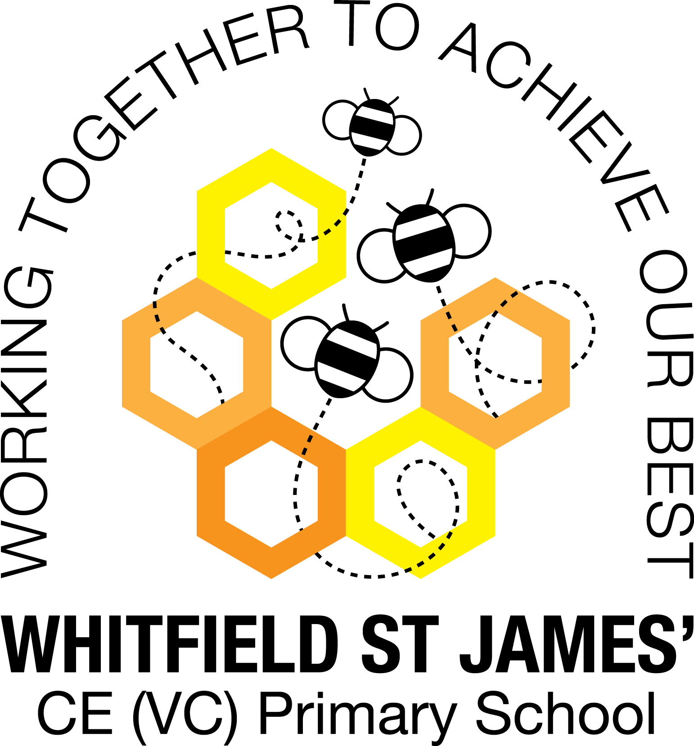

WHITFIELD ST JAMES’ CE (VC) PRIMARY SCHOOL

Whitfield St James’ English Context Statement

At Whitfield St James’ Primary School we shape our English curriculum to ensure it is fully inclusive to every child regardless of their learning needs. Our aims are to fulfil the requirements of the National Curriculum for English; providing a broad, balanced and differentiated curriculum which teaches pupils to speak and write fluently so that they can communicate their ideas and emotions to others and through their reading and listening, others can communicate with them. Through our topic based approach, we aim to provide enrichment opportunities across the curriculum from which children can express themselves using the spoken and written word.

Intent
The overarching aim for English in the National Curriculum is to promote high standards of language and literacy by equipping pupils with a strong command of the spoken and written word, and to develop their love of literature through widespread reading for enjoyment. At Whitfield St James’ Primary School we shape our English Curriculum to ensure it is fully inclusive to every pupil regardless of their learning needs. Following the National Curriculum, we aim to ensure that all pupils:

• read easily, fluently and with good understanding
• develop the habit of reading widely and often, for both pleasure and information
• acquire a wide vocabulary, an understanding of grammar and knowledge of linguistic conventions for reading, writing and spoken language
• appreciate our rich and varied literary heritage
• write clearly, accurately and coherently, adapting their language and style in and for a range of contexts, purposes and audiences
• use discussion in order to learn; they should be able to elaborate and explain clearly their understanding and ideas
• are competent in the arts of speaking and listening, making formal presentations, demonstrating to others and participating in debate.

Implementation
At Whitfield St James’ Primary School, we understand that children need a high level of English skills to be able to hold their place in society. We teach all pupils to read, write and speak fluently so that they can communicate their ideas and emotions to others.
Reading
EYFS
The Early Years framework is adhered to and children develop reading skills through studying the specific area Literacy – Reading. Children are taught to read and understand simple sentences. They use phonic knowledge to decode regular words and read them aloud accurately. They also read some common irregular words. They are taught to demonstrate understanding when talking with others about what they have read.
Key stages 1 and 2
In the teaching of reading we follow the National Curriculum Programmes of Study for English that are set out year by year for Key Stage 1 and two-yearly for Key Stage 2.
The programmes of study for reading at key stages 1 and 2 consist of two dimensions:
- word reading
- comprehension (both listening and reading)

At Whitfield St James we focus on developing pupils’ competence in both dimensions; different kinds of teaching are needed for each.
Key Stage 1
Phonics teaching - During Year 1, teachers build on the work of EYFS, making sure that sound phonic teaching is in place. Children are taught to sound and blend unfamiliar printed words quickly and accurately using the phonic knowledge and skills they have learned. The ‘Little Wandle’ scheme for phonics is followed in Nursery, EYFS, Year 1 and Year 2, with further support give to children who need it when they transition to KS2.
Key Stage 2
In KS2, children are taught reading through a daily 30 minute reading lesson, which includes whole class reading lessons using shared texts.

Through the teaching of reading at Whitfield St James’ we teach children to read, to acquire knowledge and to build on what they already know.
In all classes in school, class reading books are read daily using a book taken from the Cornerstones reading spine, which links to the class topic. This ensures that the children have a diet of quality, age appropriate reading books throughout their time at school.
Children in all year groups also participate in the 50 Reads Challenge, which challenges them to read from a list of 50 books assigned to their year group, also to ensure that they receive a diet of recommended quality reading during their time in school.
Across the school, children are encouraged to develop their reading skills in foundation subject lessons, for example reading for information, reading religious stories in RE etc.
We embrace any reading enrichment opportunities to further promote a love of reading in school, for example, Drop Everything and Read Week, book fares, World Book Day.

Writing
EYFS
In the Early Years, the Early Years Framework is adhered to and children develop writing skills through studying the specific area Literacy – Writing. Children use their phonic knowledge to write words in ways which match their spoken sounds. They also write some irregular common words. They write simple sentences which can be read by themselves and others. They learn to spell some words correctly and are encouraged to write other words that are phonetically plausible.

Key Stages 1 and 2
In Year 1, pupils’ writing develops at a slower pace than their reading due to the need to encode the sounds they hear in words and the need to develop the physical skill of handwriting. They also need to learn how to organise their ideas in their writing.
At Whitfield St James’ Primary School we follow the programmes of study (from the National Curriculum 2014) for writing at key stages 1 and 2, which are constructed similarly to those for reading:

- transcription (spelling and handwriting)
- composition (articulating ideas and structuring them in speech and writing)

Teaching develops pupils’ competence in these two dimensions and in addition, pupils are taught how to plan, revise and evaluate their writing. These aspects of writing have been incorporated into the programmes of study for composition.
In the teaching of writing we follow the National Curriculum Programmes of Study for English that are set out year by year for Key Stage 1 and two-yearly for Key Stage 2, and we teach though a topic based approach, using the Cornerstones Curriculum.

Writing down ideas fluently depends on effective transcription: children follow spelling programmes in each year group (Little Wandle and No Nonsense Spellings) to help them to build on spelling words quickly and accurately through knowing the relationship between sounds and letters (phonics) and understanding the morphology (word structure) and orthography (spelling structure) of words.
Composition involves forming, articulating and communicating ideas, and then organising them coherently for a reader. As we use a Cornerstones Curriculum topic based approach, this is taught in conjunction with other subject knowledge e.g. geography, history or science. Children are taught to have an awareness of the audience, purpose and context, and an increasingly wide knowledge of vocabulary and grammar. Success criteria (Cornerstones Curriculum ‘checklists’) are used by children when they write, to help them to produce quality writing as appropriate to genre. They are also taught to edit their own work for clarity.

Spelling, Punctuation and Grammar
Spelling, Punctuation and Grammar is taught in context wherever possible, so that it is meaningful for the children.
There are occasions when discrete grammar and punctuation lessons are taught, as appropriate.
In EYFS and KS1, daily phonic lessons help children to learn spelling patterns. In KS2, NNS (No Nonsense Spelling) lessons take place three times a week.
Opportunities for teachers to enhance pupils’ vocabulary arise naturally from their reading and writing across the curriculum. As vocabulary increases, teachers should show pupils how to understand the relationships between words, how to understand nuances in meaning, and how to develop their understanding of, and ability to use, figurative language. They should also teach pupils how to work out and clarify the meanings of unknown words and words with more than one meaning.
Throughout the programmes of study, teachers teach pupils the vocabulary they need to discuss their reading, writing and spoken language. It is important that pupils learn the correct grammatical terms in English and that these terms are integrated within teaching.

Handwriting
Children are taught handwriting skills from Nursery to Year 6 and this helps children to develop a style of writing which is fluent, legible and eventually speedy. Handwriting skills are taught daily alongside the spelling/phonics lesson, using the spelling/phonics objectives that the children are working on. We use First Class Handwriting resources to teach handwriting, and display posters with the appropriate letter formation are displayed in classrooms across the school, and line guide posters which match the lines in children’s book are used on flipcharts by staff, to model the writing. The appropriate cursive font is used by staff on Word documents, so that it is modelled to children as much as possible.

Impact
The successful approach at Whitfield St James’ Primary School to teaching reading and writing results in a high quality, challenging and engaging English curriculum, which provides children with excellent communication skills. Through carefully planned English that links with termly topics, children learn how to read and write in different genres and to discuss and debate about a range of topical issues. Children understand the importance of being able to read and write to a high standard and appreciate the talents of different authors. Children at Whitfield St James’ overwhelmingly enjoy English, and this results in motivated learners. Monitoring the impact of our English curriculum is organised in the following way:
• Through learning walks conducted by both the KS1 and KS2 English leads, headteacher and deputy headteacher and governor, with feedback given to members of staff.
• Analysis of EYFS outcomes, Key Stage 1 and Key Stage 2 SATs data by the Senior Leaders and School Improvement Advisor, in conjunction with other relevant members of staff.
• Target Tracker data for assessment levels and progress information.
• Termly Cornerstones reading and SPAG tests that show the progress of individuals and groups of learners.
- Termly assessment of children’s writing that show the progress of individuals and groups of learners.
• Book trawls targeted specifically at identifying progress in comprehension skills and writing.
- Tracking of progress in phonics using Phonics Tracker and tracking of progress in spellings, as appropriate to year group.

• Pupil interviews, looking at pupils’ learning attitudes towards reading and writing.

