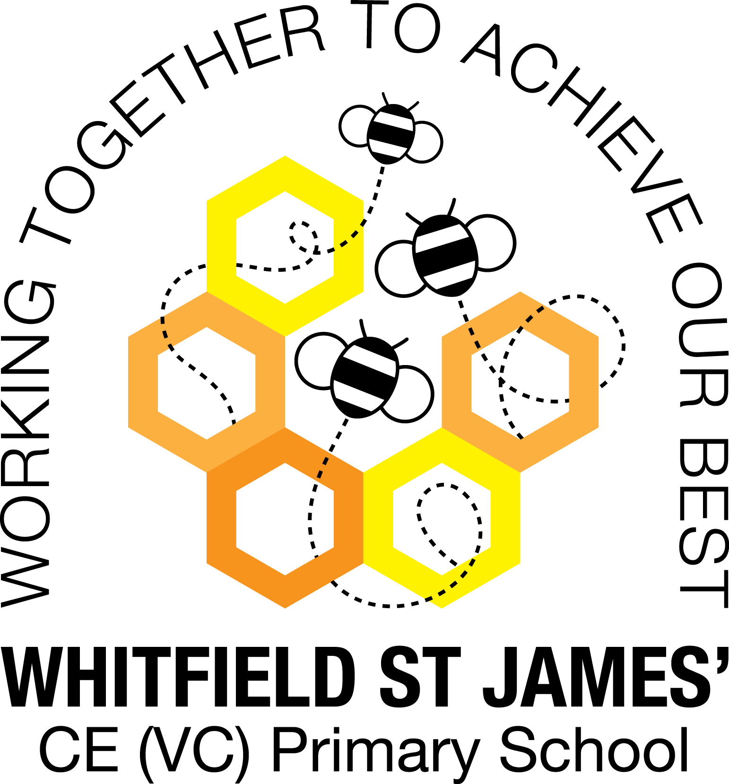

WHITFIELD ST JAMES’ CE (VC) PRIMARY SCHOOL

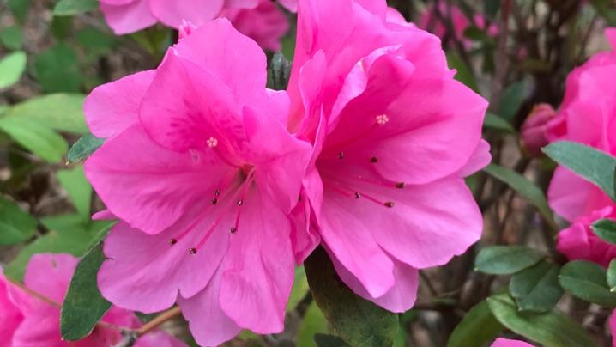

10th January 2022
Dear parents and carers of Azaleas class,
I hope that you have all had a lovely Christmas break. Last term was a huge success, the children all came out of their shells and really showed what they could do. Everybody has worked extremely hard, I hope this term will be just as enjoyable!
English and maths
This term our English lessons will be based around our topic ‘Beast Creator’. We will be using our knowledge of beasts to write instructions and advertisements, comic strips, limericks and kennings poems and fantasy narratives. We will also continue to develop our knowledge of SPAG (spelling, punctuation and grammar rules) and this is something we will focus on more, to help the children to apply these grammatical objectives to their writing.
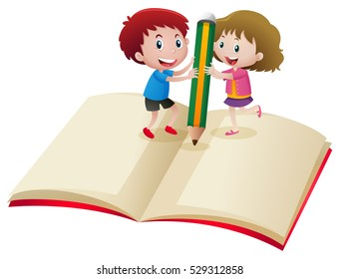
Maths this term covers lot of tricky aspects of maths. We will be looking at multiplication using the column method and division using the bus stop method, both of which are really important areas of maths and instrumental in preparing the children for their SATS next year. Following this, we will move onto fractions, which will include lots of new challenges which the children may not have faced before. Children will continue to be encouraged to log on to TT Rockstars to help them to learn their times tables or to keep working on their speed of recall of the multiplication facts. The number of children using TT Rockstars really dropped last half term so we need to encourage them to get back on it! Despite telling the time not being covered this half term, I suggest you keep an eye on your child’s ability to tell the time and support them where possible at home. Thank you for your support!
Topic
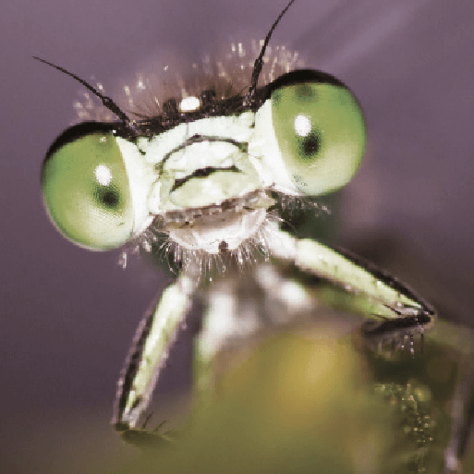
Our new topic is called ‘Beast Creator’ and this topic is a great opportunity to enjoy lots of science lessons! The children will be learning about lots of different bugs such as arachnids, insects, molluscs and myriapods. We will also gain an understanding of how to classify these animals and where they stand in the food chain. I am looking forward to our wow day to launch the topic on Monday 10th January. The children don’t need a costume but I am asking them to wear clothes they wouldn’t mind hunting for beasts in, rather than their uniforms getting dirty. Accompanying this newsletter is a knowledge organiser about the topic, which you can read with your child to find out what we are going to be learning about over the course of the term. Also accompanying the newsletter is a home learning guide, which contains some suggested activities that your child can do at home, as well as recommended reading around this topic. Any work done can be returned to school on the last Monday of term so that we can look at it over the last couple of days of term.
Other subjects
Azaleas will continue to be taught by Mrs Purdy on Wednesday afternoons, which is my afternoon out of class. She will be teaching them RE and German. For PSHE, we will be following Derbyshire’s recommended scheme - PSHE Matters. Throughout the year, we will be looking at friendships, money, relationships, keeping mentally and physically healthy as well as taking responsibility and exploring emotions. In our RE lessons, we will be following the Derbyshire Agreed Syllabus for RE and also the diocese-recommended scheme ‘Understanding Christianity’. We will also be exploring special days, festivals and significant people during our lessons and continuing with our daily collective worship in class.
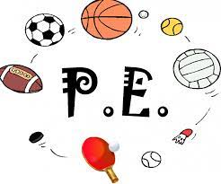
PE
Continuing from last half-term, your child will need to come in to school in their PE kit on Monday. Please could their kit be in line with our uniform policy, which is a plain white t-shirt or polo shirt, plain black shorts, plain black jogging bottoms and trainers. It may be a good idea for anyone with pierced ears to leave their earrings out on PE days to save them having to take them out, or if your child struggles to remove their earrings, they can tape them over (tape will not be provided by school). We will also be continuing our swimming lessons on Thursdays so the children will need appropriate swimming costumes and towels. Remember that once swimming ends, we will restart our Friday afternoon PE lessons, in addition to the Monday.
Homework
Homework will be given out on a Friday and will be due in on the following Thursday, when children will bring their homework books in to school for their work to be marked. Children will be provided with maths homework and spelling homework and they will also be expected to read at least five times a week, and for their reading to be recorded in their reading record. I urge the children to continue logging onto TT Rockstars, as I can track their progress online and it is really making a huge difference to them.
Reading
Your child will continue to be provided with a reading book in line with their reading age. In class, children will have access to books off our reading shelves as well as library books (which are brought in to the classroom for children to access) and we will also have our 50 Reads Challenge books in our reading treasure chest. These books are specific to Y5, and the children are encouraged to read as many, ideally all, of the books during their time in Y5. It is essential that those children who are free readers are reading books that are challenging enough for their age, and that they are accessing a wide range of genres and authors, and the 50 Reads Challenge is perfect for this! It is lovely to see how much the children are enjoying reading these books. Thank you for your support in encouraging your child to read!
I hope that you have found this information useful and if you ever need to contact me, please don’t hesitate - you can phone school or can email me directly on azalea@st-james.derbyshire.sch.uk
Thank you for your support.
Best wishes,
Mr Hannnan

