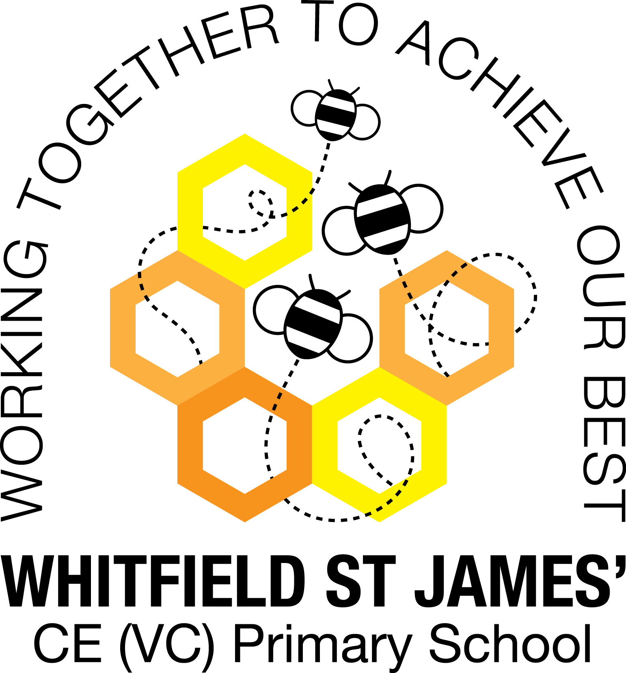

WHITFIELD ST JAMES’ CE (VC) PRIMARY SCHOOL

10th January 2022
Dear parents and carers of Aloe Vera class,
I hope that you have all had a magical Christmas and are feeling refreshed entering 2022. I am really looking forward to the term ahead and getting to know your children more.
Below is some general information as well as some more class-specific information to prepare you and your children for the Spring term. I apologise if some of this information is repeated; I know Mrs Madigan had the class very well organised!
English and maths
This term we will begin our English lessons by studying a film unit called ‘Dream Giver’, during which we will write a fantasy narrative using detailed description. The rest of our English lessons will be based around our topic ‘Heroes and Villains’ and we will be studying biographies, poetry (song lyrics, rap and riddles) as well as alternative fairy tales. The children will also listen and respond to our novel The Hundred and One Dalmatians by Dodie Smith. We will also continue to develop our knowledge of SPAG rules and will apply this to our writing. In maths, we will all begin by continuing with the multiplication and division unit. The Year 2 group will then look at statistics, properties of shape and fractions. The Year 3 group will look at money, statistics, length and perimeter and, finally, fractions. Children will continue to be encouraged to log on to TT Rockstars to help them to learn their times tables or to keep working on their speed of recall of the multiplication facts. I would be grateful if you could encourage your children to do this, as a secure knowledge of the tables helps the children in all areas of maths.
Topic
Our new topic is called ‘Heroes and Villains’ and it teaches children about fictional and non-fictional heroes and villains, both throughout history and in the modern day. Our topic will incorporate music (learning songs about heroes and villains as well as writing our own raps), PSHE (thinking about good deeds as well as exploring moral issues) and history (learning about heroes and villains in the past and how they have shaped the future) alongside many other subjects in our topic-based approach. Accompanying this newsletter is a knowledge organiser, which you can read with your child, to find out more about what we are going to be learning. There is also a home learning guide, which contains some suggested activities that your child can do at home, as well as recommended reading around this topic. Any work done can be returned to school on the last Monday of this half term so that we can look at it over the last couple of days.
Other subjects
Aloe Vera class will continue to be taught by Mrs Eccles on a Tuesday afternoon and Mrs Purdy on a Thursday afternoon, which are my two afternoons out of class. On Tuesdays Mrs Eccles will be teaching the class PE, RE and some PSHE and on Thursdays Mrs Purdy will be teaching the class MFL (German) and PE. In our RE lessons, we will continue to follow the Derbyshire Agreed Syllabus for RE and also the diocese-recommended scheme ‘Understanding Christianity’. We will also be exploring special days, festivals and significant people during our lessons and daily collective worship in class. In computing we will be continuing with our unit from Teach Computing and will be looking at using Microsoft Publisher to design a magazine. For PSHE, we will be following Derbyshire’s recommended scheme ‘PSHE Matters’ as well as continuing to use ‘R Time’ to support our learning.
PE
As mentioned above, your child will need to come in to school in their PE kit on Tuesday and Thursday each week. Please could their kit be in line with our uniform policy, which is a plain white t-shirt or polo shirt, plain black shorts, plain black jogging bottoms and trainers. It may be a good idea for anyone with pierced ears to leave their earrings out on PE days to save them having to take them out, or if your child struggles to remove their earrings, they can tape them over (tape will not be provided by school).
Home Learning
We will get back into the previous routine of setting homework every Friday and collecting it in the following Thursday. Your children will receive one piece of maths and one piece of spelling homework per week.
Children are also expected to read at least five times a week at home and for this to be recorded in their reading record.
As mentioned above, please see the home learning guide for ideas on supporting your child’s topic learning at home.
Parents of children in Year 2 will receive more information on the upcoming SATs in due course.
There are two things I have picked up on that I think would be really beneficial for all children to practise at home whenever there is a spare minute. The first one is learning to tie their shoelaces (if they can’t already) and the second one is to be able to write their full name correctly, understanding what their first, middle and last name is. Thanks for your support with this!
Reading
Your child will continue to be provided with a reading book in line with their reading age. In class, children will have access to books off our reading shelves as well as library books (which are brought in to the classroom for children to access) and we also have our 50 Reads Challenge books in our reading treasure chest. These books are specific to Y2/3, and the children are encouraged to read as many, ideally all, of the books during their time in Y2/3. It is lovely to see how much the children are enjoying reading these books. Thank you for your support in encouraging your child to read! Please encourage your child to tick off the treasure chest books they have read on the list in their homework book.
In other news, I would like to let you all know that I am expecting baby number 2 in May this year so unfortunately I won’t be seeing the year through with your lovely children. I will keep you informed when I know more about arrangements for this.
I hope that you have found this information useful. If you ever need to contact me, please don’t hesitate. You can phone school or can email me directly on aloevera@st-james.derbyshire.sch.uk
As always, thank you for your support. Best wishes,
Miss Graham

