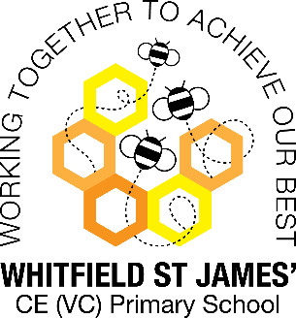Azaleas snapshot of the week

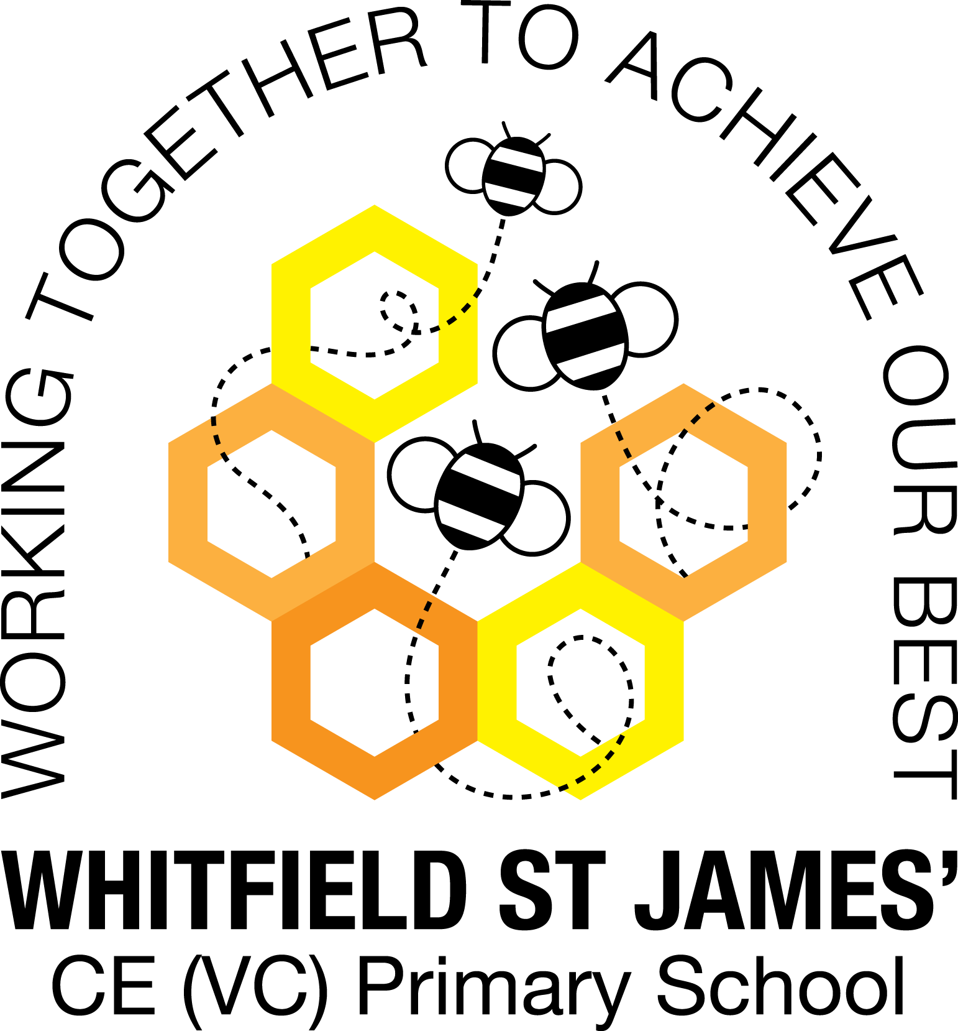

Here is a snapshot of some of the activities we have completed in our class this week. This snapshot may not contain all of the lessons and activities the children have been involved in, but will provide you with an idea of what we have done this week in Azalea class!

If you have any questions or need anything, please don’t hesitate to email me on the class email – [azalea@st-james.derbyshire.sch.uk](mailto:azalea@st-james.derbyshire.sch.uk) Mr Hannan

|  |  |
| --- | --- |
| **Topic**: Beast creator | **Week commencing**: 17th January 2022 |
| **Class book**: Charlotte’s web |  |
| **Maths**  We have continued our work on multiplication and have seen a real improvement this week, well done everyone. The children have worked their way up to 4-digit by 2-digit multiplication and have even tackled some reasoning and problem solving questions. It’s really important we keep practising, as this is such a useful skill to have across the maths curriculum. | **English**  Continuing our work on writing a thriller narrative, this week we have concentrated on how the weather, senses and noises can be used to help set a mood. We have then used these skills along with short snappy sentences and micro expressions to help build tension around our character’s subtle movements. |
| **Other lessons**  Within our topic we completed a science experiment around “Worm charming” we first made predictions on how many worms lived on our school field. We looked at what conditions worms like to live in and where we might find them. However, our actual experiment didn’t have great results (only charming 3 worms) which led to some great discussions as to why this might be, which the children really took a lot from. | **Any other information**  Just a reminder to encourage the children to regularly practise TT rockstars. They love going on it in school and hopefully we can get the same results at home. Thank you. |
| **Star of the week:** Blake  **Christian Value Award**: Nicola (resilience) |