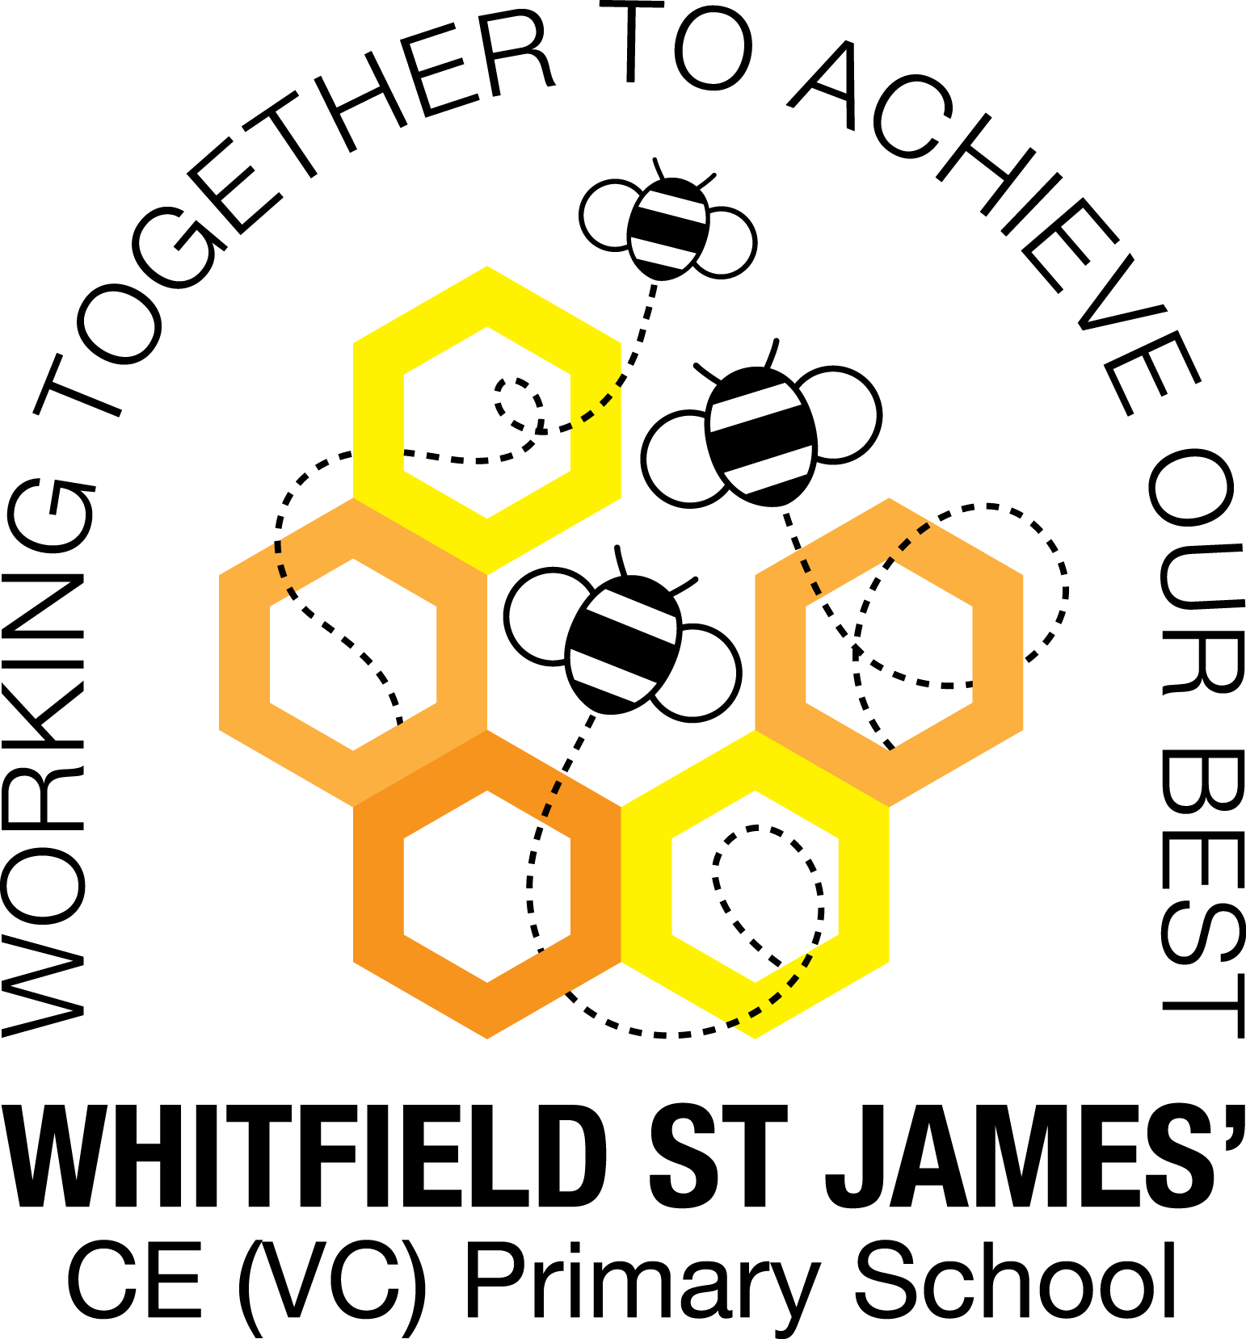
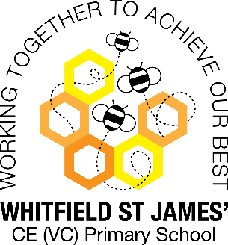
Tulips snapshot of the week

Here is a snapshot of some of the activities we have completed in our class this week. This snapshot may not contain all of the lessons and activities the children have been involved in, but will provide you with an idea of what we have done this week in Tulips class!
If you have any questions or need anything, please don’t hesitate to email us on the class email –tulip@st-james.derbyshire.sch.uk Mr Ford and Mrs Mackey.
Topic: Invasion and Warp and Weft | Week commencing: 6th December 2021
Guided Reading book: Grandad’s Island
Maths  This week we have been developing our knowledge of times tables. We have looked at different ways to use the 3 and 4 times table (Y3) and the 6 and 9 times table (Y4) to divide and multiply.  Challenge – Ask your children to count in multiples of 3 and 4 (Y3) or 6 and 9 (Y4). | English  This week we have been learning about how archaeologists work and their finds, particularly the Coppergate dig. We have been learning to record our work formally in the style of archaeological reports.  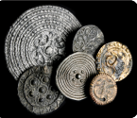
Other lessons  We have begun a mini topic on weaving, investigating yarns, textiles, designs and patterns that the people of the Dark Ages would have created. | Any other information  Please remember that Tuesday 14th December is our Christmas party day. Children can come in party clothes but please make sure their clothes and shoes are suitable for playing outside in winter weather too.  Please send in any finished ‘Treasure Chest’ books so they can be changed before the Christmas holidays.  Our ‘Wow Day’ will be the 10th January (the first day back!) more information to follow on next week’s snapshot  Please continue to send in any scraps of wool which we could use for our weaving project. Thank you very much.
Star of the week: Martha

Christian Value Award: Finlay - Friendship

