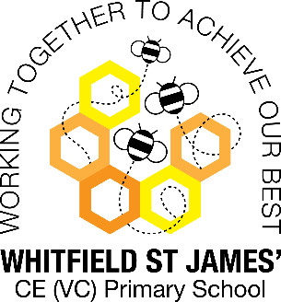Peonies snapshot of the week

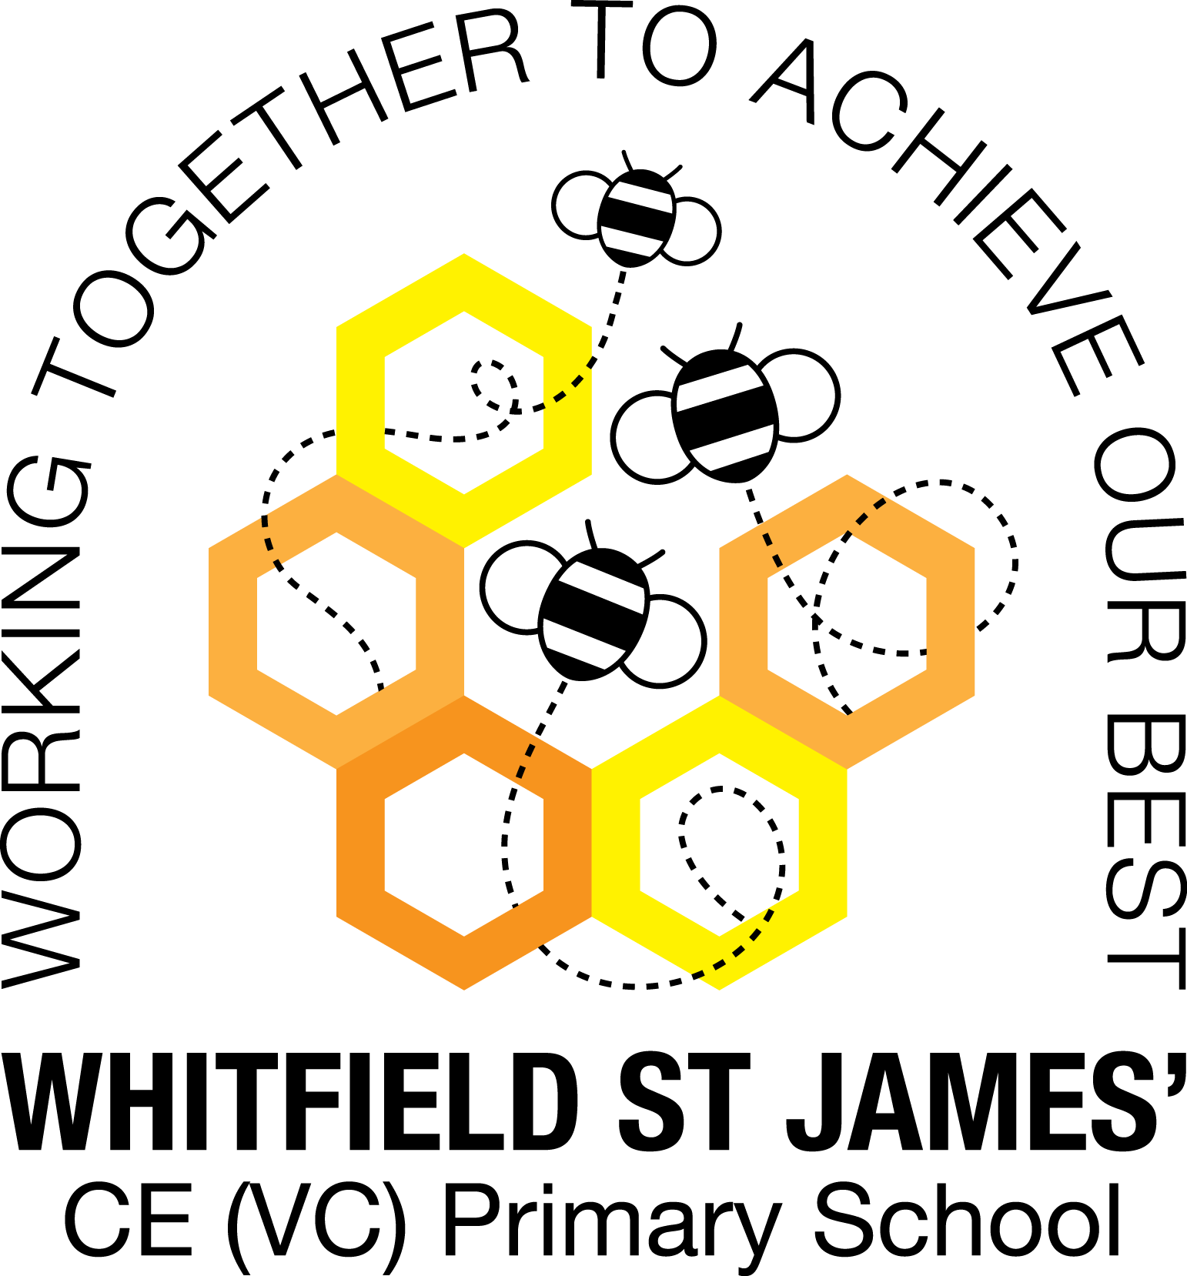

Here is a snapshot of some of the activities we have completed in our class this week. This snapshot may not contain all of the lessons and activities the children have been involved in, but will provide you with an idea of what we have done this week in Peonies class!

If you have any questions or need anything, please don’t hesitate to email me on the class email – [peonies@st-james.derbyshire.sch.uk](mailto:peonies@st-james.derbyshire.sch.uk) Miss Warburton

|  |  |
| --- | --- |
| **Topic**: Britain at War | **Week commencing**: 13th December 2021 |
| **Class book**: Carrie’s War by Nina Bawden |  |
| **Maths**  This week we have been learning how to read coordinates in 4 quadrants, and also how to solve missing coordinate problems.  In our daily TT Rock Stars lesson we have been focusing on the 9 times tables. | **English**  This week we have been learning about evolution and inheritance and we have produced some labelled diagrams and explanations about this fascinating area of science.  We are still enjoying reading Carrie’s War, and learning about what it would have been like to be an evacuee through this story. |
| **Other lessons**  We had a great time making Anderson Shelters on Friday! The children did a great job of them, we hope you agree!  We enjoyed our Zoom Christmas carol concert this week and everyone who did a reading did a great job – well done Y6!  We watched a live pantomime with Mr Doyle on Zoom this week – it was Jack and the Beanstalk. It has been a busy week! | **Any other information**  Tuesday 21st December is our last day of term. I hope you all have a restful Christmas. Thank you so much for all of your support with your lovely children, it is so very much appreciated.  On Tuesday, we will be having our marble treat, so the children can come in to school wearing their pyjamas, as we will be watching a DVD. Thank you.    **WOW day: Monday 10th January**  Our topic next term is Frozen Kingdoms, and we will be learning about the Arctic and Antarctic regions. As part of this topic we will be learning about the Titanic, so on the WOW day, your children can come to school dressed as a passenger (any class!) or crew member on board the ship. We will be making models of the Titanic, so please could your child bring a box to school with them. Shoe box/cereal box size is fine! Thank you for your support. |
| **Star of the week:** Saffra  **Christian Value Award:** Connor |