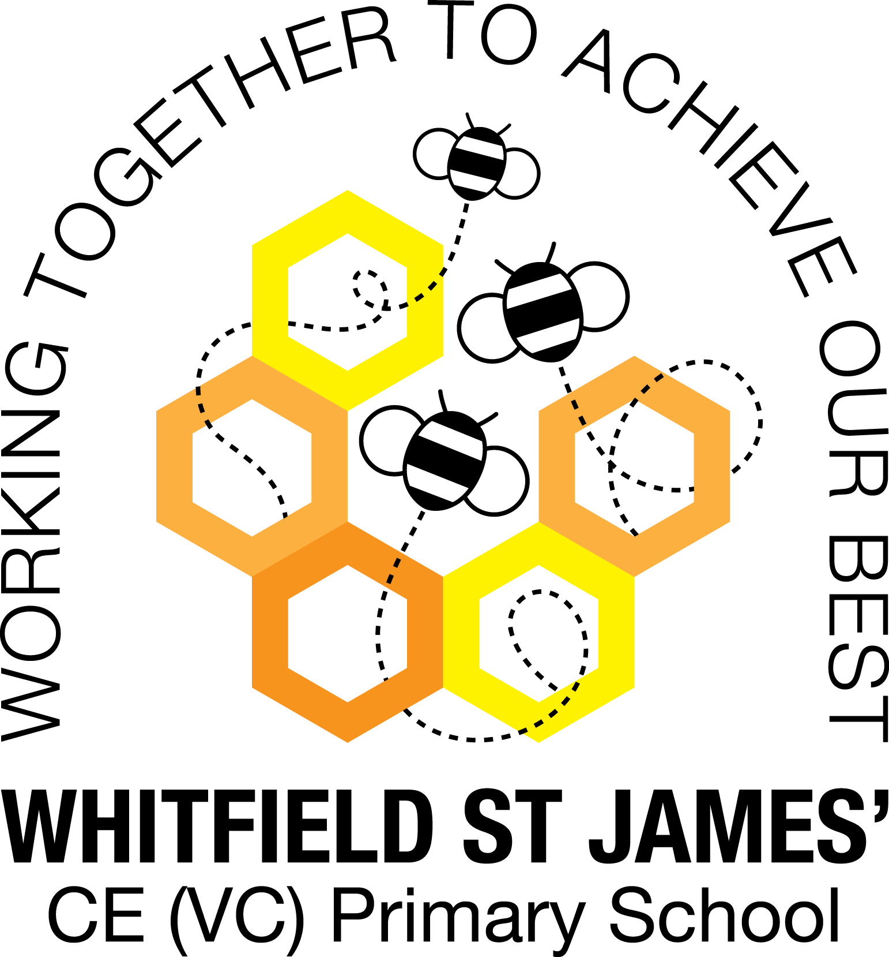

WHITFIELD ST JAMES’ CE (VC) PRIMARY SCHOOL

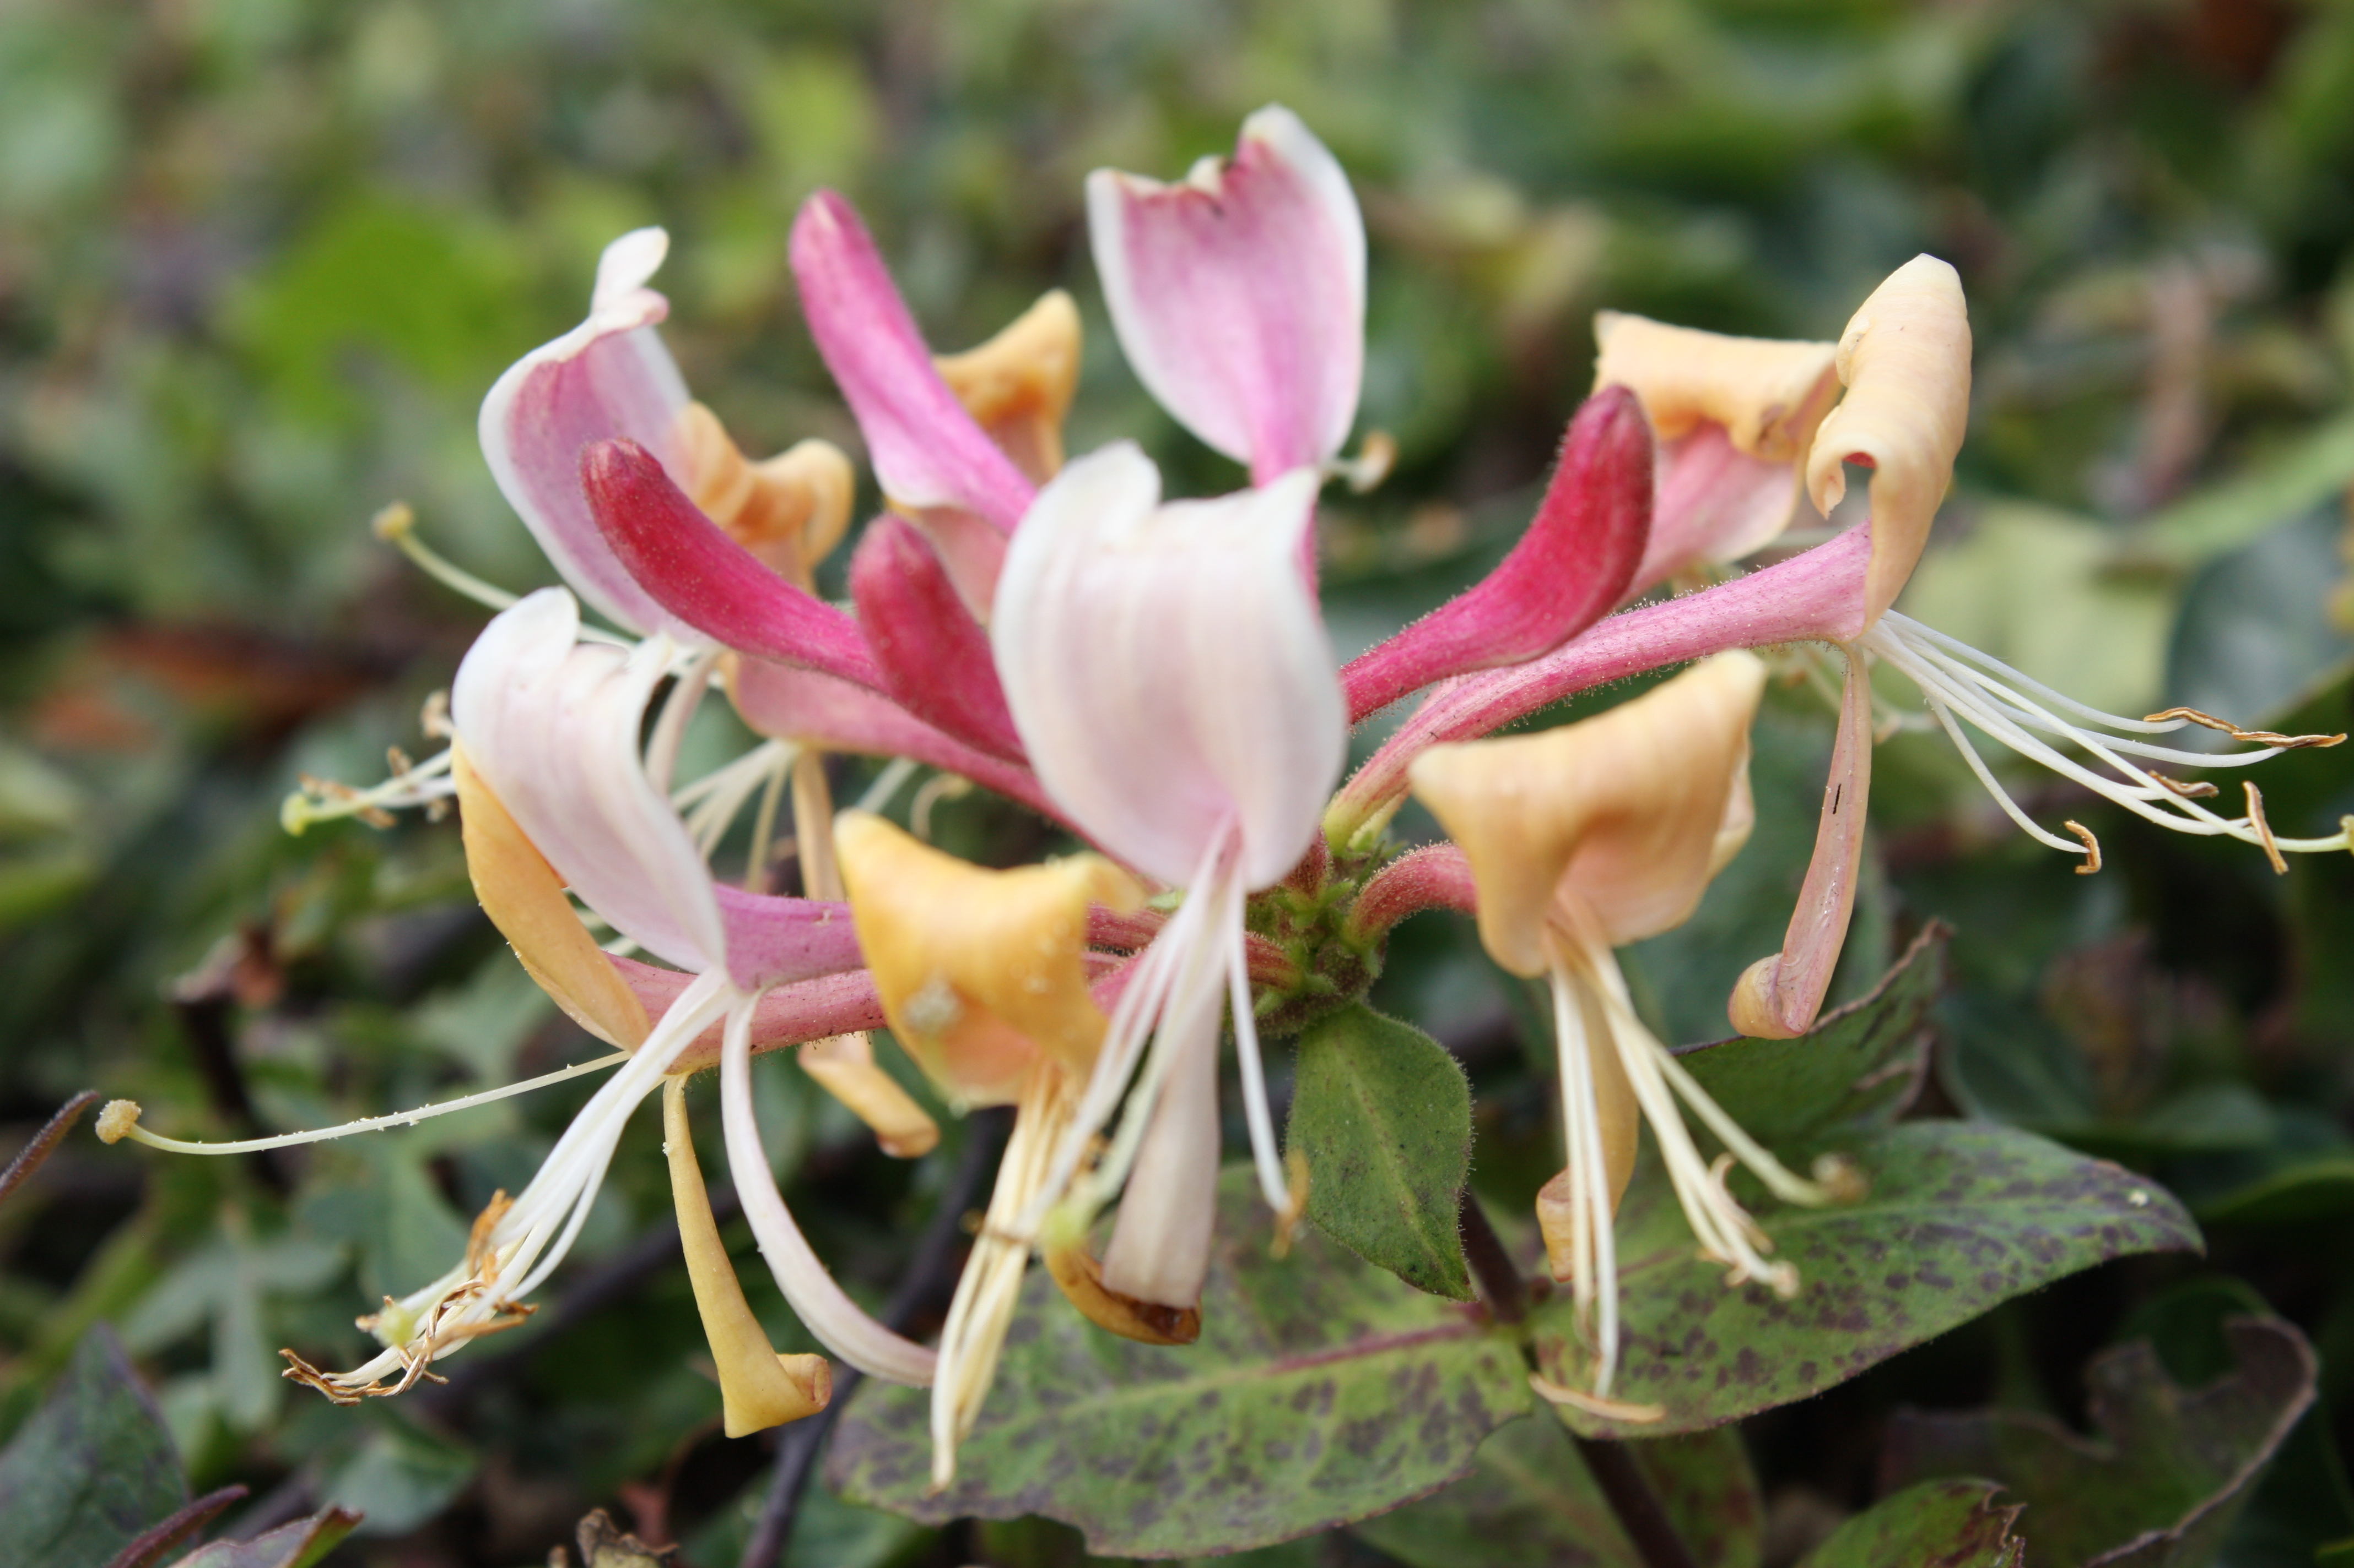

2nd November 2021
Dear parents and carers of Honeysuckles class,
I hope that you have all had a lovely half term week. Last term was a huge success, I really enjoyed getting to know the class and we had a great term together. I hope this term will be just as enjoyable!
English and maths
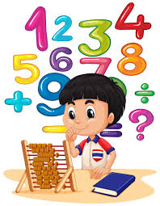
This term our English lessons will be based around our topic ‘Stargazers’. The children will be reading and listening to various narratives about space. We will also look at the features of newspaper reports and write our own report about the first man on the moon. The children will investigate free verse poetry and create their own space poems. They will also write descriptions of their own aliens. We will also use non-fiction texts to find out about The Solar system and write our own non chronological reports on one of the planets. We will also continue to develop our knowledge of SPAG (spelling, punctuation and grammar rules) and will apply this to our writing.
In maths, we will finish our unit of work about number, focusing on subtraction. We will then go on to learn about measurement, in particular finding the perimeter and area of shapes. Finally, the children will learn more about multiplication and division.
Children will continue to be encouraged to log on to TT Rockstars to help them to learn their times tables or to keep working on their speed of recall of the multiplication facts. Please encourage your children to do this, as a secure knowledge of the tables helps the children in all areas of maths. Thank you for your support!
Topic
Our new topic is called Stargazers’. It is a Science based topic where the children will Journey through space, the final frontier. Navigate beyond the Sun, the magnificent, blazing star at the centre of our Solar System. Investigate the eight planets: Mercury, Venus, Earth, Mars, Jupiter, Saturn, Uranus and Neptune. Take a look at the Moon, a celestial body that orbits Earth. Programme a rover to traverse a lunar landscape and work scientifically to investigate gravity, and what happens when there is none. Compare the times of day at different places on the Earth and get in a spin listening to the haunting sounds of space themed songs. Then it’s 3, 2, 1, blast off….. Exploring space is probably the greatest adventure that humankind has ever undertaken. Are we alone? Or are there other life forms out there?
I am looking forward to our wow day to launch the topic on Tuesday 2nd November! Accompanying this newsletter is a knowledge organiser about the topic, which you can read with your child, to find out what we are going to be learning about over the course of the term. Also accompanying the newsletter is a home learning guide, which contains some suggested activities that your child can do at home, as well as recommended reading around this topic. Any work done can be returned to school on the last Monday of term so that we can look at it over the last couple of days of term.

Other subjects
Honeysuckles will continue to be taught by Mrs Purdy on Tuesday afternoons which is my afternoon out of class. She will be continuing to teach them RE, German and some PSHE. We will be following Derbyshire’s recommended scheme - PSHE Matters. Throughout the year, we will be looking at friendships, money, relationships, keeping mentally and physically healthy as well as taking responsibility and exploring emotions. In our RE lessons, we will be following the Derbyshire Agreed Syllabus for RE and also the diocese-recommended scheme ‘Understanding Christianity’. We will also be exploring special days, festivals and significant people during our lessons and daily collective worship in class.

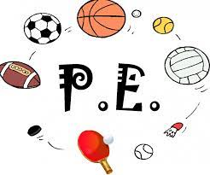
PE
Your child will still need to come in to school in their PE kit on Monday each week. Please could their kit be in line with our uniform policy, which is a plain white t-shirt or polo shirt, plain black shorts, plain black jogging bottoms and trainers. It may be a good idea for anyone with pierced ears to leave their earrings out on PE days to save them having to take them out, or if your child struggles to remove their earrings, they can tape them over (tape will not be provided by school). We will continue to swim on Thursday mornings. Thankyou for your support with getting your children to school a little earlier each Thursday. We have got into a good routine walking down and getting changed quickly. As it gets colder, please make sure your child has a warm/ waterproof coat and sensible walking shoes.
Homework
Homework will be given out on a Friday and will be due in on the following Thursday, when children will bring their homework books in to school for their work to be marked. Children will be provided with maths homework, spelling homework and they will also be expected to read at least five times a week, and for their reading to be recorded in their reading record..
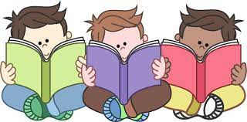
Reading
Your child will continue to be provided with a reading book in line with their reading age. In class, children will have access to books off our reading shelves as well as library books (which are brought in to the classroom for children to access) and we will also have our 50 Reads Challenge books in our reading treasure chest. These books are specific to Y4/5, and the children are encouraged to read as many, ideally all, of the books during their time in Y4/5. It is lovely to see how much the children are enjoying reading these books. Thank you for your support in encouraging your child to read!
I hope that you have found this information useful, and I look forward to getting to know you and to meeting you all at parents’ evening. If you ever need to contact me, please don’t hesitate, you can phone school or can email me directly on honeysuckle@st-james.derbyshire.sch.uk
Thank you for your support.
Best wishes,
Mrs Collins.

