

Tulips snapshot of the week

Here is a snapshot of some of the activities we have completed in our class this week. This snapshot may not contain all of the lessons and activities the children have been involved in, but will provide you with an idea of what we have done this week in Tulips class!
If you have any questions or need anything, please don’t hesitate to email us on the class email –tulip@st-james.derbyshire.sch.uk Mr Ford and Mrs Mackey.
Topic: Invasion | Week commencing: 8th November 2021
Guided Reading book: Grandad’s Island
Maths  This week we have completed our addition and subtraction block of learning. We have looked at refining our exchanging skills, checking our answers using the inverse operation and used our estimating skills so we have a rough idea of what our answers will be. Next week, we will be starting our multiplication and division block of learning! | English  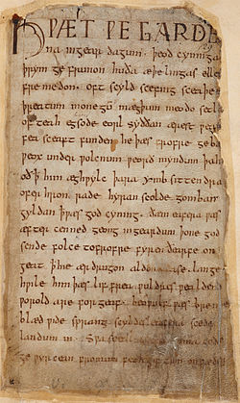  This week we have been looking at Anglo-Saxon poetry and writing our own using the Old English epic poem Beowulf as a stimulus. We have been looking at alliteration and kennings.
Other lessons  We have been looking at a timeline of the departure of the Romans from Britain and the invasion of the Anglo-Saxons. We have mapped where the invaders were from and the physical and human features they would have encountered.  We have also begun a new R.E. topic called ‘Incarnation’ studying the Holy Trinity.  In German, we have been learning how to write and say colours! We looked at how to say and write: blue, red, green, yellow, white, black and orange. We will be continuing our work on colours next lesson. | Any other information  On Friday the 19th there will be a non-uniform donation day for the PTA. More details will follow.  Please email us on the address above to arrange a mutually convenient time for a parents evening phone call.  Could you remind your children that their homework books are due in on Thursday. Thank you.  Have a lovely weekend.
Star of the week: Stanley

Christian Value Award: Isabelle – Resilience

