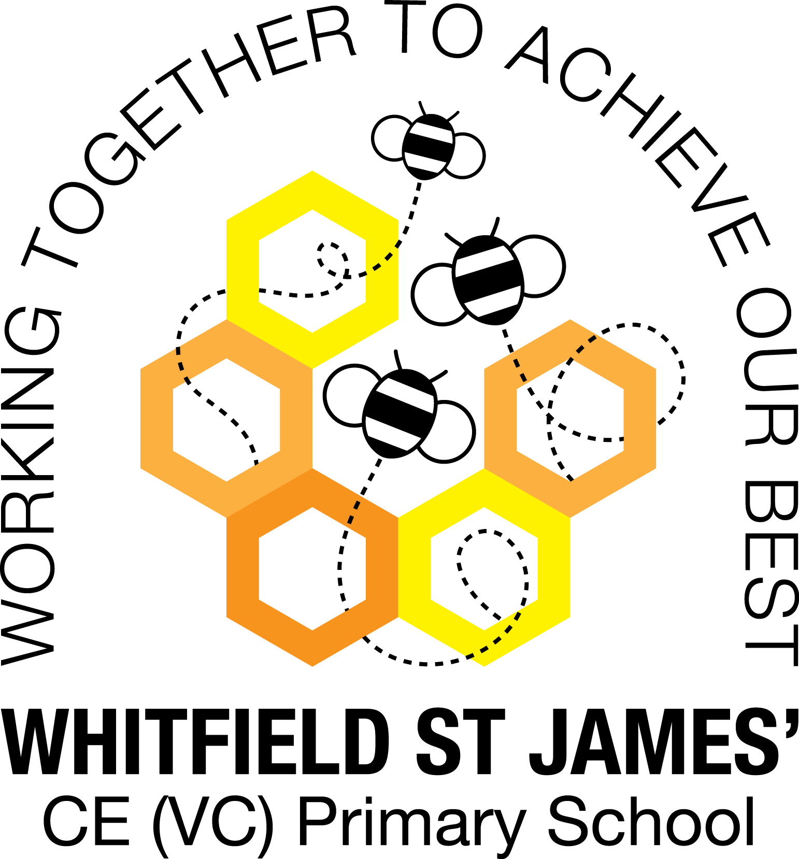

WHITFIELD ST JAMES’ CE (VC) PRIMARY SCHOOL

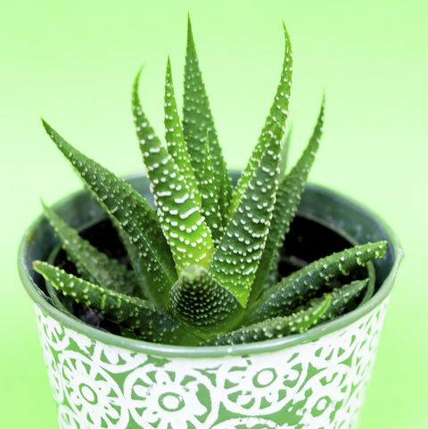

22nd October 2021
Dear parents and carers of Aloe Vera class,
We have just finished a wonderful half term and I am so pleased with the way the children have returned to school and engaged with their learning. It is a worry when we have been through so much disruption due to Covid over the previous 18 months but I could not be happier with the children and their positive attitude and enthusiasm in lessons. Mrs Eccles, Mrs Lockett and I have been working hard supporting children and groups.
English and maths
We will return to maths lessons by recapping on our learning so far and then progress onto ‘money’. We will find totals, differences, change and complete two-step problems. We will recap on methods of multiplying 2, 5 and 10 by making groups. Our topic moves onto dividing by 2, 5 and 10. We will round our topic off by multiplying by 3, 4 and 8. A gentle reminder that by the end of year 2 our pupils should know the 2, 5 and 10 times tables and our year 3 pupils should know the 2, 5, 10, 3, 4 and 8 times tables. TT Rock Stars will also support and develop these skills. Perhaps a times table poster on display at home would help support their recall of the multiplication and division facts.
Our topic has a strong history and geography focus and encouraging your child to read and age appropriate texts on the Romans and their lives would be beneficial. In class, we have information books for reference and I will share videos with fact and information to stimulate learning.

Topic
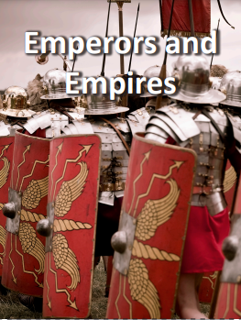
As you know, our topic is ‘Emperors and Empires’ and we will have our WOW day on Tuesday 2nd November. Accompanying this newsletter is a knowledge organiser about the topic, which you can read with your child, to find out what we are going to be learning about over the course of the term. This is a History and Geography based topic, and the children will find it fascinating. During this topic we will learn about aspects of everyday life in a Roman town include the use of the forum for decision-making; shops and market places for trade; family life, including the different roles and lifestyles of men and women; slavery and life in a Roman fort. Get ready to hear about the Roman Empire and Romans in Britain!

Other subjects
The children will continue to learn German with Mrs Purdy and develop their oral conversation skills.
We will be working on Mosaics in Art, of course! (We are studying the Roman after all.)
In Computing, we will be programming a ‘sprite’ in an animation.
PE
Your child will need to come in to school in their PE kit on Tuesday and Thursday each week. Please could their kit be in line with our uniform policy, which is a plain white t-shirt or polo shirt, plain black shorts, plain black jogging bottoms and trainers. It may be a good idea for anyone with pierced ears to leave their earrings out on PE days to save them having to take them out, or if your child struggles to remove their earrings, they can tape them over (tape will not be provided by school).

Homework
Thank you for supporting with the completion of homework. I set work, which replicates some of the learning objectives we have followed in school that week. Please encourage children to write the most interesting sentences they can, when applying the spelling strategies. Please encourage a high level of presentation and expect capital letters and full stops.
Reading
Please encourage your child to read for 15 minutes every day. Please can you sign the Reading Record: the children understand there is a reading commitment at home as well as in school. We have already moved most children up to the next book band due to regular reading.
I hope that you have found this information useful. I look forward to meeting you at Parent’s Evening shortly where we can discuss your child and the first half term. If you ever need to contact me, please do not hesitate, you can phone school or can email me directly on aloevera@st-james.derbyshire.sch.uk
Thank you for your support.
Best wishes,
Mrs Madigan

