

**Starry Night Home Learning.**

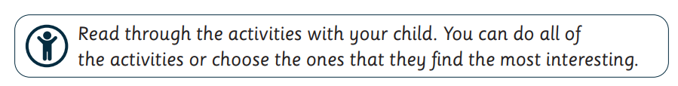

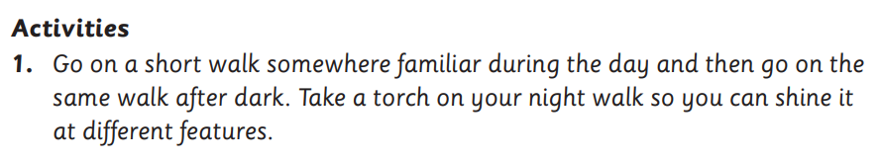

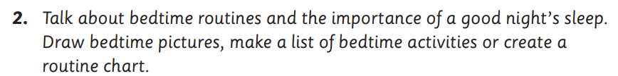



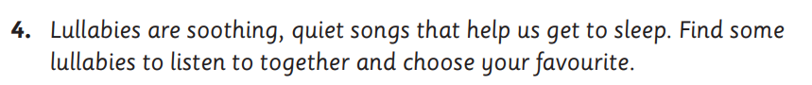

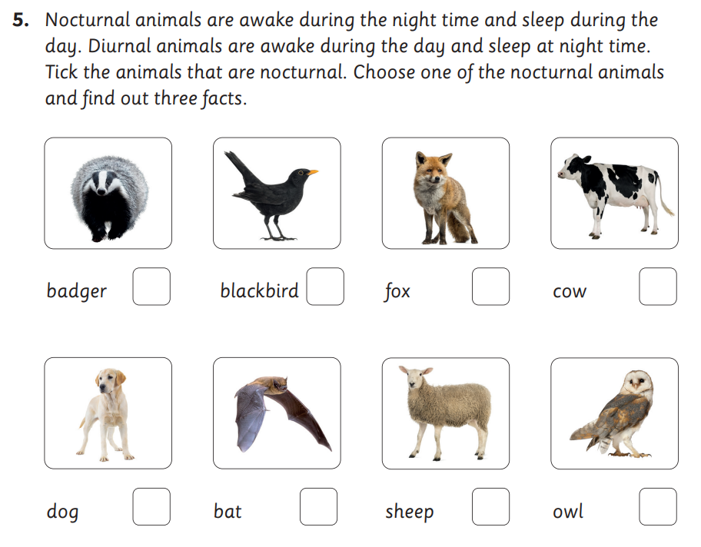



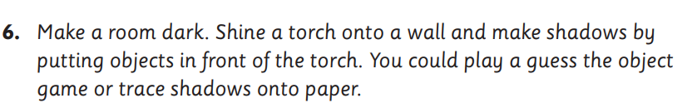

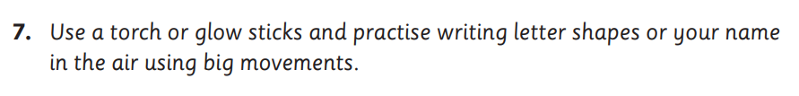

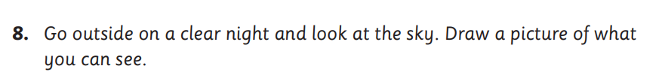



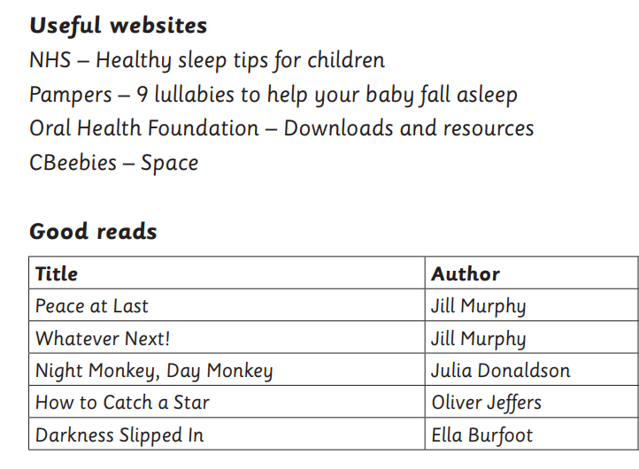

**If your child is in Reception, please post the homework onto Tapestry. If your child is in Year 1 record the homework in your child’s homework book.**

**Thank you for your continued support.**