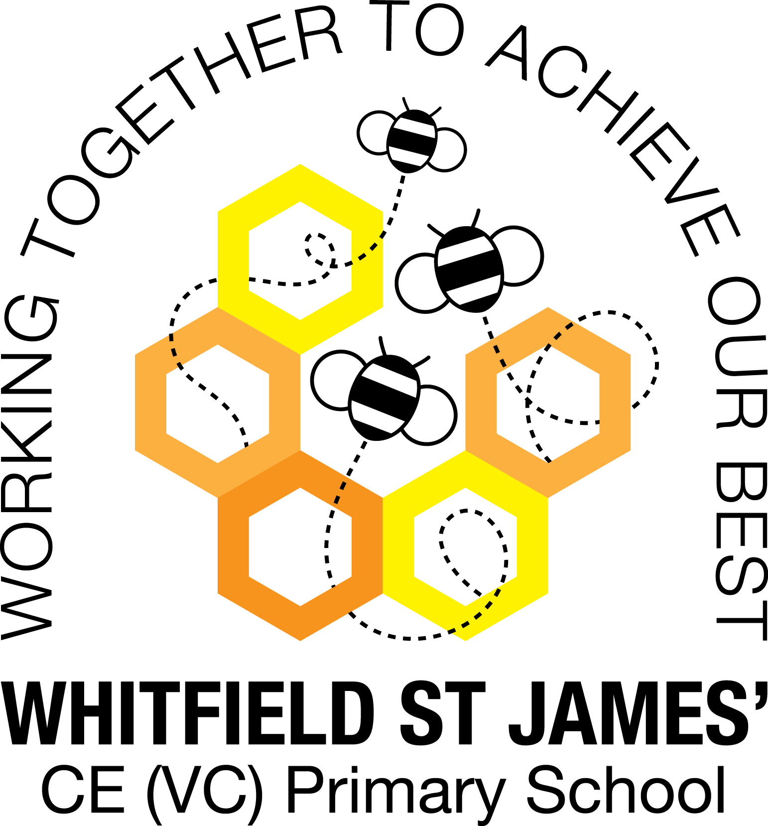

WHITFIELD ST JAMES’ CE (VC) PRIMARY SCHOOL

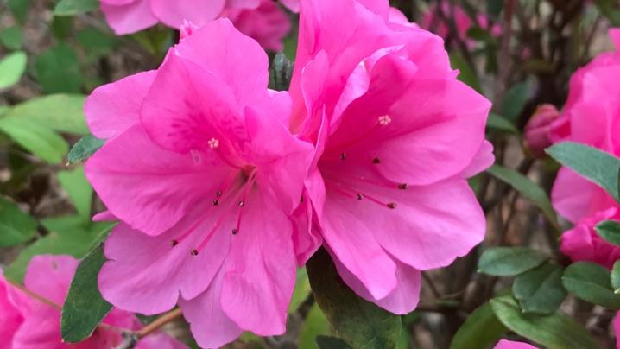

2nd November 2021
Dear parents and carers of Azalea’s class,
I hope that you have all had a lovely half term week. Last term was a huge success, I really enjoyed getting to know everybody and we had a great term together. Everybody has worked extremely hard, I hope this term will be just as enjoyable!
English and maths
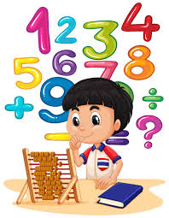
This term our English lessons will be based around our topic ‘Groundbreaking Greeks’. We will be studying historical narratives using well-known Greek myths and legends, balanced arguments and play scripts. We will also continue to develop our knowledge of SPAG (spelling, punctuation and grammar rules) and will apply this to our writing. In maths, we will finish our unit of work about number, focusing on multiplication and division before moving on to look at some statistics. Children will continue to be encouraged to log on to TT Rockstars to help them to learn their times tables or to keep working on their speed of recall of the multiplication facts. Please encourage your children to do this, as a secure knowledge of the tables helps the children in all areas of maths. Thank you for your support!
Topic
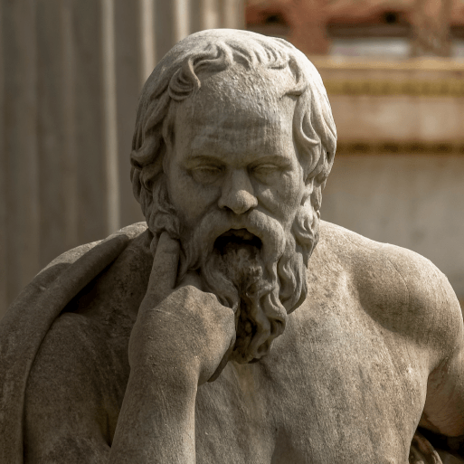
Our new topic is called ‘Groundbreaking Greeks’ and it teaches children about developments and changes over six periods of ancient Greek history, focusing on the city state of Athens in the Classical age, and exploring the lasting legacy of ancient Greece. I am looking forward to our wow day to launch the topic on Tuesday 2nd November! Accompanying this newsletter is a knowledge organiser about the topic, which you can read with your child, to find out what we are going to be learning about over the course of the term. Also accompanying the newsletter is a home learning guide, which contains some suggested activities that your child can do at home, as well as recommended reading around this topic. Any work done can be returned to school on the last Monday of term so that we can look at it over the last couple of days of term.
Other subjects
Azaleas will continue to be taught by Mrs Purdy on Wednesday afternoons, which is my afternoon out of class. She will be teaching them RE and German. For PSHE, we will be following Derbyshire’s recommended scheme - PSHE Matters. Throughout the year, we will be looking at friendships, money, relationships, keeping mentally and physically healthy as well as taking responsibility and exploring emotions. In our RE lessons, we will be following the Derbyshire Agreed Syllabus for RE and also the diocese-recommended scheme ‘Understanding Christianity’. We will also be exploring special days, festivals and significant people during our lessons and daily collective worship in class.

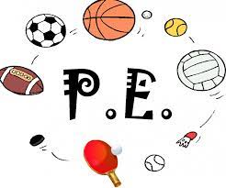
PE
Continuing from last half-term, your child will need to come in to school in their PE kit on Monday. Please could their kit be in line with our uniform policy, which is a plain white t-shirt or polo shirt, plain black shorts, plain black jogging bottoms and trainers. It may be a good idea for anyone with pierced ears to leave their earrings out on PE days to save them having to take them out, or if your child struggles to remove their earrings, they can tape them over (tape will not be provided by school). We will also be continuing our swimming lessons on Thursday’s so the children will need appropriate swimming costumes and towels. The children have all seemed to love their swimming lessons and have gained so much confidence from them.
Homework
Homework will be given out on a Friday and will be due in on the following Thursday, when children will bring their homework books in to school for their work to be marked. Children will be provided with maths homework, spelling homework and they will also be expected to read at least five times a week, and for their reading to be recorded in their reading record. I urge the children to continue logging into TT Rockstars, I can track their progress online and it is really making a huge difference.
Reading
Your child will continue to be provided with a reading book in line with their reading age. In class, children will have access to books off our reading shelves as well as library books (which are brought in to the classroom for children to access) and we will also have our 50 Reads Challenge books in our reading treasure chest. These books are specific to Y5, and the children are encouraged to read as many, ideally all, of the books during their time in Y5. It is essential that those children who are free readers are reading books that are challenging enough for their age, and that they are accessing a wide range of genres and authors, and the 50 Reads Challenge is perfect for this! It is lovely to see how much the children are enjoying reading these books. Thank you for your support in encouraging your child to read!
I hope that you have found this information useful, and I look forward to getting to know you and to meeting you all at parents’ evening. If you ever need to contact me, please don’t hesitate, you can phone school or can email me directly on azalea@st-james.derbyshire.sch.uk
Thank you for your support.
Best wishes,
Mr Hannnan

