Peonies snapshot of the week

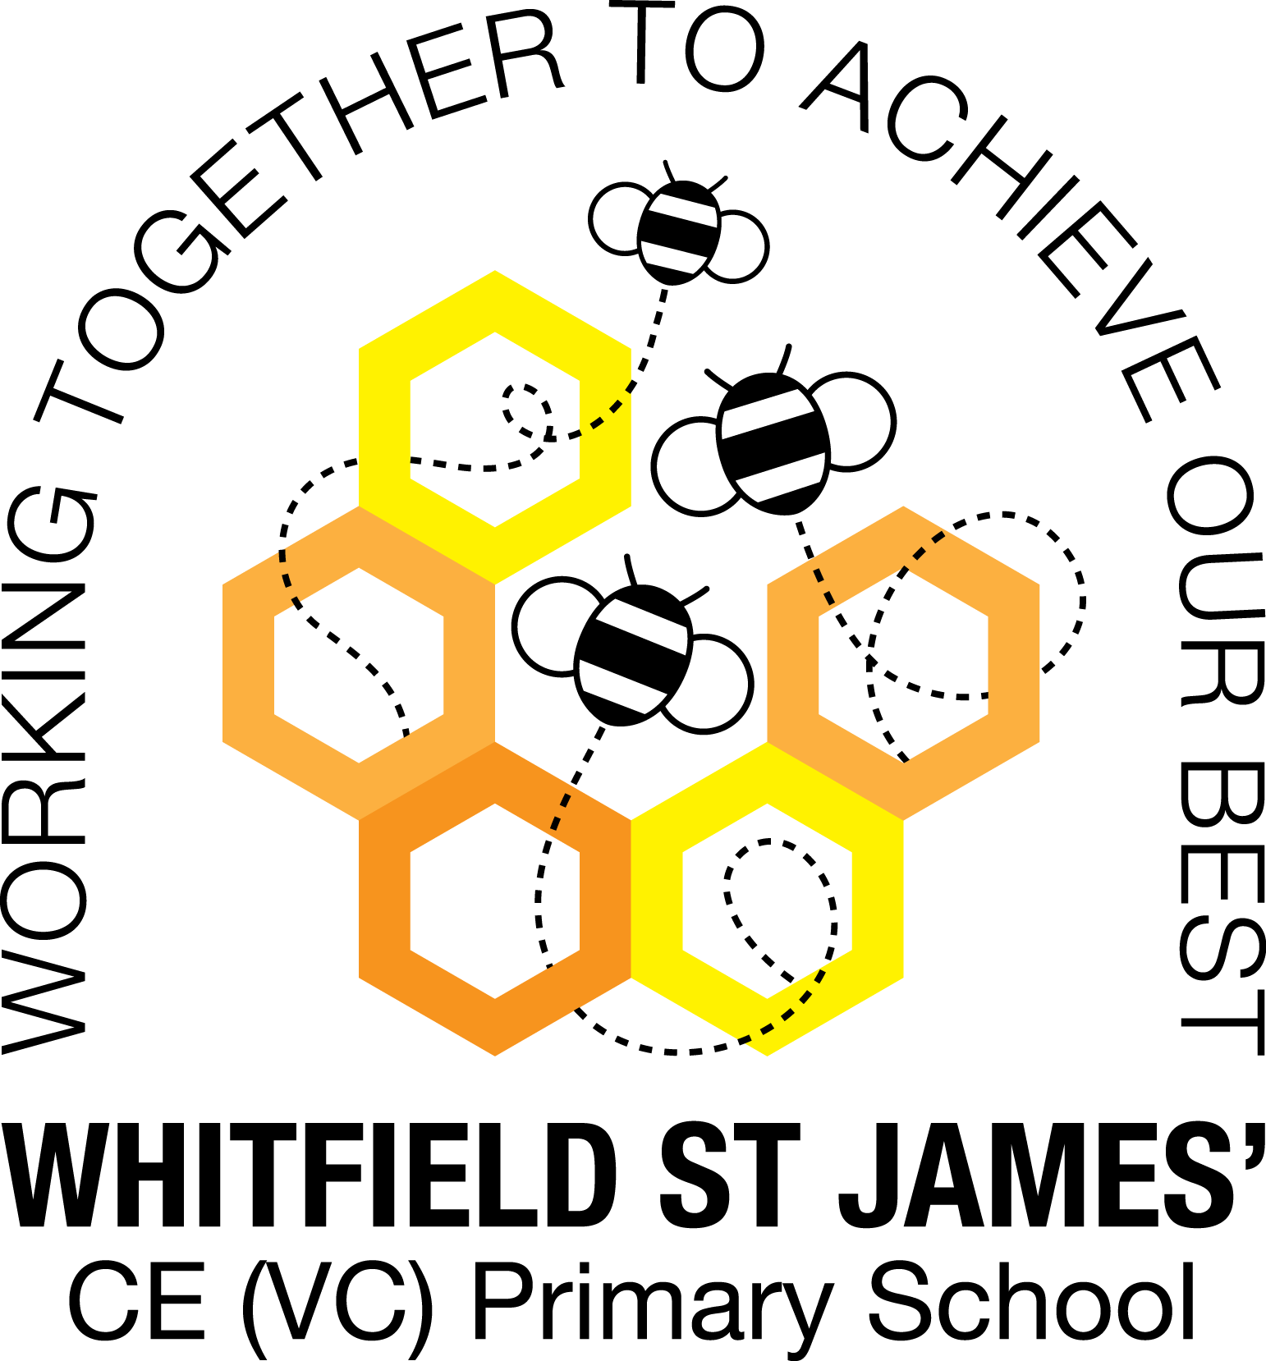

Here is a snapshot of some of the activities we have completed in our class this week. This snapshot may not contain all of the lessons and activities the children have been involved in, but will provide you with an idea of what we have done this week in Peonies class!

If you have any questions or need anything, please don’t hesitate to email me on the class email – [peonies@st-james.derbyshire.sch.uk](mailto:peonies@st-james.derbyshire.sch.uk) Miss Warburton

|  |  |
| --- | --- |
| **Topic**: Britain at War | **Week commencing**: 19th November 2021 |
| **Class book**: Carrie’s War by Nina Bawden |  |
| **Maths**  This week we have started learning about fractions. We have recapped our knowledge of equivalent fractions and simplifying fractions and we have converted improper fractions and mixed numbers. In our afternoon TT Rock Stars session we have been revising the 3x, 4x and 5x tables.  Challenge: Ask your child to explain the terms improper fraction, mixed number, numerator, denominator and highest common factor. | **English**  This week we have been learning about writing techniques such as metaphors and similes and use of repetition for emphasis. We are going to use these techniques when we write our stories with flashbacks next week. We have also finished our guided reading book, The Sleeper and the Spindle, and we loved the ending!  Challenge: Ask your child to summarise the events of The Sleeper and The Spindle. Summarising is one of our Reading Vipers skills! |
| **Other lessons**  We have loved learning about WW1 weaponry this week, and also about the Battle of the Somme and the Battle of Jutland. I have been very impressed with a lot of the children’s knowledge about the war! Mr Doyle has done some anti-bullying work with the class this week as it has been Anti-Bullying Week, and the children have made anti-bullying leaflets. | **Any other information**  On Tuesday afternoon (23rd November) we are teaching our RSE lesson on puberty to year 5 and 6, as mentioned in the letter that went out to classes last term. We will confirm by text when the lesson has been delivered, in case the children have any questions when they get home. |
| **Star of the week:** Jack  **Christian Value Award:** Mollie |