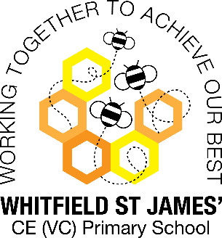Bluebells snapshot of the week

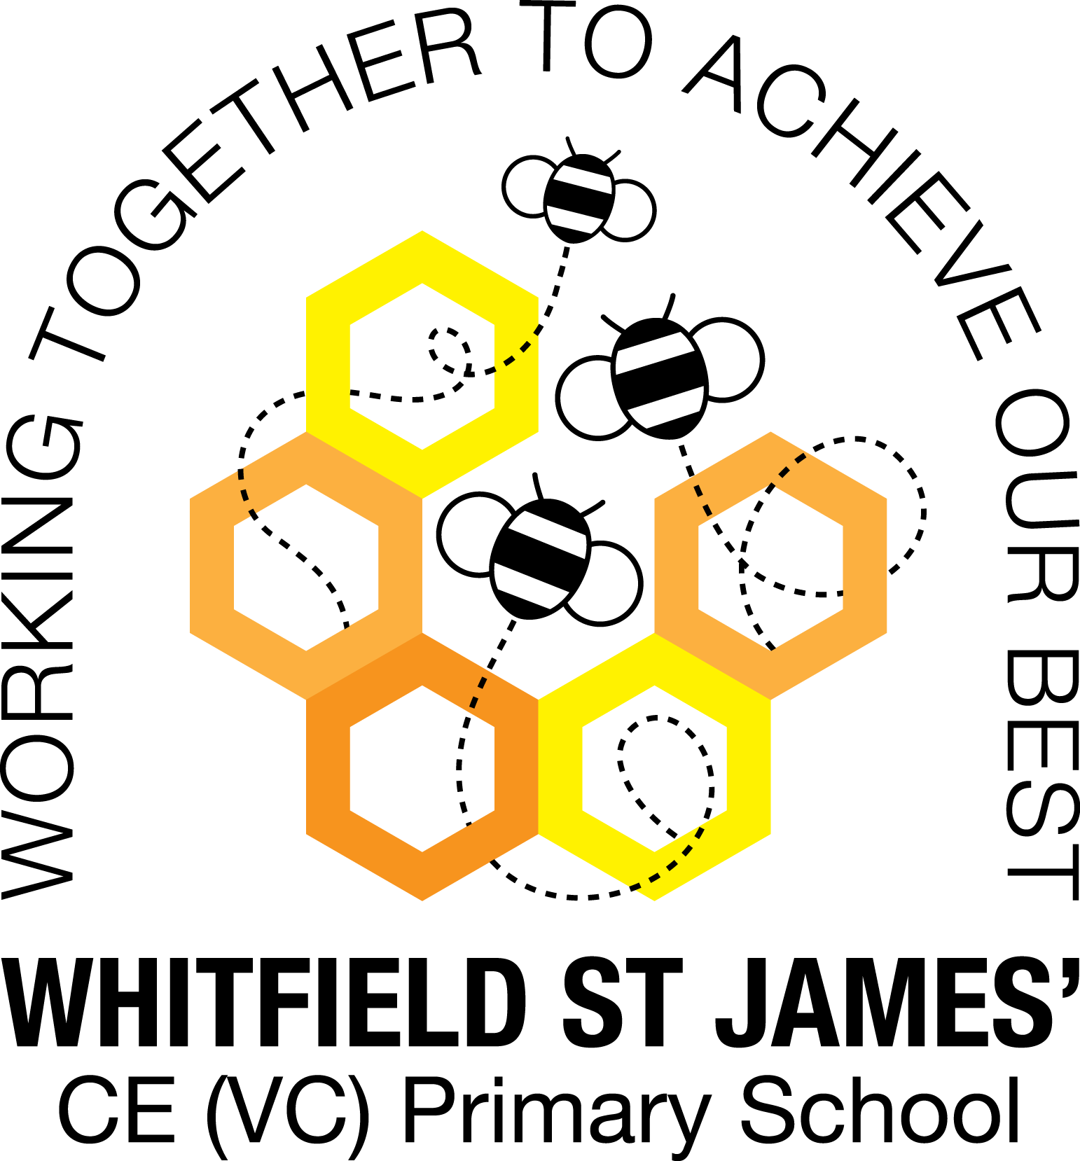

Here is a snapshot of some of the activities we have completed in our class this week. This snapshot may not contain all of the activities the children have been involved in. If you have any questions or need anything, please don’t hesitate to email us on the class email – [bluebell@st-james.derbyshire.sch.uk](mailto:bluebell@st-james.derbyshire.sch.uk)

|  |  |
| --- | --- |
| Topic: Me and My Community | Week commencing: 4.10.2021 |
| Class book: The Burpee Bears by Joe Wicks |  |

|  |  |
| --- | --- |
| **Reading**  Please make sure your child has their library book in their book bag every day.  If your child has started to bring home a reading book, please sign their yellow reading record when you hear them read at home and make sure that it is in their book bag every day.  If your child hasn’t yet got a reading book, don’t worry. They will be working on their pre-reading skills and completing activities to develop phonological awareness and blending sounds to read words. The best way to support your child at home is to practise recognising the letters using the weekly flash cards and enjoy reading and listening to stories together. | Any other information  What a busy week! We had a wonderful time meeting Joe Wicks on Tuesday. On Wednesday, we learnt about what life is like for children living in Bantama and wrote a class prayer and on Thursday we had a great day making our sticks into characters to play with.    **Next week- reading week!**  We will be doing lots of reading in school next week- look out for photos on Tapestry! Please can you upload a photo of your child reading, looking at a book or listening to a story at home? This could be on the sofa, bed time story, looking at a book in the car or even in the garden!  **Please upload by Wednesday so we can look at them in class**. |
| **Maths**  **Number of the week- Number 3**  This week we have practised our counting skills. Children will often count objects more than once or miss an object out. Practise counting at home by asking your child to line up objects and touch each one as they count, saying one number name per object. We have been using comparative language and sorting our sticks from largest to smallest. |
| Star of the week:  Charlie – making a fabulous stick man!  Christian Value Award: Michael – for thinking of others |