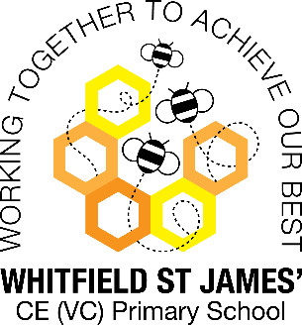**Buttercups snap shot of the week**

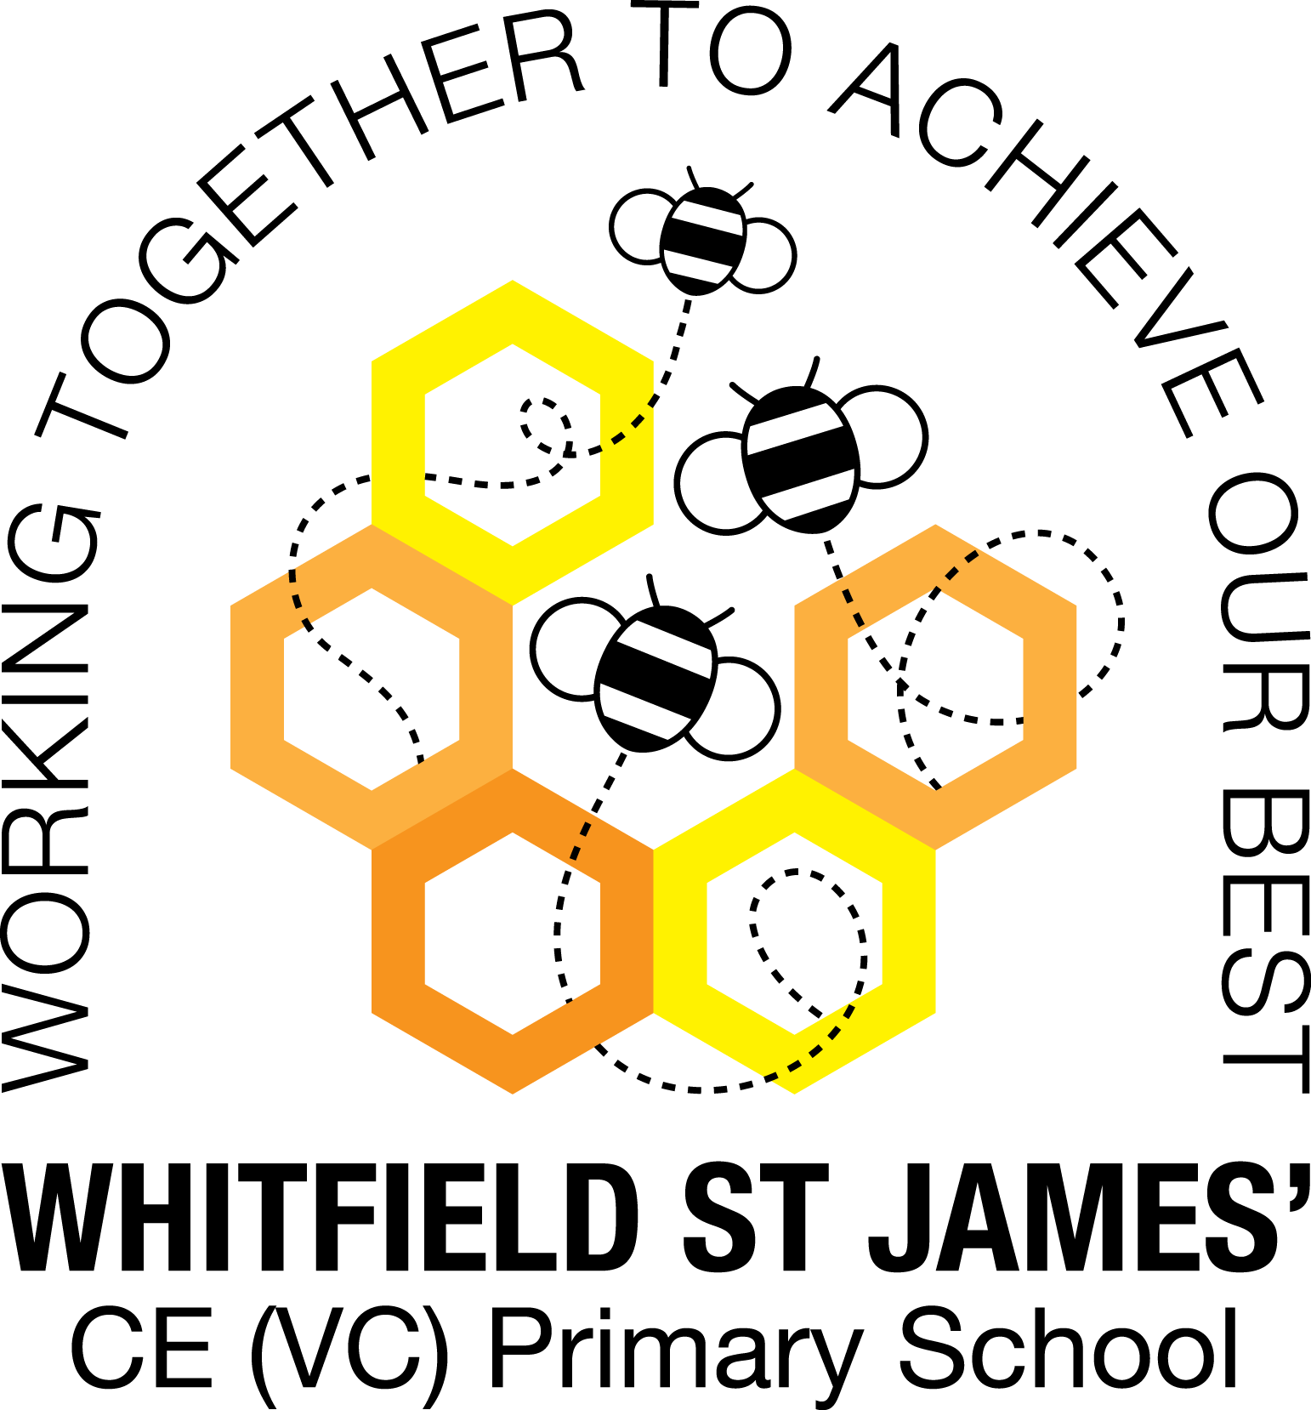

Here is a snapshot of some of the activities we have completed in our class this week. This snapshot may not contain all of the activities the children have been involved in. If you have any questions or need anything, please don’t hesitate to email us on the class email – buttercup@st-james.derbyshire.sch.uk

|  |  |
| --- | --- |
| **Topic**: Me and My Community | **Week commencing**: 27th September 2021 |
| **Class book**: Colin and Lee Carrot and Pea by Morag Hood |  |

|  |  |
| --- | --- |
| **Communication and language**  We have enjoyed chatting about what makes a good friend and why it is important to be kind to each other. The children thought of ways that they can be a good friend. Together we made a good friend checklist of all the qualities a good friend should be. | **Maths**  **Rec** This week the children have been matching and sorting. Prompt your child to find things around the house which may be sorted into groups.  **Year 1**: This week the children have been comparing amounts and numbers. Complete the sheet in your child’s homework book to help consolidate this learning at home. |
| **Other areas of learning**  This week in RE we have been thinking about the Lord’s Prayer and have been singing the following song. <https://www.youtube.com/watch?v=UwvBtcwPQS8>  It would be great if you could practice this at home, as we hope to record the children singing it for the school website next week. | **Any other information**  Bring a stick to school day. Thursday 7th October  Buttercups will be going for a walk into the local community and will create their own journey stick.  A journey stick a memento of a nature walk, featuring items collected whilst on the walk. These might be things like leaves, twigs or flowers.  Please ensure your child has weather appropriate clothing and footwear in school if the weather is wet. |
| **Star of the week:** Oliver for developing confidence within the classroom environment.  **Christian Value Award:** Adem – friendship |