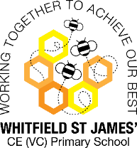Bluebells snapshot of the week

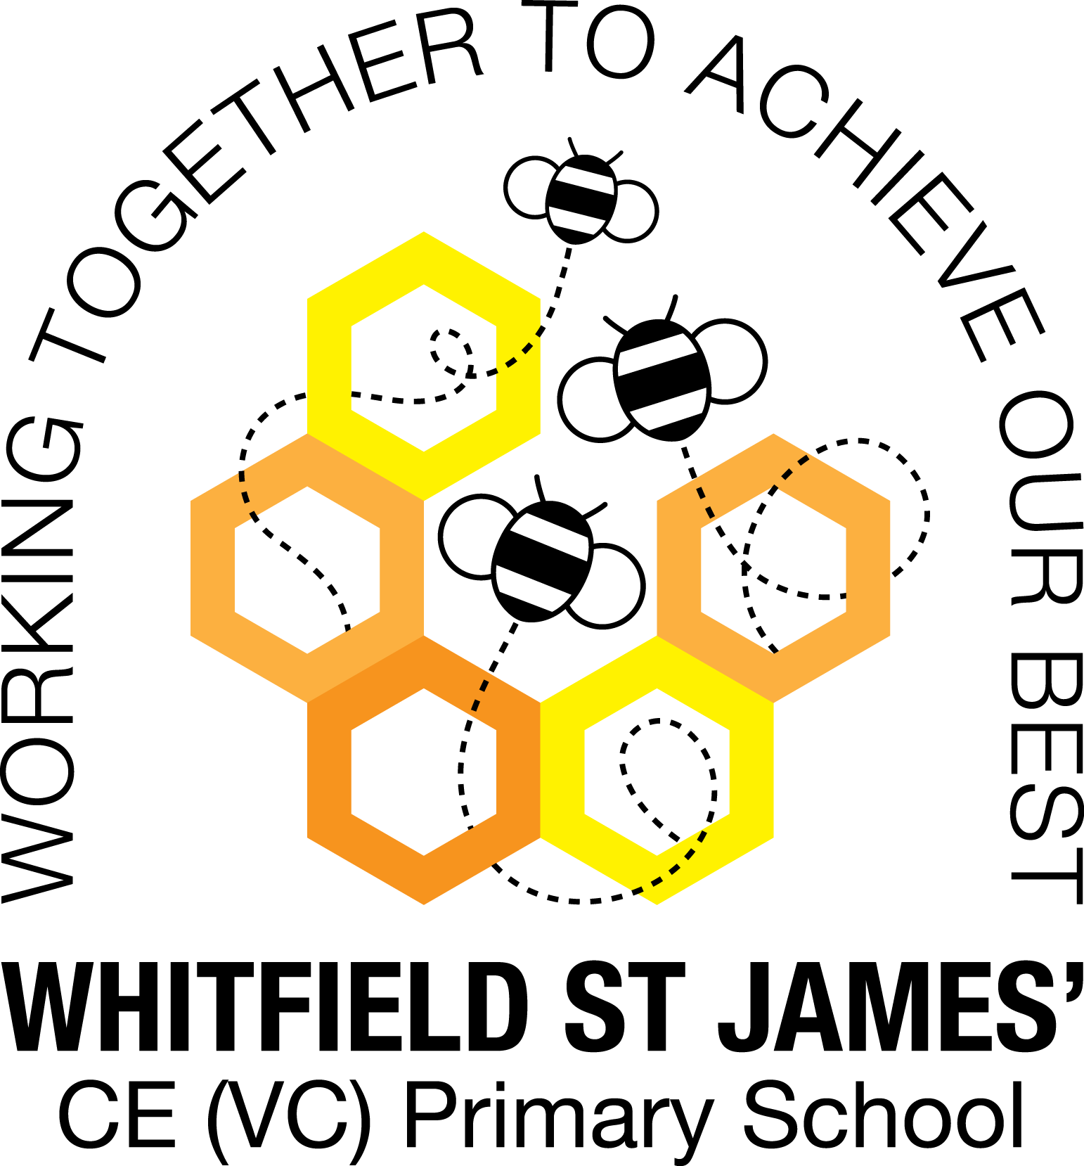

Here is a snapshot of some of the activities we have completed in our class this week. This snapshot may not contain all of the activities the children have been involved in. If you have any questions or need anything, please don’t hesitate to email us on the class email – [bluebell@st-james.derbyshire.sch.uk](mailto:bluebell@st-james.derbyshire.sch.uk)

|  |  |
| --- | --- |
| Topic: Exploring Autumn | Week commencing: 18.10.2021 |
|  |  |

|  |  |
| --- | --- |
| **Phonics**  This week we have been recapping all of the sounds we have learnt so far and we are really impressed with how well the children are doing. Please keep practising at home. | **Any other information**  **Inset Day**  Monday 1st November – school closed to pupils  **Parents Evening**  Tuesday 2nd November & Thursday 4th November  **Next Topic: “Wow Day”**  Our topic after half term is called “Once upon a time….” Our “Wow Day” will be happening on the 2nd November during school time, we will be watching a pantomime online, buying and selling tickets and eating popcorn during the interval – how exciting! Further details of our new topics will be available after half term.  **Autumn Drop-in**  It was lovely to see so many of you during the Autumn Drop-in sessions. Don’t worry if you couldn’t make it, we are hoping to do another one later in the year. |
| **Maths**  Number of the week ‘number 4’  This week we have been learning how to represent 4 in different ways. |
| Star of the week: Olivia -for trying really hard with her phonics and reading.  Christian Value Award: Edward – for helping his friends. |