Bluebells snapshot of the week

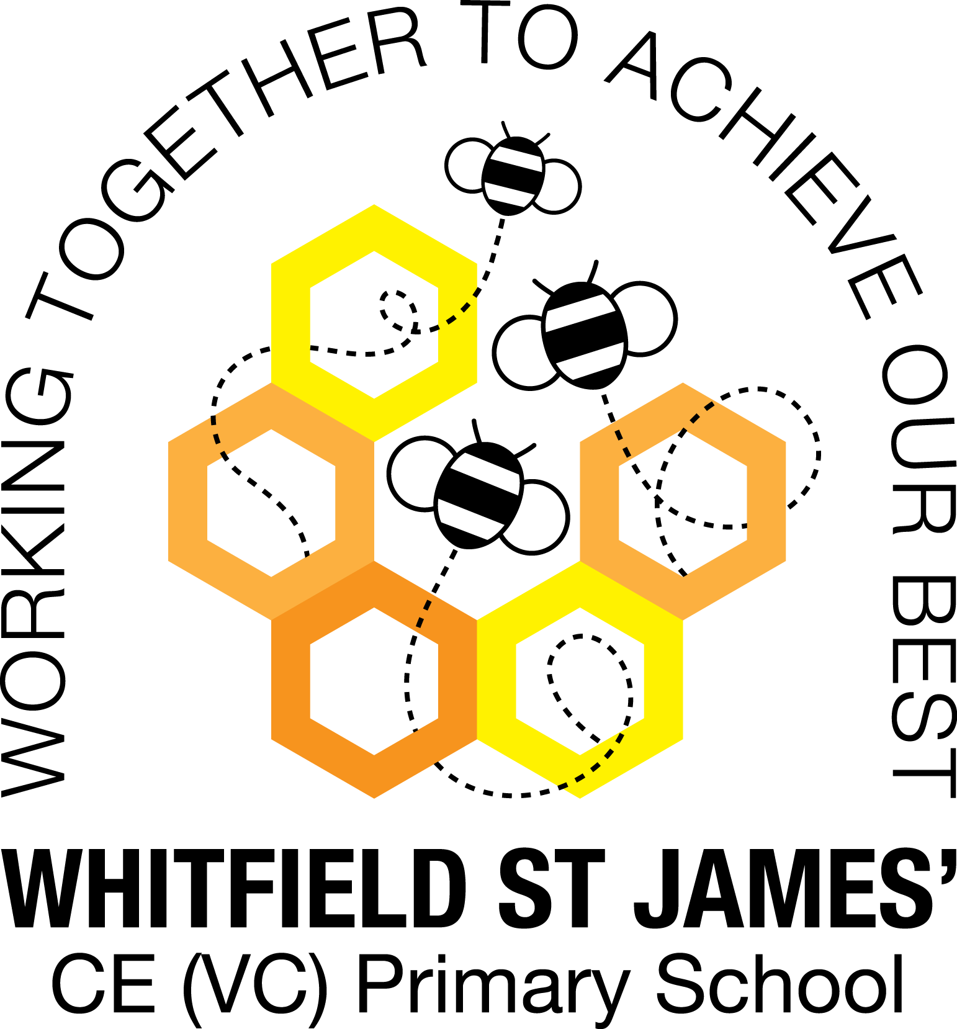

Here is a snapshot of some of the activities we have completed in our class this week. This snapshot may not contain all of the activities the children have been involved in. If you have any questions or need anything, please don’t hesitate to email us on the class email – [bluebell@st-james.derbyshire.sch.uk](mailto:bluebell@st-james.derbyshire.sch.uk)

|  |  |
| --- | --- |
| Topic: Exploring Autumn | Week commencing: 11.10.2021 |
| Class book: Pumpkin Soup |  |

|  |  |
| --- | --- |
| **Phonics**  We have this week learnt the sounds h, b, f, ff, l, ll, ss  We call double letter sounds “digraphs” because it is two letters but it only makes one sound for example “huff.”  We have also learnt some tricky words! What is a tricky word?  Tricky words are **those words which cannot be sounded out easily**. Emergent readers may find them difficult to read as they have not yet learned some of the graphemes in those words. We are learning “to, the, no, go, I, into” | **Any other information**  We have been on an autumn treasure hunt around the school grounds looking for signs of autumn, we have read the story Leaf Man and this inspired us to make create our own Leaf Man inspired art!  **Parents Evening**  Tuesday 2nd November & Thursday 4th November  Letters went home in book bags on Thursday – please circle as many time slots as you can to help us allocate the most suitable appointment. If there are siblings in school, please write on the letter the name of sibling and class teacher so we can liaise and arrange appointments around a similar time.  **Next Topic: “Wow Day”**  Our topic after half term is called “Once upon a time….” Our “Wow Day” will be happening on the 2nd November during school time, we will be watching a pantomime online, buying and selling tickets and eating popcorn during the interval – how exciting! Further details of our new topics will be available after half term.  **Autumn Drop-in**  Don’t forget it’s Autumn Activity Week next week – just choose one of the sessions and drop in! We look forward to seeing you! |
| **Maths**  We have been creating simple 2 and 3 steps repeating patterns and learning to spot the mistake in some repeating patterns. |
| Star of the week:  Daisy – for super effort during phonics!  Christian Value Award:  Evie L – for being a kind friend and thinking of others. |