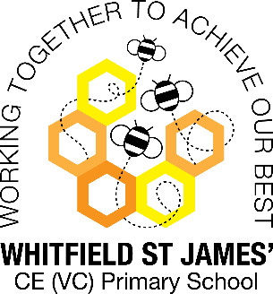Peonies snapshot of the week

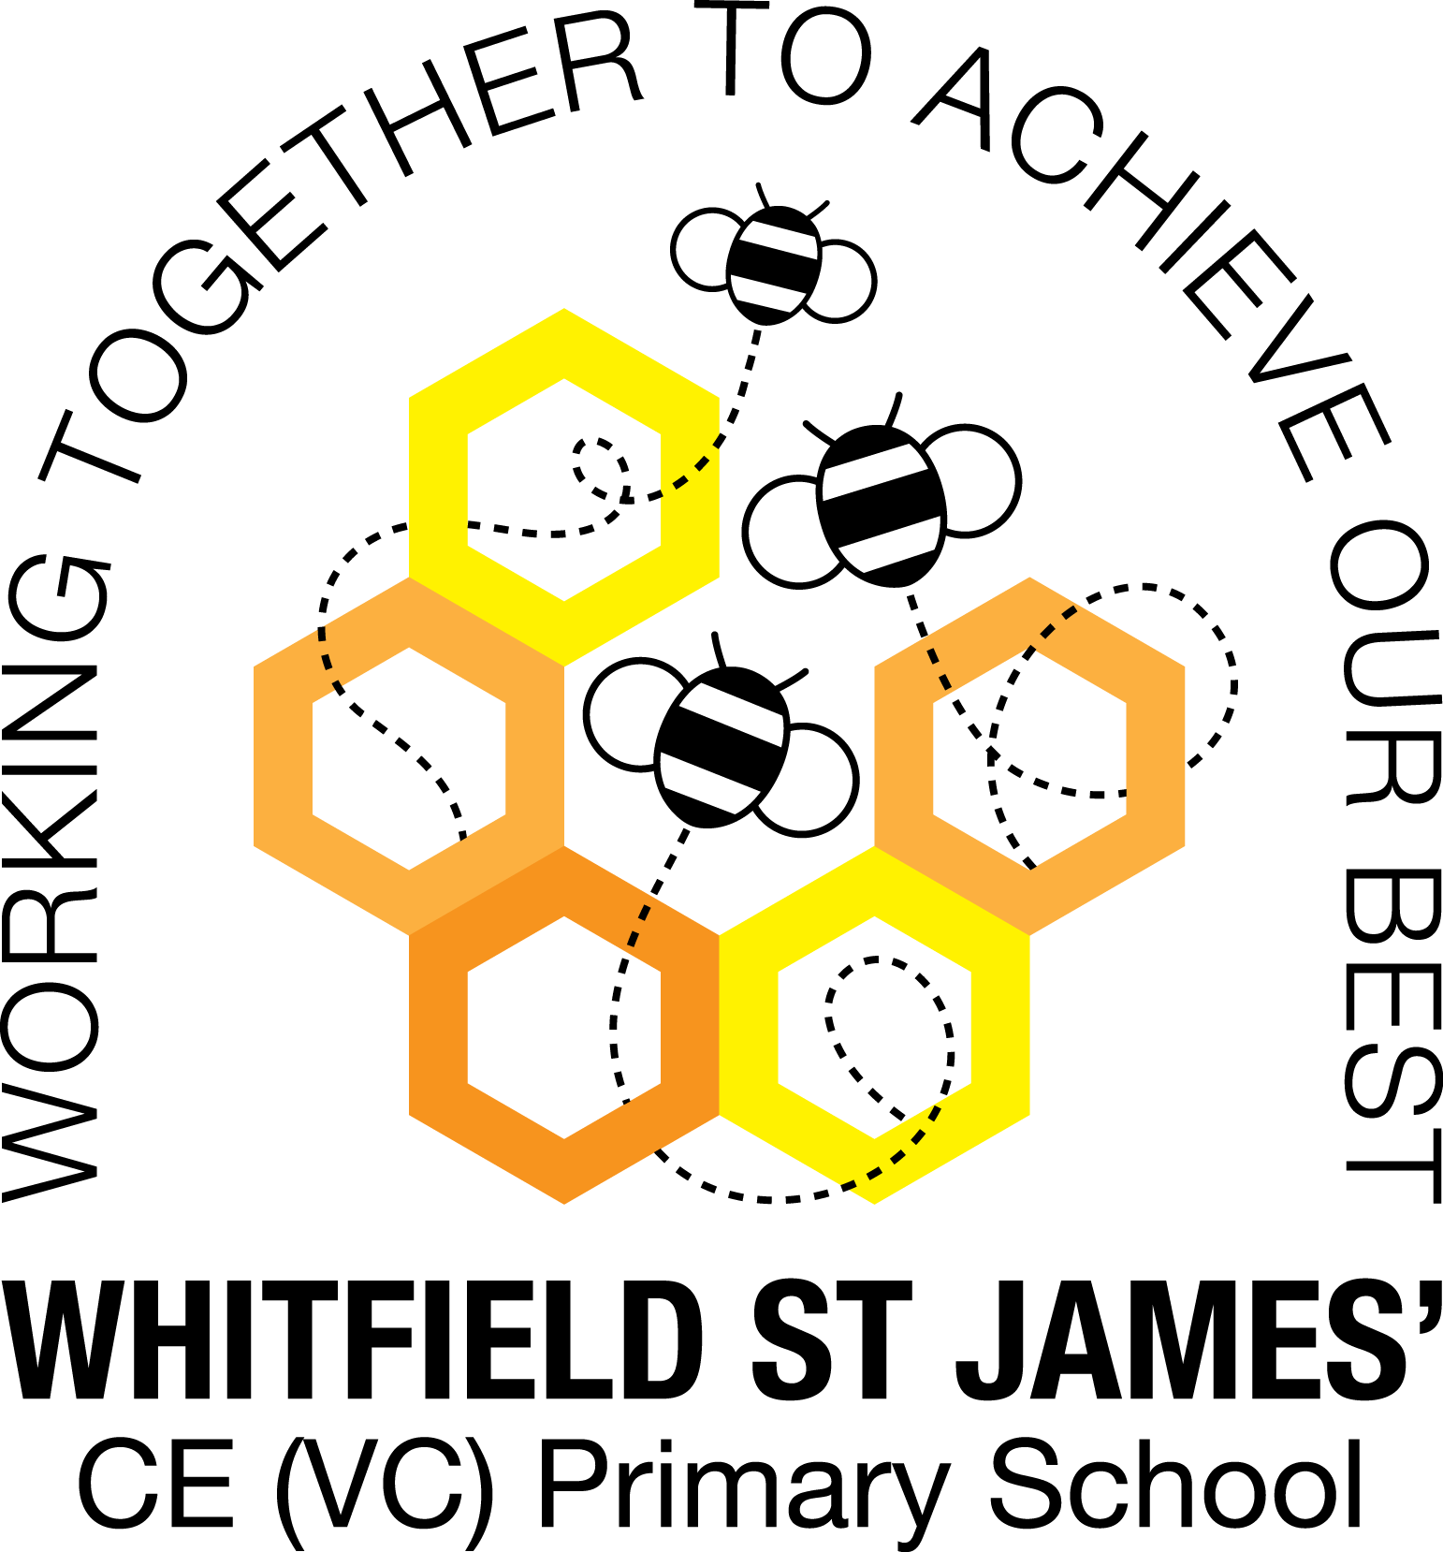

Here is a snapshot of some of the activities we have completed in our class this week. This snapshot may not contain all of the lessons and activities the children have been involved in, but will provide you with an idea of what we have done this week in Peonies class!

If you have any questions or need anything, please don’t hesitate to email me on the class email – [peonies@st-james.derbyshire.sch.uk](mailto:peonies@st-james.derbyshire.sch.uk) Miss Warburton

|  |  |
| --- | --- |
| **Topic**: Maafa | **Week commencing**: 22nd October 2021 |
| **Class book**: 1783 Freedom by Catherine Johnson |  |
| **Maths**  This week we really enjoyed the multiplication drop in lesson! We played lots of multiplication games and especially enjoyed TT Rock Stars and the counting stick game, as well as beat the calculator!  Challenge: Encourage your child to continue practicing their times tables over the half term break, on TT Rock Stars. I have set them all a Rock Slam challenge! Thank you! | **English**  This week the children have written a persuasive letter to King George III, asking him to abolish slavery. They have used lots of persuasive writing techniques and did a great job!  Challenge: Encourage your child to read daily over the half term break; daily reading makes such a difference to children’s fluency and the development of their comprehension skills. Thank you! |
| **Other lessons**  It was lovely to see some of you at the reading and times tables drop in lessons! Thank you for your support.  We have finished our black history topic, and we have thoroughly enjoyed it! It has been wonderful to see the children’s enthusiasm for this topic, and to hear of the extra reading and research they have done at home, including visits to the slavery museum in Liverpool. Well done Peonies for engaging so well with your learning, I am very proud of you all!  Well done to the children who organised and ran the cake sale this week, and to everyone who contributed cakes. There are too many of you to name, but your kindness and thought for others is a pleasure to see! | **Any other information**  Monday 1st November is an INSET day.  Tuesday 2nd November is our WOW day. On this day, please can children come to school dressed as children from WW2. Could they also bring with them, if possible, a small bag containing some items that a child may have packed when they were being evacuated – please see the example picture below for some guidance (please note: we will provide the children with a ration book to pack in their case)! During the morning of the WOW day, we are going to walk to the train station to be evacuated and then walk back to school. In the afternoon, we will be learning about the Make Do and Mend campaign. We will practise simple stitching and we will have a go at darning an item of clothing! If you are able to pack in your child’s evacuee bag a sock or shirt or anything with a hole in it then please do so, otherwise we will provide them with something to mend!  *Thank you for your support, it is very much appreciated!*    I have set the children a maths and English task on SATs Companion for their homework over the half term break. They can also keep practising the statutory spelling lists in their homework books if they wish to, and of course their daily reading!  Thank you for returning your parents’ evening appointment slips so promptly. I look forward to meeting you all properly on these dates! |
| **Star of the week:** Sammy  **Christian Value Award:** Millie |