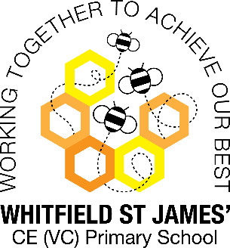Bluebells snapshot of the week

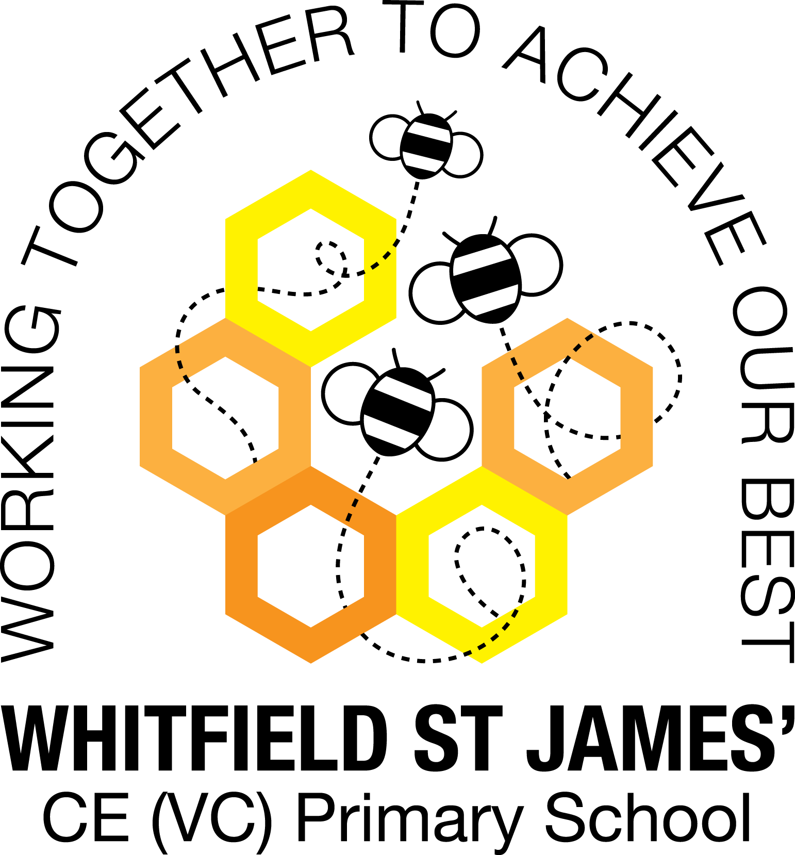

Here is a snapshot of some of the activities we have completed in our class this week. This snapshot may not contain all of the activities the children have been involved in. If you have any questions or need anything, please don’t hesitate to email us on the class email – [bluebells@st-james.derbyshire.sch.uk](mailto:bluebells@st-james.derbyshire.sch.uk)

|  |  |
| --- | --- |
| Topic: Me and My Community | Week commencing: 13.9.2021 |
| Class book: The Colour Monster |  |

|  |  |
| --- | --- |
| **Communication and language**  We have been playing circle games, learning to take turns remember our friends’ names. | **Maths**  We have been rolling the dice and counting the spots, playing dominoes. |
| **Phonics**  This week we have learnt the sounds s,a,t, p - please look in your child’s book bag for flash cards to practise recognising the letter | Any other information  Communication and Language  If you have not already done so, can you please upload a photo onto Tapestry that you think your child would like to talk about. This could be a photo of a pet, family member, favourite toy or recent experience such as a visit to the park or family holiday.  Expressive Art & Design  We will be making picture frames in our art lessons next week, so can we please ask that you send in a family photograph (any size, which we can decorate). Alternatively, you can take a family “selfie” and email to the bluebell email address above and we will print.  **Please send in a photograph or email by Monday the 20th September**. Thank you |
| Star of the week: Jacob  Christian Value Award: Kashan |